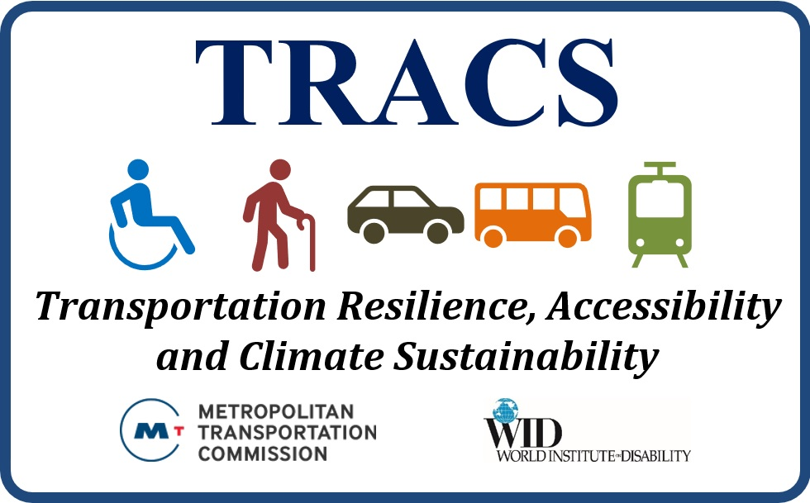

Bay Area Transportation Systems for People with Disabilities –

Overview and Analysis

World Institute on Disability
January 2020

This Page Intentionally Left Blank

Transportation Resilience, Accessibility and Climate Sustainability (TRACS)

A partnership between the World Institute on Disability (WID) and Metropolitan Transportation Commission (MTC), supported by the California Department of Transportation (Caltrans)
TRACS is an intensive research and policy analysis initiative to explore how people with disabilities (PWDs) and seniors in the San Francisco Bay Area navigate regional transportation systems. Among other topics, it will address these groups’ use of transportation, their positive feedback, frustrations, concerns, and recommendations. TRACS aims to improve the transportation system overall to support independence and well-being, with special focus on ensuring climate resilience and effective emergency management for seniors and people with disabilities. TRACS includes data analysis; research on regional transportation options, operators, policies and planning; engaging the disability community through focus groups, interviews, and surveys; developing policy recommendations; and public education initiatives through workshops and publications.

Bay Area Transportation Systems for people with Disabilities – Overview and Analysis: Table of Contents
Overview 4
people with disabilities and Seniors in the Bay Area 6
Census Tract Data – Seniors and people with disabilities 10
The Disability Experience 15
Disability History and Community in the Bay Area 16
Universal Access and Transportation 17
Travel Habits: Insights from the NHTS 20
Bay Area Transportation Systems: Operations, Performance & Planning 27
Transportation Service Types 27
A Complex Transit Network 44
Quantitative Analysis: Operational Statistics and Performance Measures 45
Operational Data by Transit Agency & Service Type 45
Quantitative Analysis 47
Comparing Service Types 49
Conclusion 57
Appendices 59
Appendix 1: Full-Size Population Maps 59
Appendix 2: NHTS Survey Responses (Individual Data) 65
Appendix 3: NHTS Data (Householder Responses) 68
Appendix 4: Quantitative Analysis Tables Using FY 2015-16 Data 70
References 77

Overview
The San Francisco Bay Area (“Bay Area”) is a geographically, economically and demographically diverse region comprising the 9 counties of Alameda, Contra Costa, Marin, Napa, San Francisco, San Mateo, Santa Clara, Solano and Sonoma Counties. According to the US Census Bureau, the Bay Area has over 7.6 million residents as of 2017; approximately 9.8% of the population has a disability and 14.8% are seniors (age 65 and above), while the combined disability and senior populations represent 20% of the region’s residents (this is lower than the sum of disability and senior figures, as there is overlap between the two population groups). This is a significant constituency that will likely grow in the coming years given the area’s aging population and correlation between age and disability. The constituency also has unique experiences and needs related to the region’s economy, services and infrastructure. It is important to understand, evaluate, and address these needs moving forward.
Transportation is one of the largest concerns to people with disabilities and seniors in the Bay Area. people with disabilities – including but not limited to individuals with mobility, sensory, psychological, learning, intellectual and/or developmental disabilities – have distinct needs around transportation ranging from physical accessibility (e.g. functioning ramps, elevators, and wheelchair-accessible private vehicles) to ease-of-navigation to information being available in accessible and/or alternative media (e.g. brochures in braille, screen-reader-accessible websites and apps, etc.). people with disabilities and seniors also utilize transportation options that are not necessarily available to younger individuals without disabilities, including paratransit, volunteer driving services, and assorted fare discounts on public transit.
Navigating the Bay Area can be extremely difficult for seniors and people with disabilities. Individuals with limited or no access to private vehicles must work through a complex web of transportation options that are often delineated by counties or other boundaries. Some options include buses, rail (e.g. BART, Caltrain, Muni and VTA light-rail, SMART, Amtrak etc.), ferries, paratransit, volunteer driver services, taxis, transportation network companies (TNCs) like Uber and Lyft, using pedestrian pathways and bike lanes, and being driven by friends or family with personal vehicles. Each transportation option across the Bay Area’s nine counties has its own service profile regarding cost, geographic “footprint,” speed, reliability, physical accessibility, availability of personal assistance, public information (on websites, apps, etc.) and other features. Operators – such as county transportation agencies, contracted service providers, businesses (e.g. taxis and TNCs), and nonprofits – likewise must address these “service profile” features while handling concerns around budgets, revenue sources, permitting, advertising, and other logistics. Unfortunately, physical and programmatic accessibility is insufficiently addressed across the region, with significant room for improvement.
Overall, the Bay Area features 25 public transit providers who manage the region’s fixed-route bus, rail, and ferry transit options; 19 of these operators provide paratransit and/or demand-response service; and finally, Amtrak’s Capitol Corridor commuter rail and several Amtrak interstate rail lines run through the Bay Area. Public or semi-public agencies are not the only transportation service providers, as many nonprofit, for-profit and community-based transportation providers round out the region’s transportation options. Most Bay Area households have personal vehicles, making driving of those cars, vans, trucks, motorcycles etc. another significant factor in the region’s transportation. The disconnected nature of the Bay Area’s transportation system – notably, its public transit and paratransit services – means that individuals using transit and/or paratransit and planning longer trips (or even short trips that move from one agency’s terrain to another’s) must often plan ahead and may encounter significant delays, wait times, or difficulties around accessibility, payment options, etc. Paratransit users, who are frequently required to call an agency at least one day in advance and are given “time windows” for pick-up and drop-off, can sometimes wait for well over one hour at the border between paratransit providers when they take longer trips. These and other difficulties will provide a basis for some of this report’s findings.
The Bay Area is also vulnerable to numerous natural disasters, ranging from earthquakes to forest fires to flooding to heat waves, and must prepare accordingly. Transportation is a key component of disaster readiness and response and must be shaped accordingly – and shaped with all groups in mind, including seniors and people with disabilities. For example, transportation supports disaster-related evacuations, which may occur with advance notice (e.g. before a dangerous storm), during a disaster with little-to-no notice (e.g. to escape a forest fire), or after an emergency hits (e.g. to leave damaged homes post-earthquake). Larger vehicles may deliver emergency supplies, food, water, etc. to shelters or community-level distribution sites. If some but not all transportation assets are damaged and non-operational, regions may need to rely on the remaining, functioning transportation systems until damaged assets are rebuilt or replaced. Ultimately, it is imperative for transportation systems to accommodate disaster readiness and response: they must support safe and timely evacuations, maintain life-sustaining operations (e.g. by delivering food, water, and medical services) post-disaster, and provide resilience to facilitate recovery in the medium- to long-term; this all requires multi-modal, resilient, responsive, coordinated transportation systems with enough redundancy to guarantee that needs will be met in any time frame. Importantly for our purposes, all services must consider seniors’ and people with disabilities’ current situations regarding transportation habits, capacities, flexibility, and more.
Some of this report’s key findings include:
- people with disabilities and seniors collectively represent approximately 20% of the Bay Area’s residents and have unique transportation needs. This figure may be an under-count given methods of defining disability in government surveys.
- The distribution of people with disabilities and seniors varies significantly from county to county. For example, 13.0% of Santa Clara’s residents are age 65 or older, while 21.9% of Marin County’s residents are seniors – a difference of 68%; meanwhile, 8.2% of San Mateo’s residents have disabilities compared to 13.1% of Napa County’s residents – a difference of almost 60%.
- Areas with higher percentages of seniors and people with disabilities tend to be less geographically dense with spread-out public transportation systems, which can be more difficult and time-consuming to navigate. This raises questions of causality, as many factors may push these groups to suburban and rural areas, such as: the benefits of lower housing costs; a preference to age-in-place; an affinity for “peace and quiet” over urban qualities; and seniors’ and people with disabilities’ disproportionate rates of being out of the labor force (i.e., because of income and savings limits tied to many public benefit programs) and, thus, lower desire to live near strong urban job markets.
- The Bay Area features numerous transportation options for seniors and people with disabilities, including but not limited to pedestrian walkways, personal vehicles, fixed-route buses, demand-responsive buses, paratransit, heavy rail (e.g. BART and Caltrain), light rail, ferries, and San Francisco’s historical duo of Streetcars and Cable Cars. Each of these provides some benefits to seniors and people with disabilities, while all have barriers or drawbacks to some extent. Certain transportation options have significant barriers that receive significant criticism from seniors and people with disabilities.
- The lack of a unified transportation service provider – or even unified providers for specific transportation types, whether fixed-route bus, paratransit, etc. – can create difficult, costly and time-consuming journeys for seniors and people with disabilities. The disconnected nature of paratransit, which has 19 operators and many contracted services, combined with its other characteristics (e.g. wide time windows for pick-up and drop-off), creates significant challenges for paratransit riders making longer trips.
- Paratransit, when compared to other public transit options, is significantly more expensive and less efficient to operate, both in general and per trip. Paratransit riders also express frustration and experience frequent delays when using the system. Passengers transferring from one paratransit provider to another (when crossing service areas) may experience long waits and a lack of coordination – and, in some cases, entirely miss transfers from one vehicle to another.
Seniors and people with disabilities are valuable members of the Bay Area population, with a long history of community involvement, social integration and advocacy. The modern disability rights movement began in Berkeley and evolved to support accessible public transit, economic integration, and widespread federal legislation for physical access and nondiscrimination. Progress was made through direct-action protests (including blocking inaccessible buses with lines of wheelchair-users), legislative advocacy, legal challenges, deep involvement in government proceedings, and more. We hope that this document provides useful background and frameworks for developing a universally accessible, responsive and affordable transportation system for seniors and people with disabilities across the Bay Area.

people with disabilities and Seniors in the Bay Area
The U.S. Census Bureau publishes annual statistics of population characteristics at many geographies, including national, state, county, and city levels. These American Communities Survey (ACS) data provide valuable insights into an area’s age, racial, disability-related, economic, and other characteristics. ACS data feature a plethora of information including total population, total noninstitutionalized population, age groups, rates of disability, employment and income characteristics, and more. This report utilizes 2017 five-year estimates in data tables and graphs, unless otherwise noted.
We must recognize a slight conundrum when utilizing ACS data for rates of disability specifically. Because of the way the Census Bureau counts disability, combined with some people with disabilities’ failure to acknowledge and/or share that they have a disability, the ACS likely under-represents true rates of disability in its tabulations. For example, ACS identifies six “disability types” of hearing, vision, cognitive, ambulatory, self-care, and independent living difficulty. The true nature of disability, though, is far more complex and intersectional, and some people with disabilities may not identify as being in one of these six “categories” and thus do not report having a disability when surveyed. It can also be argued that ACS’s reported rates of disability for youth are artificially low for the following reasons: (1) a person may have a disability from birth or develop one during childhood, and even show symptoms or characteristics in that timeframe, but the disability itself may not be diagnosed until later in life; (2) only two of the ACS’s six disability-related questions are even asked about for people under age 5 (hearing and vision difficulty), while four are asked of ages 5 and above (difficulty concentrating/remembering/ making decisions, difficulty walking or climbing stairs, and difficulty dressing or bathing), and the final question is only asked of persons aged 15 and over (difficulty doing errands alone). Another factor is that the ACS only records disability in the “civilian noninstitutionalized population,” which leaves out individuals in penal facilities (jails/prisons), mental facilities, and homes for the aged; given the nature of these institutions, rates of disability are almost certainly higher than in the noninstitutionalized population. Although individuals in institutions still have transportation needs (e.g. to medical appointments), the following statistics only reference civilian noninstitutionalized groups given available data. Using its 2017 5-year estimates, ACS shows the national rate of disability in the civilian noninstitutionalized population to be 12.7% (approximately 40.7 million out of 320.8 million individuals), up from 12.0% in 2010; however, a Census Bureau publication titled “Americans With Disabilities: 2010” noted that, in 2010, the percentage of Americans with a disability was 18.7%, while 12.6% had a “severe disability” – so ACS appears to have under-counted the prevalence of disability in 2010 (and likely continues to do so, at least some extent).
Still, the ACS provides the best overall resources for granular data at the county and regional levels, and thus the most useful information for technical reports – which is why we use it here. It is also important to recognize that “disability” is an overarching term that represents many physical, emotional, psychological, sensory, and other personal characteristics, as well as social, infrastructural and institutional factors affecting people with disabilities. Disability is not clear-cut; it is intersectional and multifaceted in ways that are difficult to capture using surveys and related data. Keeping with the aforementioned disconnect, though, it may be a good rule-of-thumb to adjust ACS data upward between 20% and 50% to get a more reasonable upper-limit of rates of disability (so the Bay Area’s 9.8% estimate per ACS may represent a true rate closer to 12-15%).
Taken together, the total number of people with disabilities in the Bay Area is approximately 753,287, or 9.8% of the civilian noninstitutionalized population. Figures range from lows of 8.2% in San Mateo and Santa Clara counties, to 13.1% in Napa County.

Table 1: Population of people with Disabilities in the Bay Area
County | Total Population* | people with Disabilities | Percent
Alameda | 1,619,367 | 154,753 | 9.6%
Contra Costa | 1,141,780 | 133,310 | 11.7%
Marin | 256,005 | 23,646 | 9.2%
Napa | 139,286 | 18,283 | 13.1%
San Francisco | 880,097 | 86,234 | 9.8%
San Mateo | 767,094 | 63,179 | 8.2%
Santa Clara | 1,928,741 | 158,053 | 8.2%
Solano | 432,898 | 56,427 | 13.0%
Sonoma | 500,585 | 59,402 | 11.9%
Total | 7,665,853 | 753,287 | 9.8%
* Total Civilian Noninstitutionalized Population
ACS data also provide age distributions of both the overall population and noninstitutionalized population in different geographies. For the sake of consistency, we will address only the noninstitutionalized population in the following statistics.
Out of 7,665,853 Bay Area residents, 1,137,821 are seniors 65 years old and over, representing 14.8% of the region’s population. Rates range from a low of 13.0% in Santa Clara County up to 21.9% in Marin County. This is in line with each County’s economic, geographic and related profiles, which is elaborated below.

Table 2: Population of people age 65+ in the Bay Area
County | Total Population | 65 Years and Over | Percent
Alameda | 1,619,367 | 219,776 | 13.6%
Contra Costa | 1,141,780 | 173,127 | 15.2%
Marin | 256,005 | 55,929 | 21.9%
Napa | 139,286 | 24,978 | 17.9%
San Francisco | 880,097 | 133,665 | 15.2%
San Mateo | 767,094 | 120,238 | 15.7%
Santa Clara | 1,928,741 | 251,029 | 13.0%
Solano | 432,898 | 65,680 | 15.2%
Sonoma | 500,585 | 93,399 | 18.7%
Total | 7,665,853 | 1,137,821 | 14.8%
* Total Civilian Noninstitutionalized Population
Taken together, the total estimated population of people with disabilities and/or seniors in the Bay Area is approximately 1.5 million people, or 20% of the region’s residents. Rates vary from a low of 17% in Santa Clara County to 25.8% in Marin County; the nine Bay Area counties are, from lowest to highest percentages, Santa Clara (17.0%), Alameda (18.9%), San Mateo (19.1%), San Francisco (19.9%), Contra Costa (22.1%), Solano (22.9%), Napa (24.7%), Sonoma (25.4%), and Marin (25.8%).

Table 3: Total people with disabilities (PWDs) and/or Seniors in the Bay Area
County | Total Population | PWDs and/or Seniors | Percent
Alameda | 1,619,367 | 306,080 | 18.9%
Contra Costa | 1,141,780 | 252,108 | 22.1%
Marin | 256,005 | 65,949 | 25.8%
Napa | 139,286 | 34,390 | 24.7%
San Francisco | 880,097 | 174,710 | 19.9%
San Mateo | 767,094 | 146,612 | 19.1%
Santa Clara | 1,928,741 | 328,071 | 17.0%
Solano | 432,898 | 99,030 | 22.9%
Sonoma | 500,585 | 127,215 | 25.4%
Total | 7,665,853 | 1,534,165 | 20.0%
* Total Civilian Noninstitutionalized Population
It is important to note that rates of disability increase with age. For example, across the Bay Area, 2017 ACS data shows that approximately 753,287 Bay Area residents in the “noninstitutionalized population” have disabilities, out of the total noninstitutionalized population of 7,665,853 – for a rate of disability of 9.83%. However, delineated age groups reveal large disparities in rates of disability, which are: 0.5% of children under 5 years old; 3.7% of children aged 5 to 17; 4.7% of adults aged 18 to 34; 8.3% of adults aged 35 to 64; 19.6% of adults age 65 to 74; and 48% of adults 75 and over. In fact, nearly half of all people with disabilities are seniors: 17.34% of all people with disabilities are age 65 to 74 and 30.05% of all people with disabilities are age 75 and over, for a cumulative 47.38%. Given the aging population (40.8% of Bay Area residents are age 35 to 64), these numbers are projected to increase over the next several decades.

Figure 1: Civilian Noninstitutionalized Population Characteristics
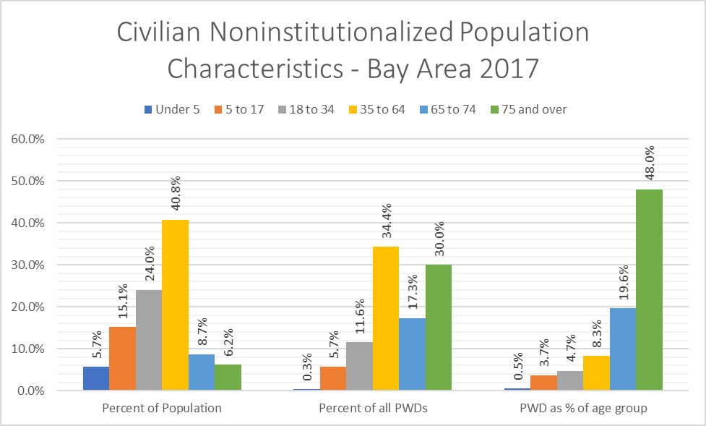
These and other figures make sense given each County’s layout, economy, and other factors. For example, Santa Clara County hosts a dense and robust economy, largely focused around “tech” jobs and related industries, and has a high cost-of-living that usually must be supported through active employment that is out-of-reach for many people with disabilities (who have lower rates of employment and income) and retirees. Conversely, Marin County is less densely developed, has a local service-oriented economy, and is recognized as a prime location for retirement and for wealthier individuals who work in other job centers, e.g. San Francisco and Alameda Counties. This is supported by other data: just looking at homeownership as a proxy for wealth and depth into one’s career or retirement, 57% of Santa Clara’s occupied housing units are owner-occupied, while 64% of Marin County’s units are owner-occupied – a 12% difference. Understandably, leaders in areas with aging demographic profiles (namely Napa, Marin, Sonoma and Solano Counties) are cognizant that projected increases in the number of seniors and people with disabilities will impact local economies, government revenues, and residents’ needs ranging from social services to medical supports to transportation infrastructure.

Census Tract Data: Seniors and people with disabilities
Decennial Census and American Communities Survey (ACS) data can be used to identify estimated demographics at census tract levels, with figures covering overall population, age distribution, numbers of people with disabilities, people with disabilities as parts of other demographic groups (i.e. by age, gender, race, ethnicity, etc.), household income, and dozens of other characteristics. The following analysis addresses statistics for people with disabilities, seniors (age 65 and over), and the combined people with disabilities/senior populations; the two statistics for each group are their percentage of the overall population and population density per mi².
Our analysis focuses on defined municipal boundaries rather than every acre of Bay Area (which includes forests, unincorporated areas, and other geographies not covered by transit agencies). The nine County Bay Area has 1,581 non-water census tracts with land areas ranging from 0.022 mi² to 589.759 mi² and population estimates ranging from 58 to 13,864 (using ACS 5-year data, 2017).
Appendix 1features several maps highlighting geographic trends for disability, senior, and combined populations. The maps show these groups as a percent of the area’s population and density per square mile. Planners and other stakeholders can utilize these maps as they deem fit.

Overview of Population Percentage and Density
Demographic estimates for people with disabilities vary widely by region and census tract. people with disabilities as a percent of the population range from 0% up to 43.1%. On the low end, only one tract has 0%, while three others are under 2%, 15 more are under 3%, 70 are between 3-5%, 821 are between 5-10%, 622 are between 10-20%, 35 are between 20-30%, and nine are over 30%; meanwhile, the highest percentage (Tract 2009, Napa County, at 43.1%) has a small overall population and thus a large margin-of-error (MOE), although some tracts with higher densities (above 30%) do have relatively small MOEs. Outside of the one census tract with 0% people with disabilities, the population density of people with disabilities per mi² range from 0.24 to 56,338.93. Four tracts are under 1 PWD per mi², 16 are between 1-5, 27 are between 5-10, 17 are between 10-20, 42 are between 20-50, 67 are between 50-100, and 200 are between 100-200 people with disabilities per mi²; on the high end, one tract has 56,338.93, one has 33,567.41, three are between 20,000-25,000, seven are between 10,000-20,000, and 27 are between 5,000-10,000 people with disabilities per mi².
Demographic estimates for seniors likewise vary widely. Seniors as a percent of the population range from 0% to 89.74%, where approximately one quarter of all tracts are under 10%, over half are between 10-20%, around 14% are between 20-30%, 23 (under 2%) are between 30-50%, and seven are over 50%. On the low end, four census tracts show 0% seniors, while seven are under 1%, two more are between 1-2%, and nine are between 2-3%; on the high end, three adjacent tracts (Tracts 3511.01-3511.03, Contra Costa County) are between 88.78-89.74%, while one tract has 74.04%, one has 66.01%, and two are in the mid-high 50s. Outside of the census tracts with 0% seniors, the population density of seniors ranges from 0.385 up to 44,083.677 seniors per mi². On the low end, only one tract is under 1, while 11 are between 1-5, 8 are between 5-10, 25 are between 10-20, 36 are between 20-50, 43 are between 50-100, and 94 are between 100-200 seniors per mi²; on the high end, one tract has 44,083.677, two are between 20,000-25,000, 14 are between 10,000-20,000, and 34 are between 5,000-10,000 seniors per mi².
Figures around the sum of people with disabilities and seniors (people with disabilities age 0-64 and everyone 65+) follow similar trends to people with disabilities and seniors on their own, but skew higher simply by combining groups. This constituency as a percentage of population ranges from a low of 0.62% up to 90.11%; nine tracts are under 5%, 50 are between 5-10%, 849 are between 10-20%, 573 are between 20-30%, 77 are between 30-40%, nine are between 40-50%, there are two each in the 50s, 60s, 70s, and 80s, and a single high of 90.11%. Densities range from a low of 0.519 seniors and people with disabilities per mi² to a high of 73,754.57 seniors and people with disabilities per mi². On the low end, only one tract is under 1 person per mi², nine are between 1-5, six are between 5-10, 16 are between 10-20, 32 are between 20-50, 34 are between 50-100, and 76 are between 100-200 seniors and people with disabilities per mi²; on the high end, one tract has 73,754.57, 9 are between 20,000-40,000, 20 are between 10,000-20,000, and a full 78 are between 5,000-10,000 seniors and people with disabilities per mi².
A graph showing numbers of census tracts by percentage of population is in Figure 2, below. With regards to persons per mi², the categories not noted above – ranging between 200 and 5,000 persons per mi² – can be found in Figure 3 (with figures denoted in hundreds of persons per mi²). Categories of 200 persons per mi² are used through 2,000, followed by categories of 1,000 apiece from 2,000 through 5,000 per mi².
The general trend of both graphs shows a lower percentage and density of people with disabilities compared to that of seniors and, ultimately, the combined seniors and people with disabilities figures. people with disabilities as a percentage of the population is skewed relatively low, where more than three-quarters of census tracts (1214 total) have less than 12% people with disabilities, while nearly half (732) are under 9%; the largest single group is 6-9%, with 533 census tracts – or just over one-third of all tracts. Seniors, on the other hand, have a bell curve that is more even than people with disabilities and is skewed slightly left-of-center, but still farther right than people with disabilities alone. The largest percentage group is 12-15% (332 tracts), fitting the median of 13.5%; meanwhile, nearly 20% of tracts have senior populations under 12% and just under one-quarter have tracts with 15% or more. Finally, the combined groups feature a bell curve similar to seniors alone, but shifted (and skewed) farther right. Very few tracts have small population groups: only 12 have fewer than 6% of the combined senior/PWD population, with less than 10% of all tracts having under 12% combined senior/people with disabilities. Next, the two tallest groups are adjacent and nearly identical – 15-18% has 328 tracts, while 18-21% has 327 (fitting the median of 18.9%) – over one-fifth of all tracts have greater than 24% of this population, and one-tenth have over 24%. 95 census tracts (nearly 6% of the total) have greater than 30% combined people with disabilities/seniors.

Figure 2: Count of Census Tracts by Percentage of Population

Figure 3: Count of Census Tracts by Population Density

The distribution and density of people with disabilities by census tract make sense given regional socioeconomic characteristics. people with disabilities as a percentage of the overall population skew lower in wealthier residential areas of San Francisco, Alameda County, Marin County, and the Silicon Valley; people with disabilities represent a higher proportion of the population in the suburbs of Sonoma, Napa, Solano and Contra Costa counties, as well as downtown Oakland, sections of East Oakland, and downtown San Francisco. This somewhat correlates with cost-of-living, as people with disabilities have lower rates of employment and income – while it is possible that other factors influence specific geographies, such as high rates of homelessness (which correlates with disability) in downtown San Francisco and Oakland. The density of people with disabilities per mi² are lowest in suburban areas of all counties except San Francisco, and especially in larger segments of Marin, Contra Costa, Eastern Alameda and Santa Clara counties; people with disabilities are most concentrated in San Francisco, Northwest Alameda County, Western Contra Costa County, and in some areas of the Silicon Valley, while other mid-sized cities (e.g. Fairfield, Napa, Santa Rosa, and Walnut Creek) have medium densities of people with disabilities per mi².
Seniors follow slightly different trends than people with disabilities across the Bay Area. Seniors represent a higher proportion of the population in rural areas of North Bay counties, in the hill-side segments of Silicon Valley, in suburban Central Contra Costa County, across Kensington and Eastern El Cerrito, and in some residential segments of San Francisco. The density of seniors per km2 is highest across San Francisco, in northern Berkeley and Kensington, just south of downtown Oakland, and east of downtown San Jose; densities are lowest in suburban and rural North Bay counties, suburban Central and Eastern Contra Costa County, Eastern Alameda County, and in southern Santa Clara County. These trends seem reasonable given the younger demographics of job centers (San Francisco, Silicon Valley, and Northwest Alameda County) and the tendency to “settle down” and retire in more suburban and rural areas.
The following six maps show the percentage of population and population density (as persons per mi2) for 3 groups: people with disabilities (people with disabilities), seniors, and the combination of people with disabilities & seniors in the San Francisco Bay Area. The maps utilize “unclipped” census tracts and scales move from red for lowest numbers, yellow for middle figures, and green for the highest numbers. Dark lines throughout the maps represent boundaries for the Bay Area’s nine counties.
Information in these maps may be difficult to decipher considering their size, with multiple maps on one page. See appendix for more detail.

Figure 4.1: PWDs as % of Population
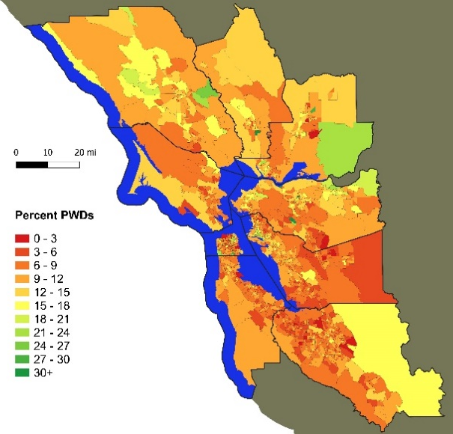

Figure 4.2: Seniors as % of Population
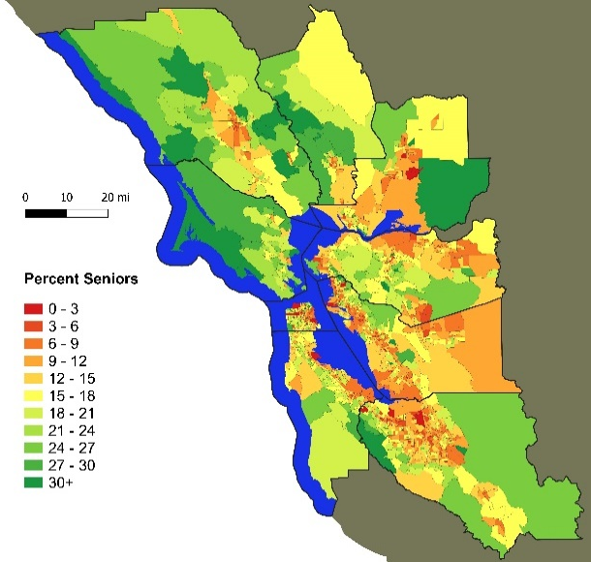

Fig. 4.3: PWDs & Seniors as % of Population
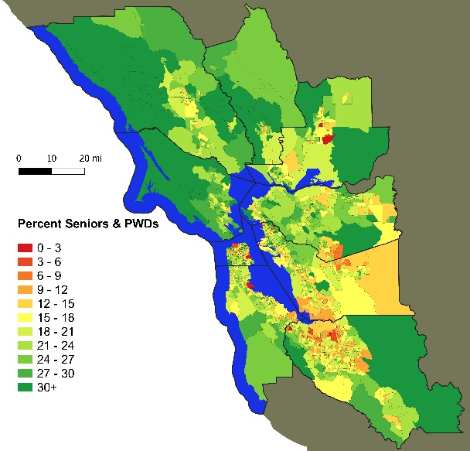

Figure 5.1: PWDs per mi²
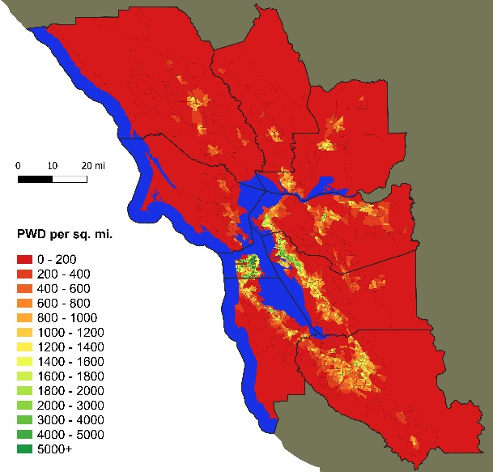

Figure 5.2: Seniors per mi²
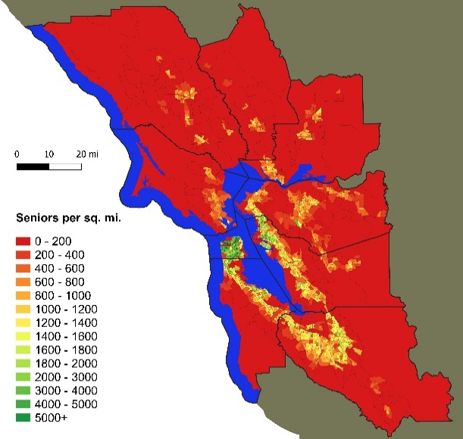

Figure 5.3: PWDs & Seniors per mi²
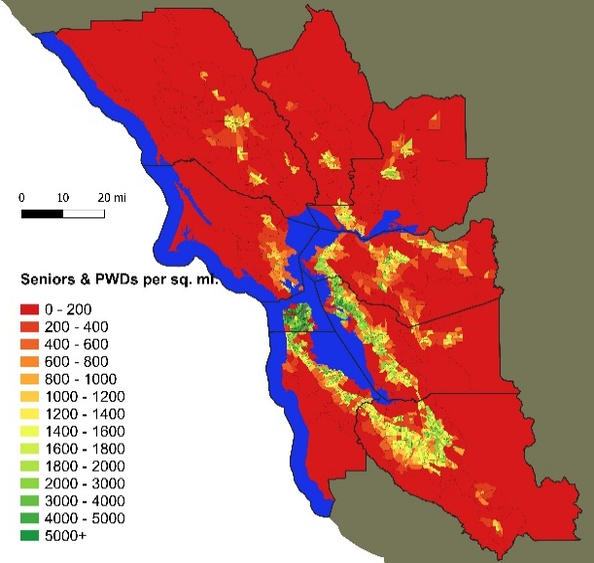

The Disability Experience
people with disabilities (PWDs) have encountered discrimination, lack of accessibility, and a host of other social ills for millennia. The disability rights movement has successfully fought for inclusion in many fields, such as accessible architecture for housing and public buildings, access to transportation and telecommunications, employment opportunities, integration into education at all levels, access to the arts and media, provision of personal assistance, appropriate healthcare and access to the full range of public accommodations like restaurants and retail stores. Each of these arenas had once served as a bastion of disability exclusion. With creation and enforcement of disability inclusive policies and law, these bastions are being challenged and overcome.
Accessible, workable transportation is a unique aspect of disability inclusion as it is intended to meet the essential goals of community inclusion that would enable full participation in social, economic, political and other spheres. This is a point worth emphasizing: that in order to participate in education, employment, recreation, and all other aspects of the life of the community, people must be able to get to where community resources and activities happen. Getting there is essential to participation.
Historically, traditional means of transportation for this diverse constituency has been held back by stereotyped notions that people with disabilities don’t leave home very much, aren’t likely to be employed, don’t socialize much, or don’t live lives with spontaneity, as do others in the community. These oppressive notions have constrained planning and development for full inclusion in transportation. For example, initial efforts at transportation resources in the 1960s forward, attempted to address the need to get to medical appointments, with ambulance-type vans, as if that was the primary justifiable destination for this population.
Availability of inclusive transportation sends a message, as well as facilitates the equitable reality that our society wants, expects and creates the resources for people with disabilities to get there and be there to participate in everything – not just “disability-related” activities, e.g. medical and social service agency appointments. Similar efforts at transportation-focused availability, community access, etc. are also growing for seniors. Times have changed and disability inclusion is gradually becoming a reality. Limits that present themselves are to be challenged.
Of importance to this project, the transportation system is encountering limits that are relevant to all populations, including people with disabilities and seniors. Widespread efforts to reduce the environmental footprint of the transportation system will affect the availability and reliability of assorted transportation methods, while natural disasters and climate change impacts may constrain transportation systems or bring them off-line entirely (in both short- and long-term time frames). We will need to continually expand our imagining of fully inclusive transportation to meet these and other growing challenges, such as disaster preparedness, climate change impact, and transformations toward more sustainable infrastructure.

Disability History + Community in the Bay Area
Despite historical and current systems that generate and reinforce economic and social barriers and inequities for people with disabilities, sections of the Bay Area feature vibrant networks and organizations representing people with disabilities, and active disability communities in general. Berkeley, located in Alameda County in the East Bay, is widely recognized as the birthplace of the modern Independent Living movement, which advocates for people with disabilities’ ability to reside in the community with full access to housing, employment, public spaces, and the services and accommodations necessary to achieve independence. The Independent Living movement and related advocacy reached many milestones to increase access and government services, including: publicly-funded healthcare, financial supports and personal attendant services; physically-accessible public spaces, businesses, and transportation systems; non-discrimination and reasonable accommodations in employment; and more. These achievements have been reinforced through laws and regulations, most notably Section 504 of the Rehabilitation Act of 1973 (requiring that federally-funded infrastructure, programs and services be fully accessible) and the Americans with Disabilities Act (ADA) of 1990 (which expanded requirements of accessibility to nearly all public accommodations, buildings, transportation, etc., along with guidelines for doing so). The progress of the IL movement has taken decades of navigating political spaces, engaging media, holding direct-action protests (e.g. blocking inaccessible buses with wheelchairs or crawling up the steps of Washington’s Capitol Building), filing lawsuits, and more. Results has been truly transformative, as people with disabilities’ quality-of-life are undoubtedly better than before Independent Living advocacy. However, there is much more to be done to reach full “universal accessibility” and non-discrimination, and advocates are continually pursuing legislation, regulation, and litigation to reach these goals.
The plethora of organizations serving people with disabilities in the Bay Area is an asset to transportation planners. Berkeley is home to the first center for independent living in the country, which provides an array of community supports such as assistance finding housing, hiring caregivers, navigating transportation, managing government benefits, and hosts forums, outings, support groups and other events. Centers for independent living have since spread nationwide, and there are more than 400 independent living centers across the country, including nine in the Bay Area. Similar organizations exist to serve specific disability groups, such as San Francisco’s Lighthouse for the Blind and Visually Impaired and Oakland’s Deaf Counseling, Advocacy & Referral Agency (DCARA). Independent living centers and other disability-focused organizations can serve as a “go-to” partners and sources of information for any organizations and agencies looking to understand the disability community and meet their needs.

Universal Access and Transportation
“Transportation” in both concept and service occurs through a plethora of modalities, from individual pedestrian travel to private vehicles to buses to heavy-rail trains to ferries. As population groups, people with disabilities and seniors navigate the world around them differently than able-bodied individuals. Some of the specific barriers faced by people with disabilities and seniors include:
- people with disabilities and seniors may face difficulties navigating pedestrian areas (inside homes/buildings, on sidewalks, in parks and nature areas, etc.) relative to able-bodied individuals. For example:
  - Individuals with physical disabilities may walk comparatively slower, experience pain and/or fatigue while walking, or be unable to walk altogether; this often requires the use of mobility equipment, from canes to walkers to manual and power wheelchairs; in severe cases, individuals may need others to push a manual wheelchair or a operate a power wheelchair.
  - Some people with disabilities and seniors may be unable to walk up and down stairs or escalators, including smaller staircases on buses, and mobility equipment may likewise be unable to get up curbs and/or stairs. Individuals therefore need curb cuts, elevators, ramps, lifts, elevated platforms, and/or level entryways to navigate pedestrian pathways, enter and move around buildings, and enter vehicles. Certain areas, such as dirt pathways in nature areas and parks, are outright inaccessible and nearly impossible to modify.
  - people who are blind or low-vision may be unable to see pathways (entirely or in part) and thus use white-tipped canes and/or guide dogs to identify ideal paths-of-travel and barriers/uneven pathways. If they are taking pathways to bus stops or other pick-up locations, they may have difficulty finding the pick-up area and/or “flagging down” drivers.
  - people who are deaf or hard of hearing may be unable to notice auditory cues, such as car horns or sirens from police cars, fire trucks and ambulances.
  - people with cognitive disabilities may have difficulty understanding maps, directions and paths-of-travel. This may also pose problems in utilizing public transit.
- Because of the disproportionately low income and assets of people with disabilities and seniors, as a group they have lower rates of personal vehicle ownership and higher reliance on other transit systems. They may prioritize affordable transit (e.g. buses instead of heavy rail), forgo trips altogether, or ensure that they run multiple errands at once to minimize transportation costs. Finances and/or insurance coverage may also affect individuals’ access to mobility equipment, guide dogs, etc.
- A large number of people with disabilities and seniors cannot drive conventional or any personal vehicles: this may be due to physical disabilities and the space needed by mobility equipment; physical disabilities which affect the ability to operate gas and brake pedals and/or steering wheels; sensory disabilities which affect the ability to see roadways and/or hear important auditory cues, such as car horns and sirens; etc. These individuals may therefore use fixed-route transit, demand response, paratransit, modified vehicles (e.g. minivans with fold-out ramps and hand-controls for gas and brake pedals), TNC companies, taxis, friends’ and family’s vehicles, etc.; however, costs associated with some or all of these transportation alternatives may be prohibitive.
- Some people with disabilities and seniors may be unable to stand for long periods of time (e.g. in buses or subway trains), and thus need regularly-available, designated seating; individuals with wheelchairs, scooters, and some other mobility devices cannot use vehicles absent designated “parking areas” and, in some cases, tie-down straps for safety.
- Individuals using accessible minivans with entry ramps on the side must ensure that there is sufficient room to unfold the ramp and exit their vehicle; this is only possible in designated “handicapped parking” spaces with striped adjacent areas, or in some curb-side parking. Vans with rear-entry ramps likewise require sufficient exit room.
- Some ambulatory people with disabilities and seniors (including those using canes and walkers) without ramp-vans still may experience pain and/or fatigue and thus have difficulty walking long distances; these individuals benefit from parking spaces near their destination(s).
- The transportation systems frequently used by people with disabilities and seniors – such as fixed route transit, paratransit, demand response, and even walking or rolling on pedestrian pathways – require more time from origin to destination than do the cars, vans, trucks, bicycles, scooters, and other vehicles used by many able-bodied people, as well as walking and jogging in some cases. This compromises independence and life activities, including employment opportunities; resulting unemployment and/or low incomes further limit transportation options.
These and other barriers require transportation systems, including pedestrian pathways, which go beyond those built for able-bodied and non-senior groups. Modified systems should ideally incorporate the framework of “Universal Access.” Universal Access with regards to transportation builds on the concept that people with disabilities and seniors should have equal access to transportation modalities – and if any one modality is inaccessible, a reasonable alternative must provide comparable service with regards to affordability, timeliness, flexibility and comfort. Access to mobility opens doors to the world, allowing people with disabilities and seniors to have increased independence, socialization, seamless healthcare, employment and more.
Ultimately, Universal Access utilizes concrete actions, technologies and resources to reach life-quality and social goals. It can build off the 7 principles of Universal Design, which are listed as: 1) Equitable Use; 2) Flexibility in Use; 3) Simple and Intuitive Use; 4) Perceptible Information; 5) Tolerance for Error; 6) Low Physical Effort; and 7) Size and Space for Approach and Use. The life-quality and social goals that can guide the development of an effective transportation system – and which serve as cornerstones of TRACS’s analysis and recommendations – include:
- Smooth, comfortable, safe, affordable and efficient transportation throughout one’s community in ways that facilitate social integration, health, safety, and economic stability.
- The ability to navigate one’s environment in manners comparable to those used by able-bodied and non-senior groups (with regards to speed, safety, comfort, affordability, etc.).
- Smooth, efficient, and safe access to services which serve notable roles in the senior and disability communities, such as healthcare centers, community organizations, social service offices, day programs, etc.
- Access to educational, employment and economic opportunities, such as local colleges/universities, job placement centers, and employment centers (whether smaller, rural downtowns or the larger job centers of San Francisco, Oakland, San Jose, etc.), with the speed and flexibility to access many opportunities, high income potential and improved quality-of-life.
- Appropriate transportation to maintain health and safety during and after natural disasters and other crisis situations; this can include providing safe and efficient evacuation to hospitals and/or accessible shelters, connecting people with disabilities and seniors with their immediate support networks (caregivers, family, etc.), and more. Disaster management should keep in mind people with disabilities’ and seniors’ existing transportation situations, such as lower rates of vehicle ownership, higher reliance on public transit and paratransit, and so on.
- Where needed, achieving goals through modified vehicles, services, and/or financial supports to enable equal access to mobility, community integration and assorted life quality benefits.
Some illustrative examples of transportation-focused universal access include:
- people with disabilities and seniors who have difficulty walking around their environment or walking for extended periods of time should have access to mobility equipment including, but not limited to, canes, walkers, manual wheelchairs, power wheelchairs, and scooters. Individuals with limited or no arm movement should be given advanced control systems, including “joystick -like” controls that can be used by moving one’s head or other body part. people with disabilities with severe immobility who cannot push a joystick or otherwise manage a power wheelchair should have access to caregivers (funded by insurance, government agencies, etc.) to push their manual wheelchairs or operate power wheelchair joysticks.
- Public walkways must be wheelchair-accessible by using smooth sidewalks, curb cuts, etc. Important landmarks and pathways should have markers for blind/low-vision and deaf/hard-of-hearing individuals, e.g. crosswalk buttons with audio features, curb cuts with installed bumps, and flashing lights notifying of oncoming cars in smaller intersections.
- All public transit vehicles should feature designated wheelchair-accessible seating areas, audio announcements for blind individuals (e.g. for announcing arriving vehicles or upcoming stops), and other universal access features.
- Rail transit should have fully accessible entryways with functioning elevators, elevated platforms, ramps and/or lifts.
- Buses should have ramps and/or lifts for entry and exit; importantly, this was the foundation of one of the major direct-action disability advocacy organizations, Americans Disabled for Accessible Public Transit (ADAPT), which successfully pushed for accessible buses beginning in the 1970s.
- Under any circumstance where people with disabilities and/or seniors have difficulty using conventional fixed-route transit, agencies should provide reasonable alternatives. This has since evolved into ADA-regulated paratransit (both run directly by agencies and outsourced to contractors), demand-response transit, taxi scrip programs, and other similar services. Certain agencies/providers provide services beyond those mandated by the ADA, such as accompanying riders from buildings to vehicles and vice versa.
- Transportation managed and provided by private, non-government entities – for example, taxis and the expanding system of TNCs – should not discriminate against people with disabilities and seniors. This must include those entities having accessible vehicles available in a timely manner, ideally in timeframes comparable to their “conventional” vehicles, e.g. sedans and SUVs; another example is allowing guide dogs and other service animals in vehicles.
- people with disabilities who cannot travel outside their wheelchair (and therefore cannot use car seating) but could otherwise afford and maintain a personal vehicle should be able to purchase vans with built-in ramps and sufficient internal space for a wheelchair to maneuver, park, and be secured. These are now available as minivans and full-size vans, although they can cost anywhere from $30,000 to over $70,000 brand-new, depending on manufacturer and model.
- “Hand driving control” systems should be available to people with disabilities who are able to enter a driver’s seat or park their wheelchair in the driver’s area of a van with removable seating, but otherwise cannot use their legs enough to press gas and brake pedals. In recent years, more advanced (albeit expensive) hand driving controls have been designed to enable people with incomplete arm movement – such as somebody with a mid-level cervical spinal cord injury – to drive.
- Most or all people with disabilities and seniors should be given reduced fares on most or all transit systems to counter limited transportation options, as well as disproportionately low income and asset levels and other negative economic conditions – including economic conditions resulting from systemic inequalities, discrimination and government policies (e.g. income and asset limits tied to SSI, SSDI, Medicaid/Medi-Cal and other benefits programs).
- people with disabilities and seniors who need direct assistance navigating the world around them – for example, by receiving guidance from buildings to vehicles or having others drive personal vehicles – should receive that assistance at little or no cost.
These and other systems enabling universal access in transportation may be provided by many entities including, but not limited to: infrastructure managers (e.g. for sidewalks at curb cuts), private companies multi-modal transit agencies, individual transit service agencies, and contractors. Government can provide direct support for accessible services (e.g. through grants), regulate private and public entities, and mediate conflicts between transportation providers and advocates (either individual or organizational). Advocates have pursued universal access goals through many venues including, but not limited to: media engagement, conventional lobbying, lawsuits (often under the ADA), and direct action (as is the case with ADAPT). The struggle is ongoing, both at the national level and local levels – including the San Francisco Bay Area.

Travel Habits: Insights from the NHTS
The National Household Travel Survey (NHTS) assembles individual- and household-level data on travel habits through “travel diaries” distributed to participants around the country. The 2017 NHTS provides valuable insights to the travel habits of the Bay Area population in general, as well as for specific population groups – including seniors and people with disabilities. Because of the relatively small sample size of the NHTS, this section will evaluate travel habits for the entire Bay Area, rather than addressing individual cities or counties. Even with this broader area, the NHTS and related conclusions help to understand the current experience of seniors and people with disabilities. It should also inform policies and practices moving forward.
The statistics covered below and in the appendix address five population groups:
- Non-Seniors Without Disabilities (listed as “Neither Senior or Disabled”)
- Seniors Without Disabilities
- people with disabilities (Non-Seniors)
- Seniors with Disabilities
- All Seniors and people with disabilities
Topics covered for individuals include:
- Driver status
- Paratransit Use (# of times in prior 30 days)
- Rideshare Use (# of times in prior 30 days)
- Package Delivery Service Use (# of times in prior 30 days)
- Reasons for Not Leaving Home (for individuals who did not leave on their “diary day”)
- Primary Alternative Transportation (as a substitute for personal vehicles)
- Seniors’ and people with disabilities’ Ways of Adjusting Travel (regarding disability and age limitations)
- Reasons for Not Using Transit More
The NHTS also collects data from the “householder,” or the first adult to answer the transportation survey. Householder data addressed below includes:
- Frequency of Transportation Modality Use for: personal vehicle, taxi, bus, train, and paratransit
- Whether these two reasons were included in the top 10 reasons for choosing a home location:
  - Cost
  - Proximity to Transit
- Primary Transportation Method (solo driving, carpool, transit, walking, biking, motorcycle, taxi, or other).
A set of relevant tables from NHTS data is available in the appendix at the end of this paper. Some main takeaways from the individual-level survey and travel diary results include:
- Smaller proportions of both seniors and people with disabilities drive, compared to the rest of the population. Looking at all persons age 18 or over, approximately 89.9% of Bay Area adults list themselves as drivers (responding “yes” to “do you drive?”). 90.2% of persons without disabilities age 18-64 drive compared to 87% of seniors without disabilities, 56.4% of people with disabilities age 18-64, and 46.4% of seniors with disabilities. 73.9% of the entire target population (all seniors and people with disabilities) drive. While seniors without disabilities have similar statistics to other adults without disabilities, the driver status for people with disabilities of all ages align with themes of financial constraints, physical limitations, and insufficient availability of affordable modified vehicles.
- Data on public transit use shows interesting trends. The NHTS asks respondents how many times they used public transit in the last 30 days: for the entire population, 67.9% responded “zero,” 20.8% responded “1 to 10,” 6.4% responded “11 to 20,” and 5% responded “more than 20.”
  - For non-seniors without disabilities, figures are 68.3%, 20.1%, 6.6%, and 5.1%, respectively. The relatively high ratio of “regular” transit use (11 days or more, with 11.7%) compared to infrequent transit use (20.1%) suggest that able-bodied non-seniors who use transit may do so for jobs, school, or other regular activities.
  - Seniors without disabilities are slightly less likely to use public transit at all – 69.1% responded “zero” – and those who use transit are less likely to use it frequently: 23% of seniors used transit between 1 and 11 times, 3.7% used it between 11 and 20 times, and 4.2% used it more than 20 times.
  - people with disabilities under age 65 are more likely to use transit and, when they do, they use it with medium frequency: 64.8% do not use transit, while 25.3% used it fewer than 11 times, 7.6% used it between 11 and 22 times, and only 2.3% used it 20 or more times. Less-frequent travel among transit users may be related to lower rates of employment and, thus, fewer reasons to leave the home on a frequent schedule.
  - Only 17.9% of seniors with disabilities used transit, while 11.1% used it between 1 and 10 times, 4.1% used it between 11 and 20 times, and 2.7% used it over 20 times. This likely reflects a higher frequency of staying at home, difficulty navigating public transit systems, and a need for direct transportation (e.g. in a personal vehicle, as a passenger in a personal vehicle, or in a taxi) to and from activities and appointments.
- Seniors and people with disabilities are far less likely to use ridesharing apps than the rest of the population. Almost one quarter (23.6%) of able-bodied non-seniors had used ridesharing apps in the prior 30 days, while 2.2% used apps 11-20 times and 0.9% used them 20 or more times. In contrast, only 7.5% of seniors without disabilities used apps, and very few (0.4%) used them more than 10 times in 30 days. 10.3% of people with disabilities under 65 used apps, with 7.9% using them 10 days or less, 1.5% using them 11-20 times and 0.9% using them over 20 times. Lower usage may be related to accessibility of TNCs, cost compared to seniors’ and people with disabilities’ limited incomes and savings, seniors’ limited use of cell-phone apps in general, and/or seniors and people with disabilities simply leaving home less frequently than other groups.
- Individuals who stayed home on a designated “travel day” (the NHTS asks some participants to keep “travel diaries” for one day) were asked about the primary reason that they did not leave their home that day. The differences between non-disabled non-seniors, people with disabilities and seniors are drastic and likely influenced by levels of employment, access to reasonable transportation options, rates of illness, and personal identity around simply being “home-bound.”
  - Non-disabled non-seniors were most likely to list “vacation or personal day” (30.1%), “something else” (14.6%), “not scheduled to work” (11.7%), and that they worked around the home (9.1% worked for pay and 6.1% did not get paid for their work at home); only 0.2% listed that there was no transportation available and 0.9% listed “disabled or home-bound” as their reason.
  - In contrast, a full 40.1% of people with disabilities under age 65 listed “disabled or home-bound” as their reason, followed by “personally sick” (22.0%), vacation or personal day (11.6%), and “something else” (10.5%). 10.4% worked at home that day but 9.6% were not paid, while 0.8% were – in stark contrast to the pay ratio of able-bodied non-seniors. Very few people with disabilities listed bad weather (2.3%), caretaking (0.5%), “no transportation available” (1.0%), or “not scheduled to work” (1.4%); 0% listed “out of country.” The high rate of personally identifying with disability/home-bound status as a reason to stay home conflicts with the Independent Living and equitable community integration frameworks encouraged by disability advocates.
  - More than one third of seniors without disabilities (34.7%) listed “worked around home (not for pay)” as their reason for staying home, likely referring to housework that, despite the unpaid effort, can still be engaging and personally fulfilling for unemployed/retired individuals. “Something else” represented 25.5% of responses, followed by “personally sick” (12.1%) and “bad weather” (6.2%). “Worked at home (for pay)” (5.3%) and “vacation or personal day” (5.2%) also had notable percentages, highlighting the continued employment of some seniors and flexibility of working at home. Relatively few seniors listed “disabled or home-bound”, while “no transportation available” was the highest of any group at 1.7%).
  - It should be noted that, although “no transportation available” was relatively low for people with disabilities under 65 (1.0%), seniors without disabilities (1.7%) and seniors with disabilities (3.0%), those figures were several times higher than for non-disabled non-seniors (0.2%), and a full 15 times higher for seniors with disabilities. This suggests that seniors and people with disabilities have a more difficult time finding reliable, accessible and affordable transportation than do other members of the public – and even 1-3% of those constituencies is significant from an equity standpoint.
- Both seniors and people with disabilities were asked if they adjusted their travel habits because of a medical condition and, if so, how they adjusted their travels. Not all seniors and people with disabilities replied that they had adjusted travel habits, but those who did leaned heavily toward reducing their travel, asking for rides, and not driving at night; people with disabilities also frequently noted giving up driving, using less transit and using specialized transportation. All groups listed reduced-fare taxis as a less-frequent change to travel habits. Not all respondents stated that they adjusted travel habits due to a medical condition, and some respondents provided multiple transportation options; the following percentages are based on the entire group population (whether or not they responded to the question).
  - Very few seniors with disabilities noted adjusting travel habits, with no one answer over 6.6% and all answers adding up to 22.2% of the population group. The group’s most frequent responses were, in order: not driving at night (6.6%), reducing travel (5.9%) and asking for rides (4.7%). There is a notable drop to the other responses, which include using transit less (1.9%), giving up driving (1.5%), using specialized transportation (1.2%) and using reduced-fare taxis (0.5%).
  - Over three-quarters (76%) of people with disabilities under 65 responded that they have reduced travel as a result of their medical condition, followed by 40.8% who asked for rides, 26.9% who gave up driving, 20.7% who use less transit, and 18.2% who drive less at night. The two less-frequent responses included specialized transportation (7.6%) and reduced-fare taxis (3.4%).
  - Seniors with disabilities also reference reducing travel as the most-frequent adjustment (78.7%), followed by asking for rides (45.4%), giving up driving (40.6%), no night driving (26.6%), less transit use (13.9%), special transportation (5.1%) and reduced fare taxis (5%). Higher rates of giving up night driving or driving altogether – or having previously been able to drive before acquiring a disability, compared to some younger people with disabilities who were never able to drive in the first place.
  - The high rates of reducing travel due to a medical condition among people with disabilities of all ages (people with disabilities under 65 and seniors with disabilities) may again reflect people with disabilities perceiving their disabilities as a reason to travel less, which can lead to social isolation and other negative effects; hopefully, improved transportation systems and community engagement can improve people with disabilities’ rate of travel and out-of-home experiences.
- All participants were asked if there were any reasons why they did not use transit more. Respondents did not need to list any one reason (for example, if they took all their intended trips and did so on transit) and those who answered could list multiple reasons. It is not clear how many respondents did not answer any questions at all, or which respondents gave multiple reasons, including what those reasons were. The following percentages reflect affirmative answers as a percentage of the entire population group.
  - Able-bodied non-seniors were most likely to list that they prefer driving (34.5%), that there were no stops near their destination (29.8%), and service was too infrequent for their liking (25.6%). Other responses between 10-14% included cost, safety concerns, reliability and schedules not running early or late enough. Few respondents mentioned weather (4.7%), unsafe street crossings (1.1%), and outdoor air quality (0.5%).
  - Over half of seniors without disabilities (52%) mentioned a preference for driving as a reason to use transit less, followed by no stops near a destination (31.5%) and infrequent service (23.8%). Reliability (11.5%), safety concerns (11.1%), not enough early/late service (8.2%), weather (7.5%) and cost (5.1%) were less frequent responses. As with able-bodied non-seniors, unsafe street crossings (1.7%) and air quality concerns (0.5%) were rare reasons. Seniors’ reasons for preferring driving may be due to multiple reasons, such as: wanting to get to destinations quickly, higher likelihood of living in suburban and rural areas with more dispersed transit, or a generational connection to the “car culture” of personal vehicle ownership and driving. Meanwhile, lower rates of cost concerns (when compared to able-bodied non-seniors) could be due to available senior discounts or personal financial stability with retirement funds, Social Security checks, etc.
  - people with disabilities under age 65 followed seniors and able-bodied non-seniors by listing the most frequent response as a preference for driving, at 24.2% – followed by no stops near their destination, with a 20.9% response. Next, infrequent service (19.4%) was followed by safety concerns (18.1%), reliability (13.8%), cost (11.5%), not enough early and/or late service (8.5%), air quality concerns (1.5%) and unsafe street crossings.
  - Just over one quarter of seniors without disabilities (27.8%) listed that they prefer driving, followed closely by safety concerns (25.2%). No stops near a destination was next, at 17.6%, followed by infrequent service at 12.6%. All other answers were under 6%, led by unreliability (5.4%) with air quality listed last (0.5%). Reliability was lower than all other groups, as was cost (3.5%) and early/late schedules (2.5%).
The NHTS also collects household data, which simply addresses the travel habits of the “householder” – the first or lead adult filling out the form. Household data includes demographic makeups, income levels, number and type of vehicles owned, frequency of transportation used (e.g. car, bus, train, etc.), reasons for choosing a home’s location, and other travel characteristics. Using these categories provide some useful insights:
- Respondents were asked how frequently they used assorted transportation types, including cars, taxis, buses, trains, and paratransit. The 5 answer categories were: daily, a few times a week, a few times a month, a few times a year, and never; data sets also included “missing value” for all transportation categories except for cars. Some of the more notable differences include uses of cars at all frequencies, taxis, trains, and paratransit, while bus usage saw relatively smaller differences between household groups.
  - Over one-half of all groups except seniors with disabilities used cars daily, including 71% of non-seniors without disabilities, 56.8% of seniors, and 59% of people with disabilities; on the other hand, only 31.4% of seniors with disabilities drove daily. The gap between seniors and non-seniors without disabilities is made up for by householders that used cars “a few times a week,” accounting for 15.5% of non-seniors without disabilities and 28.9% of seniors without disabilities (for daily-to-weekly totals of 86.5% and 85.7%, respectively). people with disabilities under age 65 saw a more significant drop off at 14.3%, while seniors with disabilities drove a few times a week at a 28% clip (for daily-to-weekly totals of 73.4% and 59.4%, respectively). Householders responding “never” saw a much bigger gap, with only 6.5% of non-seniors without disabilities, 8.2% of seniors without disabilities, 19.5% of people with disabilities under 65, and a full 27% of seniors with disabilities never using their own car(s). This reflects seniors’ and PWD’s less-frequent travel, difficulty driving, and especially lower car-ownership among people with disabilities.
  - Non-seniors without disabilities were much more likely to use taxis/ridesharing services than seniors and people with disabilities. 62.15% of non-seniors without disabilities used taxis/ridesharing a few times per year or more – compared to 37.85% saying “never” or with missing values – with over 7% using services a few times a week or more and another 19.3% using them a few times a month. Seniors without disabilities show an almost-opposite ratio, with 33% using taxis/ridesharing and 67% replying “never” or with missing values; almost all seniors that used taxis/ridesharing did so infrequently, either a few times per month (5.6%) or a few times per year (25.3%). people with disabilities under 65 showed an almost-even split – 47.2% using taxis/ridesharing, 47% not using them, and 5.7% with missing values – and, like seniors, did so relatively infrequently (11.4% a few times per month and 31.8% a few times per year). Seniors with disabilities avoid ridesharing and taxis at almost the same rate of seniors without disabilities (54.1% responding “never” and 12.8% with missing values, for a total of 66.9%). However, those that use taxis and ridesharing use them more frequently than seniors without disabilities and people with disabilities under 65: 5.8% use taxis/ridesharing daily and 2.7% use it a few times per week, for daily-to-weekly rates (8.5%) that are two times higher than people with disabilities under 65 and four times higher than seniors without disabilities; daily ridership is also significantly higher than non-seniors without disabilities and daily-to-weekly totals are higher by 1%. Given the survey’s other insights, it seems that seniors with disabilities who do not need modified vehicles may be inclined to give up driving overall and just use taxis and ridesharing as a substitute.
  - Bus ridership varies among householder types, both in usage and frequency thereof. Senior householders with disabilities were least likely to use buses at all (34.4%), followed by seniors without disabilities (39.1%), non-seniors without disabilities (47%) and people with disabilities under age 65 (53.6%). Non-seniors without disabilities were most likely to use buses daily (7.4%, compared to 4.6% of seniors without disabilities and 3.5% of people with disabilities in both age categories), while people with disabilities under age 65 were most likely to use buses semi-regularly – either a few times per week (15.3% compared 14.9% of seniors with disabilities, 7.1% of able-bodied non-seniors and 6.6% of seniors without disabilities) or a few times per month (15.1% compared to 8.6% of non-seniors without disabilities, 7.4% of seniors without disabilities and 4% of seniors with disabilities). Meanwhile, three categories showed similar percentages for using buses a few times per year (23.8% of non-seniors without disabilities, 20.5% of seniors without disabilities, and 19.7% of people with disabilities under age 65); seniors with disabilities were notably far behind at 12%. It’s likely that buses serve as a significant mode-of-travel for people with disabilities under 65, but are not used daily as much as for non-seniors without disabilities, because of people with disabilities’ lower rates of employment and recreation (and, thus, less daily travel with any modality).
  - Train usage (including for commuter rail) at any frequency is much higher among able-bodied non-senior householders (69.5%) than for people with disabilities under age 65 (51.2%), seniors without disabilities (49.8%) and seniors with disabilities (33%). A full 9.8% of non-senior householders without disabilities use trains daily, compared to 2.8% of seniors with disabilities, 1.7% of people with disabilities, and only 0.2% of seniors with disabilities; non-seniors without disabilities are also more likely to use trains a few times per week (8.9%, compared to 4.1% of seniors without disabilities, 5.7% of people with disabilities under age 65, and 6.3 scratch that 6.4% of seniors with disabilities), a few times per month (13.9%, compared to 10.3% for seniors without disabilities, 11% for people with disabilities under 65 and 7.8% for seniors with disabilities) and a few times per year (37%, compared to 32.6% for seniors without disabilities, 32.7% for people with disabilities and 17.6% of seniors with disabilities). Trains are frequently used for work and recreation, are slightly more expensive than buses, and can be difficult to navigate for some seniors and people with disabilities – all of which may be factors in the rates of ridership.
  - Unsurprisingly, senior householders and householders with disabilities were more likely to use paratransit than were non-senior householders without disabilities (4.3% of seniors without disabilities, 16.8% of people with disabilities under 65, 11.2% of seniors with disabilities, compared to only 2.9% non-senior/non-disabled householders. people with disabilities under 65 are most likely to use paratransit daily (0.7% compared to 0.3% for seniors without disabilities, 0.2% for non-seniors without disabilities, and 0% of seniors with disabilities) and a few times per week (3.3% compared to 0.2% seniors without disabilities, 0.8% of seniors with disabilities and 0.3% of non-seniors without disabilities); seniors with disabilities have a slight lead for taking paratransit a few times per month (5% compared to 4.7% for people with disabilities under 65, 0.3% for non-seniors without disabilities and 0.3% for seniors without disabilities). people with disabilities under 65 are still more likely to use paratransit a few times per year, but with a smaller margin than the more frequent categories: 8.14% use paratransit rarely, compared to 5.5% of seniors with disabilities, 3.5% of seniors with disabilities and 2.1% of non-seniors without disabilities. It may seem counterintuitive that anyone who is not a senior and does not have a disability would use paratransit, but respondents who do may ride alongside non-housemate family or friends with disabilities, or if they work as a caregiver and travel with clients with disabilities.
- Caltrans also added a supplemental set of questions/data on top of the usual NHTS. In one section, respondents were asked to list their top 3 reasons for choosing their specific home. The reasons included: cost/price of home, home size and characteristics, neighborhood characteristics, home or lot size, school district/system, convenience to work, convenience to school, convenience to retail, close to friends and family, close to public transportation, and close to scenic location; answers can also include “does not know,” “no other reasons,” or “refused to answer.”
  - people with disabilities under age 65 were more likely to include cost as one of their three top factors, with 66.2% listing it as a main reason for choosing their home. This was actually followed by 53.1% of non-seniors without disabilities, 47.4% of seniors without disabilities and 43.8% of seniors with disabilities. Younger, pre-retirement groups – with and without disabilities – are understandably inclined to be price-conscious when choosing a home. Working-age individuals continue to struggle in an increasingly-expensive Bay Area housing market, are more likely to rent, and may view fixed expenses as a major cost-cutting category; people with disabilities under 65, who may live on limited fixed income (e.g. SSI’s sub-$1000 monthly check) and are less likely to be employed (or if they are employed, have a mid-to-high income), have even more financial stress. Senior groups may be less concerned about price because of higher rates of homeownership and the modest (i.e. not poverty-level) income from Social Security and/or SSDI benefits.
  - people with disabilities under age 65 were also most likely of all four groups to list proximity to public transit as one of their three top reasons for choosing their home, at 23.6%. This was followed by non-seniors without disabilities (21.3%), seniors with disabilities (17.7%) and seniors without disabilities (14.7%). So non-seniors age groups listed transit proximity at higher rates than seniors, while people with disabilities in both age groups listed transit at a higher rate than their able-bodied counterparts. This may reflect such trends as working-age individuals’ use of transit to reach job centers (e.g. on BART or Caltrain), younger people with disabilities’ use of transit for independent living, and seniors’ inclination to either drive or use responsive transit (e.g. taxis and rideshare) as a primary transportation alternative.

Bay Area Transportation Systems: Operations, Performance & Planning
The Bay Area features a complex network of transportation systems including, but not limited to: pedestrian pathways; bicycle boulevards; surface streets; major highways and freeways; multiple bridges; taxi operators and TNC companies; 19 fixed-route bus operators; several shuttles; the Bay Area Rapid Transit (BART) heavy rail system; Caltrain commuter rail; the Altamont Corridor Express (ACE) commuter rail; the Sonoma-Marin Area Rail Transit (SMART) commuter rail; segments of Amtrak, including the “Capitol Corridor” segment between San Jose and Sacramento; several ferry lines; light rail systems; paratransit systems; demand-response and flexible-fixed-route systems; and several operations unique to San Francisco, including trolleys, trolley buses, and the world-famous cable car.
The following provides an overview of different systems, operators, existing services, and concerns around disability inclusion and universal access.

Transportation Service Types
As noted above, the Bay Area’s transportation system includes numerous types of transportation and service providers. The transportation types, brief descriptions, and relevance to seniors and people with disabilities, are as follows:

Pedestrian Pathways
Pedestrian pathways are important to everybody, including seniors and people with disabilities. The Bay Area features sidewalks on main boulevards and side streets, as well as some recreational pathways (e.g. in parks and shoreline areas) and pedestrian bridges. Older pathways are sometimes bumpy, especially when tree roots push sidewalks upward; “curb cuts” on corners are also necessary and appear in various steepness, with occasional “tactile paving” in various configurations to alert blind and low-vision individuals. Some corners do not have curb cuts, requiring people with mobility equipment to find another corner or go down driveways, potentially in dangerous situations. Sidewalks and curb cuts are usually maintained and/or regulated by cities, although sidewalks are often considered part of adjacent residential and commercial plots and must be maintained by those property owners, which can cause barriers to speed and reliability of upkeep. Some cities are taking extra efforts to improve reporting and repair of missing curb cuts and uneven sidewalks, such as the city of Oakland’s dedicated sidewalk repair webpage, ADA sidewalk repair application and waiver of permit fees for property owners looking to repair sidewalks.
Seniors and people with disabilities face some safety concerns when using sidewalks, curb cuts and crosswalks. Vehicle traffic at intersections, business entryways and driveways can be especially dangerous for seniors and people with disabilities who may have difficulty noticing oncoming traffic (e.g. due to sensory or cognitive disabilities), who cannot quickly move out of the way in an emergency, or have heightened risk of injury from even minor bumps or collisions (e.g. due to physical disabilities such as osteogenesis imperfecta, or “brittle bones syndrome”); drivers may also not notice people with shorter stature, including those sitting on wheelchairs or scooters, and risk driving toward seniors and people with disabilities when they otherwise would have avoided taller pedestrians. Finally, the recent proliferation of shared-mobility motorized scooters has led to fast-moving scooter-users on sidewalks – despite the requirement to use roadways and bicycle lanes instead of sidewalks – and seniors and people with disabilities must sometimes move quickly out of the way to avoid a collision.
Seniors and people with disabilities may have difficulty navigating sidewalks if there are obstructions blocking some or all of a pathway. While able-bodied individuals could move the obstruction or walk around it, many seniors and people with disabilities – especially those who use mobility equipment – must find an entirely different paved route, sometimes by entering roadways or crossing the street. Blind and low-vision pedestrians may have difficulty navigating around obstacles or, if a pathway is entirely closed off, finding an alternate route. Sidewalk construction signs, discarded furniture, improperly parked cars (e.g. partially sticking out of driveways), and trash cans are frequent obstructions. More recently, shared-mobility motorized scooters have been left in the middle of sidewalks after use, sometimes in ways that block the movement of seniors and people with disabilities who cannot physically move the scooters.

Bike Lanes and Bicycle Boulevards
Bay Area cities and agencies focused on transportation, economic development, environmental issues, and myriad other topics are taking many actions to increase the use of bicycles and scooters on surface streets. Actions include, but are not limited to: rearranging street layouts to create designated bicycle lanes; including bike lanes in large-scale street redevelopment efforts, e.g. when transforming middle street lanes to “greenways” with pedestrian and bicycle pathways; and designating certain residential side-streets as “bicycle boulevards.” These serve as safety measures to keep bicycles and scooters away from motorized vehicles as much as possible; they also provide pathways so that bike and scooter riders do not use sidewalks and endanger pedestrians.
Some seniors and people with disabilities who motorized wheelchairs and scooters – choose to ride in bike lanes and bicycle boulevards because they tend to be smoother than sidewalks, and because individuals do not have to worry about whether there are curb cuts on corners. Other seniors and people with disabilities who are physically able to use bicycles or shared-mobility scooters may prefer to do so instead of walking or using other transportation (because of lower physical effort compared to walking, lower cost compared to transit, positive environmental impact, etc.). Therefore, the expansion of safe bike lanes and bike boulevards benefits some seniors and people with disabilities. They also provide an opportunity for infrastructure and transportation managers to explore conversations around bike lanes and bike boulevards being more disability-friendly for wheelchair and scooter users.

Personal Vehicles
Although this report largely focuses on public transit and other transportation services (e.g. taxis and TNCs), we must recognize that a large number of seniors and people with disabilities do own personal vehicles or ride in friends’ and family members’ personal vehicles. In fact, the National Household Travel Survey (NHTS) notes that 78.3% of seniors and 51.8% of people with disabilities over 18 y/o list themselves as drivers; this jumps to 87% of seniors without disabilities and 56.4% of people with disabilities aged 18-64. If seniors and people with disabilities use “conventional” (non-modified) cars, vans, and trucks, they on average have less money to spend on gas and maintenance compared to non-senior, able-bodied groups, and have extra needs such as designated parking due to mobility and/or energy levels. The Bay Area also has several specialized dealers who sell minivans and full-scale vans with lifts and ramps, and can also install “hand controls” on those and non-modified vehicles (the latter, for example, could be used by a paraplegic who can otherwise transfer into a sedan but not press gas and brake pedals); specialized vehicles are also available on the secondary market, e.g. through Craigslist or classified ads. However, modified vehicles carry a higher price tag than do non-modified vehicles, which can be prohibitive for most seniors and people with disabilities absent funding from government agencies or other entities.

Fixed-route buses
Fixed-route buses are mid-to-high-capacity buses that follow designated routes, from just a couple to over one dozen miles long. Buses usually have a capacity of several dozen riders – while some articulated buses (a dual-section vehicle with the rear body section connected by a main, accordion-like joint mechanism) and larger inter-city buses can hold 60 or more passengers. The Bay Area features gasoline, diesel, hybrid, compressed-natural-gas (CNG), hydrogen, and battery electric powered buses. Accessibility features include ramps or hydraulic lifts, and at least two designated wheelchair-parking spots per vehicle with safety tie-downs and seatbelts.
The Bay Area features 18 fixed-route bus operators, most of which serve multiple cities or entire counties. Buses on main thoroughfares and lesser-used streets have stops anywhere from one block to 5 or 6 blocks apart, although in some cases they are even further; longer inter-city and Trans-Bay lines can go several miles without stopping. Some Bay Area providers are relatively small: Petaluma Transit has 18 vehicles and 6 local bus lines, and Vacaville’s service has 21 buses and 6 local lines. Other providers have an impressive number of lines: the largest fleet-operator, AC transit (which operates in Alameda County and Contra Costa County, but also has Trans-Bay service to San Francisco) has a Bay Area-leading 639 buses and features 77 local lines, 28 Trans-Bay lines, 6 all-nighter lines (including one Trans-Bay), and 46 school lines. Some Bay Area agencies also operate and/or are developing “bus rapid transit” (BRT) projects with exclusive lanes, which can provide efficiency and travel times akin to light rail.
Fixed-route buses are considered a cornerstone of public transit and provide one of the most affordable transportation options around. The Bay Area’s low-income residents – especially those who have a personal vehicle but cannot afford parking or bridge tolls, or who do not have a vehicle and cannot afford or prefer not to use TNCs services – often view these buses as a primary option, or the only realistic option, for meeting their travel needs. Transit agencies provide discounts to travelers with disabilities and seniors, and buses usually take Clipper cards (the Bay Area’s universal transit payment system), including the “Regional Transit Card” (RTC) transit discount card for people with disabilities.
Trips on fixed route buses usually take more time than personal vehicles, simply because the bus makes stops along its path and travelers may need to go one or more blocks on a sidewalk from their origin to the pick-up spot and/or from the drop-off spot to their destination. This is heightened when stops are especially far away from origins or destinations, causing riders to walk or roll several blocks more than they would otherwise; when riders have to wait long times for pickup (e.g. if a bus is running late or the rider misses a pick-up time); or if someone’s journey requires them to transfer from one bus to another. Buses are faster when they use designated BRT lanes. When finished, BRT projects will certainly provide reduced travel times compared to personal vehicles during commute hours and other high-traffic situations.
Finally, bus systems have room for improvement with regards to serving seniors and people with disabilities. Among other considerations: bus stops are sometimes difficult to approach for people using mobility equipment; some stops are hard to identify by blind/low-vision individuals; wheelchair-parking spots on buses are hard to approach for larger mobility equipment (e.g. scooters); hydraulic lifts have weight limits that may exclude some passengers; lifts occasionally have maintenance problems; on-board security straps are sometimes tough to use and drivers must intrude on riders’ personal space to secure mobility equipment; stops are not always announced using audio (for blind/low-vision individuals); and riders with psychological disabilities may be treated poorly by others or may have trouble independently navigating the system. Bus operators should explore solutions to these and other accessibility barriers in partnership with the senior and disability communities.

Flexible/Deviated Fixed-Route Bus
Flexible or deviated fixed-route bus systems generally use smaller vehicles than regular fixed-route buses, and are able to go “off-route” to pick up passengers closer to their departure location and drop them off closer to their destination. These flexible buses usually have a pickup and drop-off “window” of time, similar to paratransit and demand response (which are described in detail below). Few transit systems offer flexible or deviated routes.

ADA Paratransit
ADA Paratransit is adaptive bus service mandated by the Americans with Disabilities Act (ADA) to provide complementary transit service to people with disabilities and seniors who cannot independently use conventional fixed-route transit some or all of the time. Paratransit is often viewed in a “medicalized” way as a method to get people with disabilities and seniors to doctors’ appointments and other medical services – and not to participate in other activities, such as shopping, recreation, or even getting to and from places of employment. However, paratransit is available for all activities of daily living, and can facilitate the independence and reasonable quality-of-life for individuals who cannot otherwise use conventional fixed-route transit. Vehicles vary in size and appearance, ranging from miniature buses to full-size vans, and generally have wheelchair lifts for riders using mobility equipment. Most buses have one driver and no other staff.
In order to use paratransit, passengers must apply and justify their need for its services. Each ride must generally be scheduled one day in advance. Passengers request a pick-up and/or drop-off time and agencies give them a “window” ranging from 20 minutes to around one hour, depending on the agency.
There are 19 paratransit agencies in the Bay Area. Some agencies directly operate paratransit service, and some contract out services to private operators (MV Transit and TransDev are the two largest private paratransit service providers), usually through competitive bidding and multi-year contracts. The numerous paratransit providers offer varying levels of services and reliability, with some sticking to minimal ADA-mandated services while others go above and beyond the baseline. Customers going from one service area to another must also negotiate “hand-offs” between vehicles, which can require long waits. Like fixed-route transit, the patchwork system of paratransit in the Bay Area means that some customers receive quality, reliable service while others encounter delays, limited services and other major barriers – which may impact their ability to reach destinations in a comfortable manner.
Paratransit is one of the most frequently-cited services in people with disabilities’ frustrations with transportation systems. The requirement to arrange rides one day in advance limits individuals’ ability to live vibrant, spontaneous lives or manage last-minute emergencies and scheduling changes. Paratransit’s lengthy pick-up and drop-off time “windows” can eat into other potential life activities: if a customer needs to reach a noon medical appointment 30 minutes from home and paratransit requires a one-hour flexible pick-up window, the individual will need to keep their schedule open from 10:30-11:30 AM at home – and if they are picked up at 10:30, they may wait in the doctor’s lobby for one hour before their appointment starts; then, they may wait in the lobby after their appointment for another hour just to be driven home. Other brief errands, like a 20-minute grocery store run, can force paratransit riders to set aside several hours on their schedule, potentially waiting at home or in the grocery store for an hour or more. As with other transportation systems, the barriers in paratransit can especially affect job-seekers and workers with disabilities who do not feel they are able to reliably maintain a work schedule with unreliable transportation – or, in an effort to get to work on time, sacrifice sleep and/or other activities to hold open pick-up and drop-off windows.
Another barrier regarding paratransit is eligibility. The ADA required that paratransit be made available to persons who are unable to use fixed-route transit systems. Agencies are free to establish eligibility processes, which can differ from the process set by a neighboring agency.
These problems and more are difficult for all paratransit users. Many people with disabilities express hesitations about applying for paratransit because of stories they have heard through media, word-of-mouth, or simply from concerns they feel after reading about services provided, and application requirements. Other paratransit customers may limit the number of trips that they take, and thus limit their independence and quality-of-life. Others in emergency situations (including delays or cancellations by paratransit) may choose to pay for taxis, TNC rides, etc., and thus face excess costs. If they instead choose to “manage” emergencies at home, they may sacrifice their health and, in the worst situations, call emergency responders at great cost to themselves and local governments/agencies.
The range of paratransit service types, management structures, quality, can provide frameworks for best practices and ideal service levels. For example, SFMTA contracts its paratransit service and requires contractors to meet a strict 20-minute pickup/drop-off window; provide door-to-door service; and even assist some customers up and down their home’s front flight of stairs, which is especially relevant given the city’s hilly geography and older housing stock. SFMTA is in a position to commit to the extra funding needed to meet these services due in part to local sales tax measure, which permanently allocated revenue to fund paratransit operations. These and other services can provide a framework for agencies looking to improve paratransit systems.

Light Rail
Light rail consists of a series of underground and street-level rail systems with overhead electric power lines. These one- and two-car trains usually operate on dedicated pathways when at street level, although some share certain pathways with street traffic. Level platforms on subway stations and elevated platforms on some or all street-level stations provide access for individuals using mobility equipment and others who have difficulty with stairs. The Bay Area features two light rail operators with top speeds of 55 mph for VTA and 50 mph for Muni (SFMTA), respectively. Because of frequent stops (usually every several blocks), mid-day traffic on street-level pathways, and regulated speed limits in downtown areas, the average speeds are much slower: around 9.5 mph for Muni and 17.2 mph for VTA. Light rail systems provide a valuable, low-carbon and efficient transportation option for many people in Santa Clara County and San Francisco – and in the 2015-16 fiscal year, provided a combined 62,845,572 trips, for nearly 12% of the Bay Area’s trips that year.
Light rail trains have similar capacity to articulated buses and also have limited accessible seating; accessible seating may or may not have wheelchair-tie down straps and seatbelts. Ticket prices can be slightly higher than fixed-route buses, which may be prohibitive for some seniors and people with disabilities, although the 50% senior/disabled discount is available on light rail as well as bus service. Some of Muni’s above-ground lines only have elevated platforms at one in every several stops, meaning that seniors and people with disabilities with mobility disabilities may need to travel notably farther than individuals without mobility disabilities – and the excess distance may keep some people from using Muni light rail. The higher-speed segments of light rail lines (such as VTA’s travel outside downtown San Jose) and subway sections of Muni usually feature stops that are much farther apart than fixed-route buses, which raises barriers to many seniors and people with disabilities. Finally, some of Muni’s underground segments – such as the 4 downtown stops from Embarcadero to Civic Center – have elevators which are occasionally broken and often dirty, affecting seniors’ and people with disabilities’ travel options and comfort. Still, their efficiency, smooth ride and speed (on certain segments) provide valuable transportation for seniors and people with disabilities who can use them.

Heavy Rail
Heavy Rail provides diesel-powered, hybrid, and electric train systems for local commuters and longer-distance travelers. The Bay Area has four main commuter heavy rail operators – BART, Caltrain, ACE, and SMART – as well as several Amtrak segments connecting travelers to other parts of the state. Excluding Amtrak (from both heavy rail and all transit statistics), heavy rail provided a cumulative 157,150,085 trips in FY 2015-16 for more than 29% of the Bay Area’s annual public transit journeys – only second to fixed-route bus’s 222.3 million trips (42.1% of the Bay Area’s trips). Heavy rail both improves passengers’ commutes and significantly relieves traffic on highways and surface streets. Heavy rail clearly benefits the entire Bay Area population, whether they ride its tracks or do not.
BART, which is considered a “backbone” of the Bay Area’s transit network, serves Alameda, Contra Costa, San Francisco and San Mateo counties; mainly operates electric trains, including an automated guideway Oakland Airport Connector between the Oakland Coliseum stop and the Oakland Airport; has a newer eBART “Diesel Multiple Unit” (DMU) 3-station segment in Contra Costa County; features a cumulative 112 miles of rail with 6 rapid transit and one automated guideway “lines,” 48 stations, 2 more stations under construction, and 7 planned/proposed stations; and had an annual ridership of over 136 million in FY 2015-16. Its main electric trains travel on elevated, ground-level, and underground subway tracks and have anywhere between 4 and 10 cars each; the eBART segment’s DMUs have between 2 and 3 cars each; and the automated guideway Oakland Airport Connector has 3 (albeit smaller) cars each. BART serves as an incredibly valuable asset for seniors and people with disabilities for many reasons. Among other benefits, the system: provides efficient transportation in a large geographic area that touches major economic hubs; has a reliable schedule with relatively few delays; includes reduced fares for seniors and people with disabilities with RTC cards; features covering from inclement weather, especially in underground stations; and allows people with mobility devices to park in designated wheelchair areas without the need to have drivers secure devices using straps connected to the floor. Seniors and people with disabilities still have some concerns with the system, which are outlined in the following paragraphs.
BART’s fleet is undergoing a transition that has been met with some resistance by people with disabilities and disability advocates. BART’s main electric train rolling stock features a suite of several hundred cars built in 3 batches between 1971 and 1996, which all follow similar designs – as well as a fleet of nearly 800 newer Bombardier-manufactured trains which began entering service in 2018 and are planned to replace all older designs by August 2023. The fleet’s transformation features several accessibility benefits. BART’s older units have 4 doors per car (2 on each side), 2 bicycle and 2 wheelchair parking spaces per car (one by each set of doors), and printed maps – along with some downsides including older seats and high indoor noise levels. The newer trains feature 3 doors on each side, digital maps that highlight upcoming stops, and more standing room with more vertical poles for passengers to hold for balance. Some noted benefits of these newer cars include quieter cabins and better audio quality of announcements (which is especially useful for blind/low-vision individuals), visual markers for upcoming stops (useful for deaf/hard-of-hearing individuals, as well as some individuals with learning and cognitive disabilities), and more comfortable seats and more grab bars (which benefits persons with certain types of physical disabilities, chronic fatigue, etc.). However, the new cars have one major drawback: wheelchair parking is limited to the center door of each train and individuals with mobility equipment can have difficulty trying to park in the other train segments, as vertical poles impede turning and parking and there are no designated wheelchair parking spots. This essentially reduces the number of wheelchair-accessible entryways to one third of the old cars’ design – and markers for where accessible entry doors will open are on some stations’ platforms but are not yet present system-wide. BART has stated their intention to improve this newfound accessibility concern (such as putting markers on platforms for accessible section doors and requiring drivers to align trains’ accessible entries with those markers), but as of this paper’s writing, a solution has not been implemented.
The second set of accessibility concerns revolves around the BART system’s 138 elevators. These lifts (and 175 escalators) are spread across 48 stations – and the only station without an elevator is at the San Francisco International Airport, although elevators are needed to reach some SFO “Air Train” automated trains to terminals – which means that many stations have multiple elevators, and some stations require two elevator rides to get from street-level to the train platform. (A full list of elevator locations and directions is available at https://www.bart.gov/guide/accessibility/elevators). Because of the diverse design of stations, the number and placement of elevators varies widely throughout the BART system. For example, there are 5 designs within 5 adjacent East Bay stops: the 12th St. Oakland station features two elevators from the street to the concourse (placed several blocks apart) and one elevator from the concourse to both platforms (upper/northbound and lower/southbound); the 19th St. Oakland station features one street-to-concourse elevator and one concourse-to-platform (upper/northbound and lower/southbound) elevator; the MacArthur station has a level entry from street to concourse, then two separate platform elevators (one from the concourse to the southbound platform and one from the concourse to the northbound platform); the Ashby station has 3 entrances leading to the concourse (one level entry directly from the parking lot, one elevator with an entry/exit on the Ashby Street sidewalk, and one elevator leading inside the adjacent Ed Roberts Campus office building) and two side-by-side elevators from the concourse to the sole platform (the platform serves both northbound and southbound trains); and the Downtown Berkeley station has one elevator from the street to the concourse and one to the sole northbound-and-southbound platform. Meanwhile, some street-level elevators are relatively easy-to-find, with standalone shed-type exits in the middle of sidewalks or plazas, while some elevators can be difficult to locate as they are built into the side of buildings with limited markers nearby. These station-and-elevator layouts mean that even experienced BART riders may need extra time to locate an elevator and navigate a station; more importantly, because of many stations’ multiple lifts, even one elevator outage at a station can render some or all train platforms inaccessible.
The problems with BART elevators – aside from inconsistent layouts and station designs – are multi-fold. Even when elevators are functioning, they are frequently dirty and are notorious for being used “as bathrooms,” meaning that individuals in elevators may need to navigate urine, excrement, other filth, and unpleasant smells to reach the concourse and/or train. Some station designs are such that elevators can be used to bypass fare gates: fare-evaders’ elevator use is clearly a concern for BART management (which has led to some station modifications with new fencing, fare gate placement, etc.) and also leads to longer wait times for people with disabilities, seniors, and other passengers who need elevators to enter and exit. Finally, the operational status of elevators can severely disrupt seniors’ and people with disabilities’ use of BART. At any given time, anywhere from zero to several elevators may be out-of-service across the BART system; this is usually due to a temporary mechanical outage, a longer-term repair, or the elevator being closed for cleaning. BART has stated a goal of 98% station elevators in service, which was met or exceeded in 9 months in FY 2018 (the 3 other months were 97.3%, 97.7%, and 97.9%).
BART has taken several actions to improve elevator cleanliness and performance, with plans for more in the future. First, there are ongoing efforts and plans for elevator inspection, maintenance, and long-term repairs to improve overall reliability; this takes time and effort because, as BART notes, “[the system’s] elevators and escalators are made by 14 different companies, some of which have gone out of business.” Second, BART has employed “elevator attendants” at a few stations with historically high rates of uncleanliness and fare evasion (this will likely not be a system-wide initiative moving forward). Third, BART has rearranged the physical layout at some stations to reduce fare evasion by installing fencing and other barriers that require elevator-users to pass fare gates; the system’s emergency exits, which are placed next to fare gates and historically swung inward and outward without any locking mechanism, are also being outfitted with latches and push bars to prevent fare evasion – however, this is a barrier for some people with disabilities to process their own tickets and they now must ask for help from a station agent when entering and/or exiting stations. Finally, BART is including extra sets of elevators in some station renovation plans to provide redundancy for original elevators that are temporarily out-of-service; BART and related agencies are even exploring regulations to require street-to-concourse elevators in any new buildings built adjacent to underground stations, or in buildings undergoing renovations, to provide redundancy.
A more recent concern of seniors and people with disabilities is the physical design of BART’s fare gates. BART experiences tens of millions of dollars of lost ticket revenue annually from fare evaders who jump over gates, force gates aside, closely follow other passengers, or take elevators to avoid payment. Administrators are testing several new fare gate designs, including two that are already installed for trials at the Richmond and Fruitvale stations. One design (at Richmond) features a second pair of gates around 2 feet above the existing setup and a second design (at Fruitvale) has two extra, 4-inch “blade-like” steel extenders which pop up from the existing gates. Some people with disabilities – several of whom have taken photos and shared them on social media – show that these designs may pose a safety hazards for individuals with physical disabilities, especially people whose heads are notably shorter than able-bodied riders (e.g. persons using wheelchairs). BART is aware of these concerns but has publicly stated that they are confident the gates are safe for all passengers; the public discourse is likely to continue as new gates are designed, tested and installed.
Over the past several years, BART has modified its evening, weekend and holiday schedules and operating routes: these already featured limited service and transfers from one “line” to another, but the operating lines and transfer stations have changed several times recently. Such changes can make navigating the system difficult for any passenger – but system changes are especially hard to manage for blind/low-vision passengers and passengers with cognitive or learning disabilities. One possible solution would be for BART to adopt one modified evening/weekend/holiday schedule for the long-term and design its modified schedule to balance efficiency with ease-of-navigation.
Caltrain is a 77.4 mile, single-line commuter rail system that runs between Gilroy and San Francisco, although only 3 northbound morning and 3 southbound evening trains per day reach the 5 stations south of San Jose’s Tamien stop; its trains travel at a maximum of 79 mph. Caltrain also has several proposed and/or planned changes, including extensions farther north into San Francisco and across the Bay near the Dumbarton Bridge, and a system-wide electrification beginning in 2022. The system operates 3 service types: local (23 or 24 stops, depending on time of day, traveling between San Francisco in the North and either San Jose Diridon or Tamien in the South), limited-stop (between 11 and 21 stops, traveling between San Francisco and either Diridon, Tamien, or Gilroy), and “Baby Bullet” express service (between 6 and 9 stops, traveling between San Francisco and either Diridon or Tamien). Weekdays feature a total of 46 trains in each direction (14 local, 21 Limited, and 11 Baby Bullet); local service is limited to early-morning (departures between 4:28 and 5:25 AM), mid-late morning through early afternoon (9:00 AM to 3:13 PM departures) and evenings (7:07 to 12:05 PM departures), while Limited and Baby Bullet trains run during morning (5:07 to 9:43 AM) and afternoon/evening (2:16 to 6:58 PM) commute hours. Weekends feature just over one-quarter the service of weekdays, with 14 trains each direction on Saturdays (12 Local and 2 Baby Bullet) and 12 trains each way on Sundays (10 Local and 2 Baby Bullet); trains only run between Diridon and San Francisco, and there are timed shuttles between Diridon and Tamien and vice versa. Caltrain features a direct transfer to BART at the Millbrae station, and travelers can also take SFMTA light rail between the San Francisco Caltrain station and SF’s downtown BART stops, if they choose. Diridon station is also served by ACE heavy rail, VTA light-rail, and Amtrak; several bus lines arrive and depart from Diridon (including longer-distance bus service by Amtrak, Greyhound, etc.); and BART’s southbound expansion past South Fremont is scheduled to include an underground station adjacent to Diridon to open in 2026.
For the most part, Caltrain operates well for people with disabilities. The system’s passenger cars feature two types of accessible entries, depending on the train model and design. Older cars have fold-out pneumatic lifts, like those seen on most Amtrak trains, which must be operated by Caltrain staff. Newer cars are accessible using ramps that connect from the train to elevated platforms at Caltrain stations; these ramps must also be put in place by Caltrain staff. Passengers with physical disabilities are advised to park and wait at elevated accessible platforms when trains arrive so that staff will notice them and either connect the ramp to the elevated platform or guide the passenger to the car with a fold-out lift. Once on-board, passengers tell the staff which stop and they intend to get off at, and staff return to operate the ramp or lift. Trains have on-board accessible restrooms, albeit with less maneuvering space than ADA restrooms in buildings (as is normal on nearly all heavy-rail restrooms, when available, e.g. those on Amtrak). The few shortfalls around disability include, but are not limited to: loud train noise affecting people with sensory disabilities; comfort and safety concerns using pneumatic lifts (although they almost always operate smoothly); weight limits on pneumatic lifts preventing passengers above a certain weight (individual + mobility equipment) from using some trains; difficulty attracting staff’s attention if an individual decides to get off at an earlier stop than they originally told staff; and the complex train schedule potentially being difficult for individuals with learning or cognitive disabilities. By skipping anywhere from 1 to 4 stations at a time, the trains’ schedules can make travel difficult for seniors and people with disabilities with limited transportation options to stations with service (e.g. inability to use a bicycle, use most TNC vehicles or afford the cost of TNCs), especially during mid-morning and mid-afternoon weekday service with no Local trains. Caltrain’s higher prices relative to other transportation options can also be prohibitive. Finally, Caltrain – along with the North Bay’s SMART commuter rail – sometimes sees suicides on its tracks when pedestrians jump in front of trains, which is a concern around psychological disabilities, depression, and suicidal ideation.
Sonoma-Marin Area Rail Transit (SMART) is a commuter heavy rail service currently traveling 43 miles between Sonoma County Airport and San Rafael, with 10 total stations; the system has 6 more planned stations reaching out to Larkspur in the South (opening 2019) and Cloverdale in the North (timeframe TBD), which, if/when completed, will make SMART a full 70 miles long. Its weekday schedule features 17 northbound and 17 southbound trains, and weekends feature 5 northbound and 5 southbound trains. Trains are 2- and 3-car Diesel Multiple Units seating approximately 80 passengers per car. SMART station platforms are elevated and level with the entryways of trains, trains have accessible seating areas, and trains feature on-board accessible restrooms. There are no major documented concerns around disability access or inclusion; however, there have been several suicides on SMART’s tracks, which raise concerns around psychological disabilities, depression, and suicidal ideation. SMART is pursuing ways to minimize or eliminate collisions with pedestrians and will share plans when they are available.
Altamont Corridor Express (ACE) is an 85-mile commuter heavy rail service serving 10 stations between San Jose and Stockton, which is located outside MTC’s jurisdiction in the Central Valley. All but 3 stations – the trio of Stockton, Lathrop/Manteca, and Tracy – are within MTC’s jurisdiction and located in either Santa Clara or Alameda County. ACE operates 2h12m journeys during commuter hours, with 4 westbound trains in the morning (leaving Stockton between 4:20 AM and 7:05 AM) and 4 eastbound trains in the evening (leaving between 3:35 PM and 6:38 PM); there are 7 annual modified holiday schedules and 8 holidays per year without service. Diesel-powered trains have between 5 and 8 dual-level passenger cars each – and the final stop at San Jose Diridon gives commuters a major transfer point to Caltrain, Amtrak, VTA light-rail, several bus lines, and the future San Jose BART extension.
ACE lists its accessibility features as ADA compliant platforms and a service ramp for boarding and exiting (similar to some Caltrain cars); wheelchair accessible highways and seating areas; folding seats near wheelchair storage areas; ADA compliant restrooms; and allowing service animals on-board. The ACE website also has a dedicated page for submitting accessibility complaints.
Amtrak (formally the National Railroad Passenger Corporation) is a passenger rail service that provides inter-city travel within the United States and to several Canadian cities near the US-Canada border. In addition to trains, Amtrak operates dedicated “Thruway bus” services on segments of routes without rail lines; it also contracts out some Thruway services to partners using a combination of buses, trains, ferries, vans and taxis. Amtrak’s Bay Area train stations include San Jose Diridon, Santa Clara (transit center), Santa Clara (Great America), Fremont, Hayward, Oakland Coliseum/Airport, Jack London Square (Oakland), Emeryville, Berkeley, Richmond, Martinez, Antioch/Pittsburgh, Suisun City, and Fairfield; bus stations featuring Thruway service include Gilroy, Morgan Hill, Fremont, Dublin/Pleasanton, Livermore, Cloverdale, Healdsburg, Santa Rosa, Rohnert Park, Petaluma, Napa, Vallejo, Six Flags (Vallejo), and 4 stops in San Francisco (West, Shopping, Financial, and Transbay). Amtrak rail service thus serves Santa Clara, Alameda, Contra Costa and Solano Counties; bus service serves Santa Clara, Alameda, Contra Costa, Solano, Napa, Sonoma, and San Francisco counties; and Marin and San Mateo counties are not served by Amtrak.
Four Amtrak train routes run through the San Francisco Bay Area: the California Zephyr (from Emeryville through Chicago), San Joaquins (from the Bay Area to Southern California), Capitol Corridor (from San Jose through Sacramento and Auburn), and Coast Starlight (connecting Los Angeles, the Bay Area, the Central Valley, Oregon and Washington state). These routes differ with regards to the number of stops, stations used, trains per day, and connecting buses (if any).
- The Coast Starlight provides daily service and features 4 stops (Martinez, Emeryville, Jack London Square, and San Jose) with bus connections to San Francisco.
- The California Zephyr is once daily and has three Bay Area stops (Martinez, Richmond, and Emeryville) with bus service to San Francisco.
- San Joaquins has 5 daily Bay Area trains (with 3 more daily trips that do not reach the Bay but instead end at either Davis or Fresno), uses 5 Bay Area stations (Antioch, Martinez, Richmond, Emeryville, and Jack London Square) and has bus connections to San Francisco and the “Redwood Coast” bus stops.
- The Capitol Corridor is Amtrak’s Bay Area-and-Central Valley “commuter train,” with a reported 68% of trips for work or business in FY 2018. It runs 15 weekday trains and 11 weekend/holiday trains in each direction, touches 13 Bay Area train stations on its 18-station route (Fairfield-Vacaville, Suisun-Fairfield, Martinez, Richmond, Berkeley, Emeryville, Jack London Sq., Oakland Coliseum, Hayward, Fremont-Centerville, Santa Clara-great America, Santa Clara-University Station, and San Jose), and has several Thruway buses to San Francisco and South through Gilroy and Salinas all the way to Santa Barbara. The busy schedule is somewhat limited, as only 7 daily trains (both weekdays and weekends/holidays) reach the whole Bay Area; the other trains only travel from the Central Valley through Oakland (Jack London Square or the Coliseum, depending on the train) and do not reach San Jose – although one evening westbound train per day has a Thruway bus from Oakland to San Jose. Amtrak’s FY 2018 report notes an annual ridership of 1.7 million on the Capitol Corridor, although it does not note how many of those trips touched the Bay Area, the Central Valley, or both.
Most Amtrak trains feature wheelchair lifts on trains to reach its ground-level stations – although some trains do not have lifts and staff instead use rolling, portable lifts available at stations. Trains also have wheelchair-accessible parking spots and ADA-accessible restrooms (which are slightly smaller than most buildings’ accessible restrooms). Amtrak allows passengers purchasing tickets online, over the phone or in person to note that they have a disability and, if they use a mobility device, state the nature of that device and any related accommodations (e.g. a wheelchair-accessible parking space or a wheelchair stowaway area for folding chairs). Amtrak notes that “passengers with disabilities and up to one traveling companion are eligible for a rail fare discounts.” For longer-distance trains with sleeper cars, such as the California Zephyr from Emeryville to Chicago, passengers may request accessible bedrooms – of course, these accessible bedrooms are still tight accommodations compared to homes, hotels, etc., but they are more spacious than Amtrak’s non-accessible rooms (Superliner trains – which are used in longer travels outside New York City – have Accessible Bedrooms that are 6’9” by 9’5”). Amtrak notes that accessible bedroom reservations should be made up to 14 days in advance, as after 14 days prior to departure, accessible bedrooms are “made available to all passengers on a first-come, first-served basis.”
For the most part, Amtrak provides commendable disability accommodations. Any accessibility concerns with trains largely mirror those of Caltrain: difficulty with lifts (including the movable, rolling lifts at stations), maneuvering space within the train, size of restrooms, and notifying staff if a schedule changes. There is limited information about Amtrak’s accessible bedrooms, but several online reviews describe them as cramped, especially for persons using larger mobility equipment or needing to travel with more luggage and materials than the typical able-bodied passenger (e.g. shower/commode chairs, pressure-relieving supplies, etc.); the bathrooms alongside onboard bedrooms are also a tight fit.
Finally, Amtrak’s Thruway travel include a combination of Amtrak-operated buses and partners’ vehicles and ferries. Amtrak notes that its buses all feature lifts and accessible parking on-board. Most partners’ buses and ferries are ADA-accessible by law, although Amtrak notes that “Thruway services provided by partners are also accessible but may require up to 48 hours advance notice.” This is likely because Amtrak partners with van and taxi services, which often require notice to send an accessible vehicle – especially for longer-distance trips like many of Amtrak’s Thruway connections.

Ferries
Ferries are operated by two agencies in the Bay Area: San Francisco Bay Ferry (with an active fleet of 11 boats) and Golden Gate Ferry (with 7 boats). Ferries had a combined operating cost of $57,195,884 in FY 2015-16, using approximately 2.1% of Bay Area transit funds that year, and served 5,025,066 passengers, around 0.94% of the Bay Area’s trips. Ferries provide a valuable service for relieving congestion on roadways and rail lines – especially in areas not connected by heavy rail, such as between San Francisco and Marin – and routes are being added to ferry systems to serve more locations and passengers, which has been received with positive responses by travelers and transportation professionals alike. For example, San Francisco Bay Ferry began providing service to Richmond in 2019, providing alternatives to BART and driving/taking buses over the Bay Bridge and East Bay freeways (not to mention drivers’ struggles finding parking in San Francisco and other limited-parking areas). Ferries provide relatively fast, relaxing, and comfortable rides (with room to move around, less crowding than rush hour buses and heavy-rail services, etc.), and are the only widely-used transit service between San Francisco and the North and East Bay with on-board restrooms – which are also fully wheelchair accessible. Evacuating a ferry in an emergency would require passengers to move directly to a rescue boat or, if rescuers are not nearby, board life rafts and either wait for rescue or navigate directly to shore in rafts. Some seniors and people with disabilities may hesitate to take ferries because they worry about navigating an emergency, especially if they use heavy mobility equipment and/or are unable to swim; however, this is likely a small factor in travelers’ choices for transportation modalities.
Prices on the Bay Area’s ferries are slightly higher than some other services, which can lead some travelers (especially daily commuters) to avoid using ferries. For example, the San Francisco Bay Ferry from the SF Ferry Building to Richmond is $7 using a clipper card, while BART from Embarcadero to Richmond – a similar trip – is $4.80 on Clipper; those journeys cost $4.60 and $1.80, respectively, using an RTC discount card. That equates to around a 45% greater cost for regular clipper card and 155% jump for RTC users; for a commuter going round-trip every weekday, the difference works out to around $95/month and $120/month, respectively. Those fees are can be prohibitive for many seniors and people with disabilities, but for less-frequent travelers, individuals looking for a “new experience” and commuters with enough financial means, the benefits of ferries may be worth the extra cost.

San Francisco’s Unique Trio: Trolley Buses, Streetcars, and Cable Cars
SFMTA operates 3 services that are unique to San Francisco: Trolley Buses, Streetcars and historic Cable Cars. Trolley Buses are essentially conventional buses that run on all-electric systems with overhead bars reaching up to elevated power wires. Streetcars (also called “trolley cars” and “trolleys”) operate above-ground on rails, similar to some light rail systems, with overhead electric wires providing power; San Francisco’s system uses historic vehicles and has limited routes on and near Embarcadero and Market streets. The Cable Car is a historical feature of San Francisco: three routes traverse some of the city’s steepest hills from downtown northward, operating on above-ground rails and connecting to underground cables which “pull” the cars along. Cable Cars are a staple, moving “landmark” of San Francisco – however, they are not fully accessible and, because of their official historic designation, are not required to abide by ADA accessibility standards.
Trolley Buses: SFMTA has a fleet of 327 trolley buses – about 56% the number of their 584-vehicle conventional bus fleet – that include 40-foot vehicles as well as 60-foot articulating buses. Around half of the fleet was purchased in the early-2000s while around half was purchased between 2015 and 2019; the older buses are “conventional” styles with elevated passenger areas, steps and hydraulic lifts, while the newer buses feature lowered floors and fold-out ramps. The all-electric trolley buses travel across 15 routes throughout the city’s Potrero and Presidio districts touching downtown, SOMA, the Presidio, and other frequently visited commercial and residential areas. Trolley buses are viewed as valuable transportation assets due to their environmental benefits compared to fossil-fueled buses, the city’s relatively low electricity costs, and electric motors’ ability to climb and descend the city’s steepest hills. Because trolley buses rely on fixed, overhead wires for power, they are unable to operate during power outages and, accordingly, after any disaster that impacts the electric grid; they are also unable to navigate away from overhead grids during emergencies, whether immediate or long-term.
In general, SFMTA’s trolley buses provide the same access features, services, benefits and drawbacks as those found in conventional bus fleets. In addition, two aspects of the trolley bus system may affect seniors’ and people with disabilities’ comfort and safety. Because trolley buses traverse steep hills – some upward of 20% grade – seniors and people with disabilities may have difficulty keeping their balance and riders with wheelchairs or scooters may not feel secure on-board. Individuals with limited balance and upper-body control may fall forward when going down steep hills and either wait until a shallower grade to sit themselves back up or ask drivers or other passengers for help getting upright. Finally, the system’s vulnerability to power outages and difficulty avoiding road blockages or other emergencies may affect seniors and people with disabilities disproportionately compared to other travelers, especially if power outages impact the functioning of wheelchair lifts and ramps. These events are rare but raise important considerations nonetheless, especially with regards to disaster management.
Streetcars operate on the E and F lines through San Francisco’s waterfront Embarcadero Street and downtown’s Market Street. SFMTA describes the system as a “historic streetcar service” that came about through the development and evolution of the underground subway line below Market Street from the 1960s onward; routes expanded all the way through the 1990s until reaching the Fisherman’s Wharf in early 2000. Historic streetcars – which are individual, non-articulating vehicles that operate on rails and are powered by overhead wiring – are considered both a transportation service and a sort of “rolling museum” with domestic and international cars featuring the color schemes of more than 2 dozen domestic and international operators. SFMTA is in possession of approximately 50 streetcars, which it lists as either in operation, under repair, awaiting restoration, or out of service; the city also has a railway museum and gift shop in coordination with the active vehicles. Streetcars come from around the United States and the world, both in production and operation: less than one dozen were originally used in San Francisco, while approximately 25 represent other major cities (e.g. Boston, Chicago, Newark, and Cleveland) and 13 represent countries including Japan, Portugal, England, Australia, Canada, Mexico, Switzerland and Italy. They are truly historic items – vehicles were manufactured between 1912 and 1952 – and SFMTA has invested heavily in keeping them in good condition.
Importantly to seniors and people with disabilities, SFMTA’s streetcars were manufactured before the ADA and many other access regulations came into effect – and international cars were not designed to meet accessibility standards on par with current ADA regulations. To address this, SFMTA has modified vehicles’ interiors and developed a set of elevated platforms for boarding and departing that align with entry doors. SFMTA operates 3 different types of streetcars: President’s Conference Cars (PCCs), Milan Cars, and Antique Streetcars. SFMTA notes that all of its 27 PCCs “have been refurbished and modified to provide to wheelchair stationing areas with stop request buttons,” while both descriptions for Antique Streetcars and Milan Cars state that they “do not have stop request buttons or stationing areas, but there is plenty of space at the rear of the vehicle to position a wheelchair.” The limited access raises legitimate concerns, especially for travelers with disabilities sitting in the back of Antique Streetcars and Milan Cars who may have difficulty notifying the driver of upcoming stops. Passengers have also noted some streetcars’ inadequate ventilation, which can be especially troublesome for seniors and people with disabilities with poor body temperature regulation on San Francisco’s (albeit limited) warmer days.
Cable Cars originated in the 1870s after a Scots-born mining engineer “saw horses struggling to pull a railcar filled with passengers up one of San Francisco’s hills and decided to adapt his mining conveyor technology to pull rail cars, by means of an endless loop of cable under the street, between the tracks.” After much work and investment, the world’s first cable car line opened on San Francisco’s Clay Street in 1873. The city soon had more than one dozen lines, which have since been reduced to three lines – two Powell Street lines (Powell-Hyde and Powell-Mason) and the California Street line – and San Francisco has been the sole operator of cable cars for over 60 years, ever since the closure of the last remaining line in New Zealand in 1957.
Cable cars were designated the first moving National Historic Landmarks in 1964 and are considered a staple feature of San Francisco, serving as both a tourist attraction and a highlight of San Francisco-based media over the years. The vehicles themselves run relatively slowly (a maximum 9.5 mph) and can be cramped for travelers, some of whom hold onto bars while almost hanging off the side of the cars themselves. Although some San Francisco residents use the Cable Car system regularly or semi-regularly, the rolling landmarks are more often used as an occasional novelty for locals or a highlight for tourists’ visits. Still, demand is enough that there are often lines of waiting passengers at the three routes’ beginning stops.
Just like their historic streetcar counterparts, San Francisco’s Cable Cars were all built before any notable accessibility legislation or consideration of access needs for people with disabilities. The designation as National Historic Landmarks also gives cable cars special privileges with regards to skirting accessibility features usually required of transportation systems. SFMTA does not feature cable cars in the accessibility section of its website, but rather as a single bullet point on its Cable Cars information section, almost at the bottom of the page, noting that “Cable cars are not equipped with accessible boarding.” Treatment of manual wheelchairs and transfers is vaguer. While SFMTA does not elaborate on accessible boarding, a publication by Access Northern California states that:
“The famous cable cars are not wheelchair accessible. Manual wheelchair users who are accompanied by someone who can load the wheelchair onto the cable car may ride. Cable car operators are not required to assist with wheelchair loading.”
Of course, the lack of full accessibility – through level entry/lifts, designated seating, etc. – is unfortunate. Even passengers who may be able to board are not guaranteed a seat and may have to lean off the side while holding pillars, which may be difficult for some people with limited strength, reduced energy levels, and so on. SFMTA does not provide any clarity on its website or other materials about whether passengers with manual wheelchairs may be assisted by companions or fellow passengers (as noted by Access northern California), although being lifted into the elevated vehicles raises safety concerns. Disability advocates have voiced their disapproval of the Cable Cars’ inaccessibility, but the National Historic Landmark designation simply means that Cable Cars will not be made accessible anytime soon (and likely will remain inaccessible forever).
If there is one bright side to the Cable Car story, it is that the system is often viewed as a novelty and does not serve as a major transportation modality for most Bay Area travelers, including San Franciscans. SFMTA’s robust bus and trolley bus systems serve similar routes to the three Cable Car lines, usually traveling faster along the way – thus providing “reasonable alternatives” to the Cable Cars’ transportation purpose. Seniors and people with disabilities can still reach their destinations in a reasonable manner, even when they are excluded from riding a Moving Historic Landmark.

Non-Traditional Transportation
Non-traditional transportation services generally encompass services provided by organizations, local community members, and volunteers. Transportation provided directly by healthcare and community organizations can also serve valuable purposes. Marin Transit is the only Bay Area public transit agency that lists non-traditional transportation in its annual reports: its volunteer driver program.
Volunteer driver programs – which connect with community members to drive seniors and people with disabilities to errands and local activities – may be viewed as less reliable than direct agency services (e.g. fixed-route buses, paratransit, etc.), but have proven to be both reasonably reliable and cost-effective. Volunteer driver vehicles can provide more comfortable seating than many public transit systems and may include other benefits, such as effective air-conditioning and on-board music. Meanwhile, drivers are better positioned to have conversations and otherwise connect with passengers, which is a benefit in general and especially for seniors and people with disabilities who may be socially isolated. Finally, volunteer driver systems can build connections between the able-bodied public and senior and disability populations. This type of community engagement provides broader social benefits by raising awareness of senior and disability issues, expanding conversations around transportation access, and envisioning social equality. Some systemic downsides of volunteer driver programs include reduced accountability and, in some cases, reliability. Finally, vehicles are generally not wheelchair accessible and some drivers may not be fully versed on senior and/or disability etiquette, resulting in passengers feeling uncomfortable or unwelcome. In the end, volunteer driver programs can be a useful complementary service.
Transportation provided by non-governmental entities can be valuable for reaching medical providers, recreational activities, and other services and events. For example, the Bay Area Outreach and Recreation Program (BORP) is a local nonprofit that provides workout activities and recreational outings for people with disabilities in the East Bay; some activities are indoors while others are held outdoors, e.g. hand-cycling or adaptive sailing at the East Bay shoreline. BORP owns and operates miniature buses, similar to many paratransit vehicles with elevated passenger areas and wheelchair lifts by the rear wheels; the organization transports community members from its headquarters at the Ed Roberts Campus to its Bay-side Adaptive Cycling Center, adaptive sailing areas, and other outdoor activities. The vehicles allow for efficient, on-time transportation to scheduled activities in ways that other services cannot – and BORP has enough funds to provide transportation to its clients at little or no cost.
A wide range of non-governmental entities can provide their own transportation service. These include, but are not limited to: medical providers, residential care homes, day programs, employers, and business groups. Seniors, people with disabilities, and advocates have expressed interest in expanded transportation provided directly by medical providers, especially companies that are already realizing large revenues and profits. Paratransit is being used to reach dialysis clinics and other regular, frequent medical services at growing rates, which is stressing paratransit providers’ capability to serve all passengers effectively. Few medical service providers offer direct transportation, although this may be an area to track, particularly if there is growing advocacy or any regulatory action for medical entities.

Taxis and Transportation Network Companies (TNCs)
For individuals who can afford to pay “market rate” for individual rides, taxis and transportation network companies (TNCs), like Uber and Lyft, offer direct origin-to-destination travel in vehicles ranging from sedans to SUVs to full-size vans. Taxi companies are not required under the law to operate accessible vans, but most either operate van(s) or partner with companies that have accessible vehicles for customers with disabilities. The services have historically been a reasonable option for people with disabilities using mobility equipment, although people with disabilities may need to schedule ahead or deal with longer wait times than for conventional taxis (due to the limited number of accessible vehicles and taxi fleets). In the past decade, TNCs – led by Uber and Lyft – have used an innovative business model to provide lower-cost individual transportation; those lower costs and faster response times compared to taxi services have hit taxi operators’ and drivers’ revenues and financial stability. Taxi services have thus shrunk, taking some accessible transportation options along with them. However, TNCs did not provide wheelchair-accessible vehicles in their early years and are just recently bringing wheelchair-accessible vehicles on-board, with ongoing procedures to expand service and reliability. There are justifiable concerns about the current lack of accessible TNC options – but if TNCs can begin providing safe, reliable, and affordable wheelchair accessible service, seniors and people with disabilities will have access to another useful modality.
Taxi companies manage a fleet of vehicles and drivers to provide on-demand or previously-scheduled transportation in sedans and vans; taxis are most frequently seen in downtown areas and near airports, while they can usually meet passengers at most other origins with advance notice. The Bay Area features numerous taxi operators. Limousine and luxury sedan companies, though limited, operate in some parts of the Bay Area, especially near San Francisco and the Silicon Valley.
Although taxi operators may not discriminate against people with disabilities when taking on passengers, such as turning down passengers with service dogs, they are not required by the ADA or other federal legislation to purchase and operate accessible vans. However, many taxi companies do operate some accessible vans, while others have partnerships with companies that exclusively operate wheelchair-accessible vehicles. Most accessible taxis are rear-entry minivans with fold-out ramps; these can sometimes be crammed for larger wheelchairs and, by sitting over the rear wheels, have a bumpy ride, but the vans work reasonably well for most people with disabilities with mobility devices. Some limousine services also offer accessible options, such as Nationwide Limousine Service’s “20 passenger VIP bus with wheelchair lift.”
Taxis can be prohibitively expensive for some people with disabilities; limousine services are certainly out of the price range for most people with disabilities. Some cities and transportation agencies provide “taxi scrip” for qualifying individuals, which provides seniors and people with disabilities more affordable transportation options beyond fixed-route transit and paratransit; taxi scrip also frees up some demand for paratransit, which is beneficial to the often-overextended system. Berkeley, for example, states that its taxi scrip program “[p]rovides a limited amount of scrip (i.e., temporary paper money) to pay for rides on conventional taxicabs, wheelchair-accessible taxicabs, vans, and other selected vehicles.”
Transportation network companies (TNCs) represent a growing industry providing millions of annual rides in the Bay Area alone. TNCs operate through cell-phone apps that connect drivers to passengers: drivers operate their own vehicles and can provide individual rides, shared rides, or a mix thereof, up to their vehicle’s capacity (so four passengers in a sedan, seven in a minivan, etc). For individuals who do not need wheelchair-accessible vehicles, TNCs provide a responsive transportation option, as drivers generally show up in less than 10 minutes in urban areas; waits can be longer in suburban and rural areas but are still shorter than most other transportation options, e.g. taxis. Pricing depends on length of trips (in both distance and time) – and can also include surcharges for high-demand times-of-day and if a driver must travel long distances to reach a passenger’s pick-up point (which is a consideration for travelers in suburban and rural areas). Prices are generally lower than taxis as well: the lower prices, faster response times and wider availability of TNCs service has since created significant contraction of the taxi industry, including operators in the Bay Area.
The TNC industry has avoided many of the responsibilities and regulations assigned to conventional employers by framing themselves as communications services connecting self-employed drivers to passengers – rather than a direct employer of those drivers, a transportation business contracting with individual drivers, or other more traditional business arrangement. Media has focused on this being used to avoid paying for employee benefits, e.g. healthcare and sick/vacation time. However, the “communication service” model was also used to avoid providing wheelchair accessible service for several years. Public pressure, TNCs’ recognition that there is demand for wheelchair accessible service, and recent legislation in California has led to an expanded Bay Area pilot project for TNC wheelchair accessible service with more vehicles – and pilot projects – on the way.
TNCs currently offer wheelchair accessible service in some parts of the Bay Area. Wheelchair accessible service has slightly longer waits on average than conventional service (in the range of 15-30 minutes instead of under 10) and while the interior layout of the vans work for most wheelchair users, it can be a tight squeeze for individuals using larger power chairs and scooters – and unworkable for people with very large mobility devices. TNCs’ wheelchair accessible service will evolve and eventually go statewide, as recent California legislation directed the California Public Utilities Commission (CPUC) to open a rulemaking to require wheelchair accessible services through TNCs, and in part, will be supported by a surcharge on all rides.

A Complex Transit Network
Ultimately, the Bay Area’s transit network is complex and multifaceted with many operators and agency footprints – including some overlapping service areas. Passengers making any given trip must identify ideal bus routes, rail lines, pedestrian pathways, and more; some trips involve just one transit line while others may include one or multiple transfers, waiting times and/or advanced scheduling. This can be difficult even for regular trips, especially when services have erratic or unreliable schedules (e.g. as happens with some bus lines) or when trips require multiple transfers. Navigating new routes is often frustrating, including for some experienced transit users. It is understandable when people choose other transportation options some or all of the time – such as personal vehicles, taxi/TNCs, or paratransit (for eligible individuals) – and are hesitant to switch over to conventional public transit. Still, many decide to use public transit as a frequent or regular method of navigating the Bay Area: their reasons vary and may include cost, convenience (e.g. to avoid the responsibility of car ownership), some systems’ relative efficiency (e.g. BART in rush hour), or environmental concerns. Technology, such as Google Map directions feature operators’ real-time bus departure websites/apps, can significantly improve the experience of navigating public transit systems, whether for new or experienced users.
Seniors and people with disabilities often use transit systems more than non-seniors without disabilities for many reasons: cost considerations (including available discounts), an inability to drive, excessive prices of accessible vehicles, etc. They also face unique barriers, such as limited on-board spaces for people with mobility equipment, occasionally-broken and/or dirty elevators, no station/stop announcements for passengers with sensory disabilities, passengers’ difficulty with inclement weather (e.g. when waiting for buses), passengers’ inability to afford frequent travel (even considering discounts), or the outright inaccessibility of transportation services. Seniors and people with disabilities may also not know how to use transit-planning technology or that technology may not be fully accessible (especially for blind/low-vision individuals). Individuals who do not know how to navigate transit systems may be able to travel well with appropriate training, but may not know about travel-training options or, if aware of trainings, may avoid them anyway. Addressing these barriers and more will take time, energy, and engagement by many stakeholders. The effort will be worthwhile, though, as improving accessibility and responsiveness of this complex transit network – and providing accessible technology and training to navigate it – will surely increase ridership and related benefits for seniors and people with disabilities in the Bay Area.

Quantitative Analysis: Operational Statistics and Performance Measures
The following section outlines the overall performance of the 25 of the Bay Area’s 26 transit agencies (The analysis does not address Amtrak, which serves part of the Bay Area but did not submit a quantitative report that could be analyzed).
The Bay Area has 26 primary transportation service providers operating a combination of fixed-route and variable-route/demand-response transportation options. Some service providers only operate one transit type, while some operate multi-modal transit systems (e.g. Golden Gate Transit operates intercity buses, commuter vans, and ferries) and others contract out certain services to private entities, which is frequently the case for paratransit. Paratransit is also sometimes co-managed between 2 or more service providers, such as how AC Transit utilizes BART’s paratransit services and operational capacity.
Service providers and other relevant agencies (e.g. MTC, Caltrans, and CDPH) publish many reports regarding overall operation and concerns for specific constituencies, such as people with disabilities and seniors. Publications relevant to this effort include quantitative analyses for budgets, efficiency, extent of services, and composition of fleets; overall operational descriptions; long-term planning around infrastructure and management; climate resilience and adaptation strategies; coordinated public transit-human services plans; needs assessments and mobility management for people with disabilities & seniors; and short-range transit plans.
The following sections analyze statistical overviews and reports that outline operations, barriers, opportunities and future planning. It will be broken into ## sections. First, we present an overview of statistical summaries regarding ridership, costs, revenues, other operational factors, and effectiveness of services; these are differentiated between transit agencies/providers and between the different mobility options present across the Bay Area (e.g. fixed-route bus, paratransit, ferries, and other services). Next, we summarize existing reports addressing mobility barriers and opportunities for seniors and people with disabilities in general, and in the Bay Area. Finally, we highlight trends, similarities and differences between agencies regarding service quality and planning for seniors and people with disabilities, as presented in reports assembled by Bay Area transportation managers.

Operational Data by Transit Agency & Service Type
The transit agencies across the Bay Area are required to assemble annual reports addressing operational data and performance measures, which assists MTC and other stakeholders in tracking services and any changes over time. In recent years, statistical summaries were provided by 25 agencies; Amtrak (which manages routes including the California Zephyr, Coast Starlight, Capitol Corridor, and San Joaquins) is not subject to the same regulations and did not provide a recent statistical summary. The 25 agencies that provided reports are:

- AC Transit
- ACE
- BART
- Caltrain
- County Connection (formerly CCCTA)
- City of Dixon Readi-Ride
- FAST
- Golden gate Transit
- LAVTA
- Marin Transit
- Petaluma Transit
- Pleasanton Paratransit
- Rio Vista Delta Breeze
- SamTrans
- Santa Rosa CityBus
- SFMTA
- SolTrans
- Sonoma County Transit
- TriDelta
- Union City Transit
- Vacaville
- Vine
- VTA
- WestCAT
- San Francisco Bay Ferry

The statistical summaries from the 25 agencies listed above outline many measures including:
- Service area, population, and per capita ridership
- Active Fleet by vehicle type (e.g. bus, van, rail car & locomotive, etc.)
- Number of routes by type (e.g. local bus, transit bus, intercity rail, flexible fixed-route local, etc.)
- Operating cost by service (e.g. fixed-route bus, paratransit, heavy rail, demand response, etc.)
- Farebox revenue by service type
- Non-farebox revenue (e.g. property tax, County sales tax, federal grants, state funds, etc.)
- Operating data by service type (e.g. total passengers, average weekday ridership, vehicle revenue miles, vehicle revenue hours, and employee equivalents)
- Performance measures by service type (e.g. cost efficiency, cost-effectiveness, service effectiveness, labor efficiency, and farebox recovery)
There are 13 service types provided by Bay Area transportation agencies; 6 of these are only listed by one agency apiece, while 5 are used by between 2-4 agencies, and two are used by nearly all agencies (18 agencies use fixed-route buses and 19 utilize paratransit). The transportation types are:
- Fixed-route bus (18 operators)
- Flexible fixed-route bus (2 operators)
- Paratransit (19 operators)
- Heavy Rail (3 operators: ACE, BART & Caltrain)
- BART Oakland Airport Connector
- “Demand Response”, which sometimes includes Paratransit that is not reported separately (4 operators: City of Dixon Readi-Ride, FAST, Marin Transit & Vine)
- Ferry (2 operators: Golden Gate Transit & San Francisco Bay Ferry)
- Trolley Bus (SFMTA only)
- Cable Car (SFMTA only)
- Street Car (SFMTA only)
- Light Rail (2 operators: SFMTA & VTA)
- Shuttle (VTA only)
- Non-Traditional Transit, listed as including Catch a Ride, Volunteer Driver, and directly operated Yellow Bus (Marin Transit only)
The following overview represents insight using a compilation of vital statistics from 25 agencies using reported data from FY 2015-16, the most recent year with audited data from all agencies. The statistics demonstrate great variance in operational features, as well as derived/calculated performance measures. Detailed tables for FY 2015-16, presenting individual agency figures as well as comparing transportation modalities, are available in the appendix; figures are not inflation-adjusted.

Quantitative Analysis
The Bay Area’s agencies have a wide range of sizes (including geographic footprint, populations served, number of vehicles, expenses, revenues and other related figures), which are reported in 25 agencies’ annual reports to MTC; they also report “performance concepts” analyzing such factors as Cost Effectiveness (cost per passenger), Cost Efficiency (cost per vehicle-hour), Service Effectiveness (in both passenger per vehicle-mile and passenger per vehicle-hour), Labor Efficiency (vehicle-hour per employee), and Farebox Recovery (farebox revenue divided by operational cost). These can be used to analyze differences between agencies as well as differences among transit types (e.g. comparing Heavy Rail to Paratransit service effectiveness). Given an environment of limited funding and critical analysis from state, regional and local actors, such figures can guide both prioritization and modification of services to provide the most efficient, cost-effective, and sustainable systems while still meeting passengers’ needs. This is especially important for seniors and people with disabilities, who often rely on Paratransit and other flexible-route services that generally have substantially higher subsidy costs per rider, but are the only method of transportation for such passengers who do not own and/or cannot operate single-occupancy vehicles.
It should be noted that ACE operates heavy rail between Stockton and San Jose, with a footprint of 1,248 mi² and “population served” of 4.145 million (including Santa Clara, Alameda, and San Joaquin counties). San Joaquin County, which is included in ACE’s statistical report, has a population of approximately 752,660 and a footprint of 1426 mi². ACE is also one of 3 regional operators which provides “heavy rail” service (the others being Caltrain and BART). Given that ACE is the sole transportation provider operating partly outside the 9-County Bay Area, its report slightly skews total, mean, and median regional statistics for both quantitative profiles and performance concepts, as well as figures for heavy rail when comparing transportation types.

Quantitative Analysis: Agencies Serving the Bay Area
The 25 reports show wide variation in all statistics outlined above; we used agency profiles to outline regional totals, as well as mean and median figures for all agencies. Variations between agencies and regional profiles are outlined below; these are shown in more detail in the appendix.
The footprint, ridership, expenses and revenues vary widely across the Bay Area. In general, the smallest operators are City of Dixon Readi-Ride, Pleasanton Paratransit, and Rio Vista Delta Breeze; the largest operators are AC Transit, BART, SFMTA, and VTA.
- Service Area ranges from a low of 7 mi² (City of Dixon Readi-Ride) to 1,248 mi² (ACE). The mean is 199.3 mi² and median is 82.5 mi². Total area served by all operators is 4,981 mi²; there is some geographic overlap between agencies, so this is larger than the area served by all operators. The entire Bay Area (with “unclipped geographies”) is 6,966 mi² – more than the total area served – meaning that there are some areas without transit regardless.
- Population served ranges from 7,700 (Rio Vista Delta Breeze) to 4.145 million (ACE). Mean is 822,000 and median is 258,000. Total population served is approximately 20.558 million; this is larger than the Bay Area’s 7.75 million residents (2018), as there is overlap between operators’ populations served.
- Active Fleets – including buses, paratransit vehicles, train cars, locomotive engines, etc. – range from 4 vehicles (Rio Vista Delta Breeze) to 1,152 (SFMTA). Mean is 187.28 and median is 63. Total vehicles are 4682.
- Vehicle revenue miles (“VRM”) range from a low of 33,000 (Pleasanton Paratransit) to 74,082,950.5 (BART). Mean is 7,954,366 and median is 2,056,000; total vehicle revenue miles are 198.86 million. Notably, 7 operators have under 1 million VRM, 13 have between 1 million and 10 million VRM, and 4 have over 24 million VRM; no operators have between 10 million and 24 million. The largest operators are AC transit (24.3 million), VTA (25.5 million), SFMTA (28.1 million), and BART (74.1 million).
- Vehicle revenue hours (VRH) range from a low of 4000 (Pleasanton Paratransit) to 3,727,160 (SFMTA). Mean is 515,514 and median is 113,597; total VRH is 12,887,837.
- Annual ridership ranges from approximately 9,000 (Pleasanton Paratransit) to 233.1 million (SFMTA). Mean is 21.3 million and median is 1.7 million. Total annual ridership is 532.77 million.
- Average weekday ridership ranges from a low of 40 (both Pleasanton Paratransit and Rio Vista Delta Breeze) to a high of 727,857 (SFMTA). Mean is 68,884 and median is 5,955; total average weekday ridership is 1,722,099.5.
The finances for agencies likewise vary widely; this is due to many factors such as geographic footprint, population served, types of vehicles, efficiency of service, etc. However, agencies’ quantitative reports only present figures and related performance concepts, so any relation between finances and efficiency must be gleaned from comparing agency characteristics and differences between service types overall.
- Operational expenses range from $431,000 (Rio Vista Delta Breeze) to $637.4 million (BART). Mean is approximately $110 million and median is $19 million. Total regional expenses are $2.762 billion.
- Farebox revenues range from $17,500 (Rio Vista Delta Breeze) to $489.6 million (BART). Mean is approximately $39.8 million and median is $3.3 million. Total farebox revenues are $994 million.
- Farebox recovery as a percentage of total expenses varies widely between transportation operators in the Bay Area, with a region-wide recovery of 36.01% (mean of 23.75% and median of 16.41%). Non-farebox revenue – e.g. from taxes, state funds, federal grants, “non-fare operating revenue” (concessions, advertising, parking, etc.) and “other” categories – provides other operational funds.
- Three agencies – all of which operate only paratransit and/or flexible-route shuttles & buses – have farebox recoveries in single-digit percentages: Rio Vista Delta Breeze (4.07%), Pleasanton Paratransit (4.25%), and Vine (6%). Vine spent around 25.7% of operational costs on Paratransit and Demand Response (74.3% was fixed-route bus) and had a 12.2% farebox recovery.
- The agencies with highest farebox recovery include the region’s 3 heavy rail operators (ACE, 44.94%; BART, 76.81%; and Caltrain, 65.96%) and San Francisco Bay Ferry, 62.31%.
- The entire region had a 36.01% farebox recovery (approximately $994 million in revenue for $2.762 billion in expenses).
“Performance Concepts” are calculated by comparing assorted financial information (e.g. specific revenues and expenses) and operating data (e.g. total passengers, vehicle revenue miles, vehicle revenue hours, and full-time employees or full-time equivalents). For the most part, these are consistently calculated across agencies and service types.
- The Cost Effectiveness metric (reported as annual expenses per passenger) ranges from $3.25 (SFMTA) to $62.78 (Pleasanton paratransit). Mean Cost Efficiency is $12.15, median is $8.18, and system-wide Cost Efficiency is $5.17. 16 operators report Cost Efficiency in the single-digits, 7 report between $10 and $16, and the remaining highest operators are Rio Vista Delta Breeze at $41.40 and Pleasanton paratransit at $62.78. As with other metrics, this shows that operators of solely paratransit and flexible fixed-route services have poor performance from a logistical and financial standpoint.
- Cost Efficiency (expenses per vehicle revenue hour) ranges from $52.88 (Vacaville) to $1,708.08 (San Francisco Bay Ferry). Mean is $239.10, median is $111.13, and system-wide Cost Effectiveness is $213.52. The vast majority of operators (20) operate at $204 per VRH or less; the remaining 5 highest operators (ACE, BART, Caltrain, Golden Gate Transit, and San Francisco Bay Ferry) operate heavy rail or ferry service (in part or in full), which all have significantly higher ridership capacities than other services, e.g. fixed route buses or paratransit vehicles.
- The first Service Effectiveness concept – measured in passengers per vehicle revenue mile – ranges from 0.16 (Rio Vista Delta Breeze) to 8.31 (SFMTA), with a mean of 1.6, a median of 1.07, and a system-wide Service Effectiveness of 2.68 passengers per VRM. Rio Vista Delta Breeze and Pleasanton Paratransit (0.27 passengers per VRM) again show poor performance; 10 operators have between 0.53 and 1.0 passengers per VRM; 9 operate between 1.0 and 2.0; AC transit and Caltrain operate at 2.23 and 2.67, respectively; and San Francisco Bay Ferry (7.78) and SFMTA are high-end outliers.
- The second Service Effectiveness concept – measured in passengers per vehicle revenue hour – ranges from 2.25 (Pleasanton paratransit) to 158.23 (San Francisco Bay Ferry), with a mean of 27.3, median of 13.39, and system-wide Cost Effectiveness of 41.34 passengers per VRH. Yet again, Pleasanton paratransit and Rio Vista Delta Breeze (2.32 passengers per VRH) are bottom outliers; 13 operate between 6.7 and 15; five (5) operate between 18 and 25; while ACE (46.07), SFMTA (62.54), BART (63.08), Caltrain (88.27) and San Francisco Bay Ferry show the highest passenger per VRH performance concept.

Comparing Service Types
The 25 agencies provide a total of 13 transportation services: 6 services are provided by only one agency, 3 services are provided by 2 agencies, heavy rail is provided by 3 agencies, demand response is provided by 4 agencies, fixed-route buses are provided by 18 agencies, and paratransit is provided by 19 agencies. The following table shows major metrics for all service types across the Bay Area.

Table 4 – Major Metrics for All Service Types Bay Area-Wide
Service Type | Operators | Costs (total, 1000s) | Farebox Revenue (total, 1000s) | Ridership (total, 1000s) |  | AWR (total, 1000s) |  | VRM (total 1000s) |  | VRH (total 1000s)
Fixed-Route Bus | 18 | $1,252,118 | $229,234 | 224,288 | 730.2 |  | 78,275 |  | 6783
Flexible Fixed-Route Bus | 2 | $508 | $75 | 18.4 | 0.073 |  | 86 |  | 6.5
Paratransit | 19 | $131,008 | $10,205 | 3193 | 10.2 |  | 22,375 |  | 1684
Heavy Rail | 3 | $764,450 | $574,345 | 157,150 | 522.8 |  | 79,924 |  | 2278
Automated Guideway | 1 | $7,006 | $6,666 | 1031 | 3.14 |  | 414.3 |  | 20.6
Demand Response | 4 | $5,460 | $460 | 236.6 | 0.635 |  | 898.3 |  | 70.6
Ferry | 2 | $57,196 | $36,862 | 5025 | 16.367 |  | 508.7 |  | 29.3
Trolley Bus | 1 | $169,083 | $50,656 | 65,121 | 196.2 |  | 6205 |  | 979
Cable Car | 1 | $60,905 | $29,151 | 5800 | 15.5 |  | 258.5 |  | 139.2
Street Car | 1 | $21,254 | $5,799 | 7456 | 19.8 |  | 572.7 |  | 100.9
Light Rail | 2 | $279,687 | $49,770 | 62,846 | 204.9 |  | 8920 |  | 759.9
Shuttle | 1 | $1,863 | $747 | 429 | 1.861 |  | 194 |  | 18
Non-Traditional Transit | 1 | $1,262 | $411 | 171.4 | 0.67 |  | 227.8 |  | 18.9
All Services (Combined) | 25 | $2,761,621 | $994,361 | 532,765 | 1722.1 |  | 198,859 |  | 12,888

Ridership = Total (annual) passengers, including weekends
AWR = Average weekday ridership
VRM = vehicle revenue miles
VRH = vehicle revenue hours

When comparing service types, several things stand out:
- The two most widely-used services – fixed route bus and paratransit – are provided by nearly all operators. Fixed-route buses are provided by 18 operators and paratransit is provided by 19 operators; however, some operators share paratransit services and some contract out paratransit to private operators.
- Most services (11 of 13) are provided by between 1 and 4 operators apiece. Of those, 6 are provided by only one operator, 3 are provided by only 2 operators, one is provided by 3 operators, and one is provided by 4 operators.
- Notably, SFMTA operates a unique combination of services. In addition to fixed-route buses and paratransit, SFMTA is the sole operator of trolley buses (electric, rubber-tire buses with overhead wiring), cable cars, and street cars, and one of only 2 operators of a light rail system (the other operator being VTA). While SFMTA provides 3 “solely-operated” services, just 3 other operators provide the remaining 3 services: automated guideway Oakland Airport Connector by BART, shuttle by VTA, and “non-traditional transit” by Marin Transit. BART’s automated guideway runs from the Coliseum station to Oakland Airport, while Marin’s non-traditional transit includes “Catch a Ride, Volunteer Driver, and directly operated Yellow Bus” services.
- Fixed-route buses and heavy rail stand out as using the vast majority of all operating costs system-wide. Out of the Bay Area’s $2.752 billion in transit operating costs, fixed route bus’s $1.252 billion represents 45.5% and heavy rail’s $764.5 million represents 27.8% – for a total of $2.017 billion, or 73.3% of all operating costs.
- Several services with few operators or only one operator show low overall costs. These include flexible fixed-route buses ($507,864 between two operators), shuttle service ($1,863,000 for one operator), and non-traditional transit ($1,261,771 for one operator). The collective $3.633 million of these 3 services represents just 0.13% of the entire Bay Area’s operational costs.
- Meanwhile, SFMTA’s unique services have notably higher operational costs, with trolley buses ($169.082 million), cable cars ($60.905 million) and street cars ($21.254 million) collectively using $230.008 million. This represents 33.14% of SFMTA’s $758.1 million in operating costs – or 8.36% of the entire Bay Area’s operational costs.
- Despite being operated by 19 of 25 agencies (76%), paratransit’s $131.008 million in operating costs only represents 4.68% of the Bay Area’s transit operating costs. Adding flexible fixed-route and demand response services – which often substitute for or complement paratransit – yields 21 of 25 agencies (84%) and $136.976 million in operating costs, or 4.98% of all Bay Area operating costs.
- Paratransit only collects $10.205 million in farebox revenue, or 1.03% of all Bay Area transit farebox revenue. Including flexible fixed-route and demand response services brings revenue to $10.739 million, or 1.08% of Bay Area transit farebox revenue.
- Heavy Rail only has 3 operators but collects more than half of all farebox revenue, with $574.345 million in revenue, or 57.4% of all Bay Area revenue. Fixed-route bus is second at $229.234 million, or 23.05% of Bay Area revenue. SFMTA’s trio of unique services collects $85.606 million in revenue, for 41.41% of the agency’s revenue – or 8.61% of Bay Area revenue.
Performance measures show large discrepancies between service types, as shown in the following table and overview. More detailed statistics – including mean and median numbers for each of the following figures – are available in the appendix.

Table 5 - Bay Area-Wide Performance Measures by Transportation Service Type
Service Type | Operators | CEffic (Total $) | CEffect (total $) | EffectMi (Total) | EffectHr (total) | FareRec (total) | MPH
Fixed-Route Bus | 18 | $5.58 | $184.61 | 2.87 | 33.07 | 18.31% | 11.54
Flexible Fixed-Route Bus | 2 | $27.59 | $78.34 | 0.21 | 2.84 | 14.68% | 13.26
Paratransit | 19 | $41.03 | $77.78 | 0.14 | 1.90 | 7.79% | 13.28
Heavy Rail | 3 | $4.86 | $335.59 | 1.97 | 68.99 | 75.13% | 35.09
Automated Guideway | 1 | $6.80 | $340.94 | 2.49 | 50.17 | 95.15% | 20.16
Demand Response | 4 | $23.08 | $77.35 | 0.26 | 3.35 | 8.42% | 12.73
Ferry | 2 | $11.38 | $1952.94 | 9.88 | 171.58 | 64.45% | 17.37
Trolley Bus | 1 | $2.60 | $172.69 | 10.49 | 66.51 | 29.96% | 6.34
Cable Car | 1 | $10.50 | $437.42 | 22.44 | 41.66 | 47.86% | 1.86
Street Car | 1 | $2.85 | $210.61 | 13.02 | 73.88 | 27.29% | 5.68
Light Rail | 2 | $4.45 | $368.04 | 7.05 | 82.70 | 17.79% | 11.74
Shuttle | 1 | $4.34 | $103.50 | 2.21 | 23.83 | 40.10% | 10.78
Non-Traditional Transit | 1 | $2.40 | $21.73 | 0.75 | 9.06 | 32.56% | 12.05
All Services (Combined) | 25 | $5.18 | $214.28 | 2.68 | 41.34 | 36.01% | 15.43

CEffic = Cost Efficiency = cost ÷ passengers
Ceffect = Cost Effectiveness = cost ÷ vehicle revenue miles
EffectMi = Service Effectiveness in passengers per vehicle revenue mile
EffectHr = Service Effectiveness in passengers per vehicle revenue hour
FareRec = Farebox Recovery = farebox revenue ÷ operating costs
MPH = Average vehicle speed = vehicle revenue miles per vehicle revenue hour. NOTE: this figure is not included in annual reporting, but was calculated for this document.

- Cost Effectiveness (cost per passenger) ranges from a low (most efficient) of $2.40 for nontraditional transit (also $2.40 mean and median) to a high (least efficient) of $41.03 for paratransit ($42.21 mean, $35.28 median). This makes sense given nontraditional transit’s volunteer drivers and paratransit’s noted inefficiency. Among all transportation types, the lower end features nontraditional transit, trolley bus ($2.60 total, mean and median), streetcar ($2.85 total, mean and median), shuttle ($4.34 total, mean and median), light rail ($4.45 total, $6.11 mean and median), and heavy rail ($4.68 total, $8.63 mean and $6.60 median). Fixed-route bus, which is the second-most-operated service, is in 7th out of 13 services at $5.58 per passenger ($7.54 mean, $7.12 median). Ferry ($11.38 total, $11.37 mean and median) and cable car ($10.50 total, mean and median) float near the middle, which can likely be attributed – at least in part – to their unique systems. The 2nd and 3rd least efficient systems are flexible fixed route bus ($27.59 total, $25.51 mean and median) and demand response ($23.08 total, $22.52 mean and $21.45 median), which – as we have mentioned before – have both overlap with and similar service to paratransit.
- Cost Efficiency (cost per vehicle revenue mile) appears lowest (most cost-effective per vehicle) in volunteer and low-capacity vehicle systems: non-traditional transit ($21.73 total, mean and median), demand response ($77.35 total, $71.13 mean and $75.16 median), paratransit ($77.78 total, $80.54 mean and $82.36 median), flexible fixed-route bus ($78.34 total, $67.31 mean and median), and shuttle ($103.50 total, mean and median). Cost-effectiveness is highest for higher-capacity and historical systems: ferries ($1952.94 total, $1971.46 mean and median) are nearly 4.5 times higher than the next closest (cable cars, at $437.42), followed by light rail ($368.04 total, $384.76 mean and median), automated guideway Oakland Airport Connector ($340.94 total, mean and median) and heavy rail ($335.59 total, $522.35 mean and $580.63 median). The middle trio of trolley bus ($172.69 total, mean and median), fixed-route bus ($184.61 total, $134.76 mean and $112.04 median) and street car ($210.61 total, mean and median) use relatively middle-capacity vehicles in the Bay Area’s transit fleet.
- Service effectiveness is measured in both passengers per vehicle revenue mile and passengers per vehicle revenue hour. These figures, combined with average vehicle speed (vehicle revenue mile per vehicle revenue hour) provide some insight to average ridership, vehicle speed, and length of passengers’ trips.
- Service effectiveness in passengers per vehicle revenue mile reflects many factors including vehicle ridership (passengers per bus, ferry, rail car, etc.), distribution of trip lengths (both distance and time), and vehicle speed. So, for example, if there is a 10-person-capacity bus and 10 passengers all get on for the same 10-mile ride – and no other passengers board the bus on that trip – the bus would have a service effectiveness of 1.0; however, if 10 people take a 1 mile trip, then disembark and 10 others get on, and the pattern continues every mile for a full 10-mile route, the bus would have a service effectiveness of 10.0. The bus is just as full and goes the same distance, but the service effectiveness increases simply because passengers take shorter journeys. In fact, a half-full bus with sets of 5 passengers taking half-mile journeys would still have a service effectiveness of 10.0, even though it not at capacity.
  - This measure has a bottom trio of paratransit (0.14 total, 0.18 mean and 0.16 median), flexible fixed-route bus (0.21 total, 0.27 mean and median) and demand response (0.26 total, 0.43 mean and median), with non-traditional transit (0.75 total, mean and median) also on the low end. Heavy rail is fifth-lowest at 1.97 passengers per revenue-vehicle-mile; this makes some sense given the use of heavy rail for longer trips and the distance between stations (Caltrain and BART are both around 2.5 miles per stop and ACE is over 9 miles per stop), as well as lower ridership outside peak commute hours. Shuttle (2.21 total, mean and median), automated guideway Oakland Airport Connector (2.49 total, mean and median), and fixed-Route bus (2.87 total, mean and median) are all near the system-wide average of 2.68 passengers per VRM. Systems with higher service effectiveness include light rail (7.05 total, 6.47 mean and median), ferry (9.88 total, 10.59 mean and median), trolley bus (10.49 total, mean and median), streetcar (13.02 total, mean and median), and cable car (22.44 total, mean and median). This measure also highlights the different natures of the Bay Area’s transportation providers, even in the same service category: for example, SFMTA’s light rail has a service effectiveness of 10.08 while VTA’s is 2.86, at least partly reflecting SFMTA’s tighter urban footprint and shorter distance between stops compared to VTA light-rail’s more spread out profile (especially away from downtown San Jose).
- Service Effectiveness in Passengers per Vehicle Revenue Hour reflects many factors, just like the other service effectiveness measure – only instead of using average ride distance, it considers average ride time. If a 20-person-capacity rapid-route bus made a direct trip in one hour and all passengers stayed on for the full trip, its service effectiveness would be 20 passengers per VRH; if a 20-person “local bus” made the same trip with more frequent stops, then went through 5 rounds of passengers (for 100 total passengers) – but instead took 2 hours because it avoided rapid-bus lanes and made multiple stops – it would have a service effectiveness of 50 passengers per VRH.
  - This service effectiveness measure has the same bottom 3 of paratransit (1.90 total, 2.19 mean 10 median), flexible fixed-route bus (2.84 total, 3.16 mean and median) and demand response (3.35 total, 3.95 mean and 3.52 median). The next 3 are nontraditional transit (9.06 total, mean and median), shuttle (23.83 total, mean and median), and fixed-route bus (33.07 total, 19.93 mean and 15.85 median). Next is cable car (41.66), automated guideway Oakland Airport Connector (50.17), and trolley bus (66.51). Effectiveness is higher in the rail-based trio of heavy rail (60.99 total, 67.19 mean and 67.24 median), streetcar (73.88) and light rail (82.70 total, 72.68 mean and median). Finally, the high-capacity ferry system more than doubles light rail’s effectiveness (171.58 total, 172.59 mean and median).
- Farebox recovery – measured as farebox revenue divided by operational costs – varies widely, from a low of 7.79% for paratransit up to 95.15% for BART’s automated guideway Oakland Airport Connector. Numbers show a bottom trio of paratransit (7.79% total, 8.75% mean and 7.67% median), demand response (8.42% total, 10.57% mean and 11.02% median) and flexible fixed-route bus (14.68% total, 39.05% mean and median). Light rail (17.79% total, 15.82% mean and median) and fixed route bus (18.31% total, 18.5% mean and 17.07% median) are just barely ahead. Three other services are near 30% farebox recovery: streetcar (27.29%, trolley bus (29.96%), and non-traditional transit (32.56%). Shuttle (40.10%) and cable car (47.86%) are next up. The larger-capacity systems of ferries (64.45% total, 64.32% mean and median) and heavy rail (75.13% total, 72.95% mean and 75.96% median) are next, topped off by automated guideway Oakland Airport Connector (95.15%).
  - These differences reflect many factors. For example, the automated guideway’s low staffing needs and reliable cost recovery (without “gate-jumpers”) even out both cost and revenue; ferries and heavy rail also have reliable cost recovery (albeit with some gate-jumping problems) and benefit from operational efficiencies and economies-of-scale. By comparison, buses and paratransit are less efficient than heavy rail and ferries; importantly, they also run with the goal of providing affordable transportation to individuals who otherwise would have difficulty going about their days – and paratransit especially provides heavily subsidized fares for seniors and people with disabilities.
- Although transit agency reports to not show vehicle speed, it’s possible to find out rough vehicle speed in miles per hour by using vehicle revenue miles per vehicle revenue hour. This takes into account average driving speed and also “disadvantages” systems that have long more frequent stops, including at the beginning and end of bus/rail lines, as well as vehicles which encounter heavy traffic (e.g. San Francisco’s street cars and trolley buses).
  - San Francisco’s “unique” trio are the only which operate in the single-digits: cable car (1.86 mph) is a major outlier, followed by street car (5.68) and trolley bus (6.34). Next are shuttle (10.78 total, mean and median), fixed-route bus (11.54 total, 14.34 mean and 13.94 median), and light rail (11.74 total, 13.37 mean and median); however, light rail has a large variance between SFMTA (9.54) and VTA (17.20), reflecting SFMTA’s slower street-level network and VTA’s faster speed and less frequent stops, especially outside downtown San Jose. This all is followed by the three systems often used by people with disabilities and seniors needing more personalized transportation: demand response (12.73 total, 10.32 mean and 9.63 median), flexible fixed route bus (13.26 total, 12.50 mean and median) and paratransit (13.28 total, 13.21 mean and 12.67 median). The three systems that avoid surface streets are ultimately fastest: ferry (17.37 total, 17.15 mean and median), automated guideway (20.16) and heavy rail (35.09 total, 35.63 mean and 35.25 median) demonstrate the value of water and rail.
This all provides several insights on the performance of different systems – and can be used by transportation managers to determine system-wide planning, investments, operations, funding, and so forth. Some of these insights include:
- Paratransit services show inferior performance across nearly all measurements when compared to other service types in the Bay Area; demand response, which often includes at least some paratransit, is frequently in second-to-last-place. The one area where paratransit, demand response, and flexible fixed-route buses seem on-par or better than conventional buses is average speed, given that paratransit vehicles do not make frequent stops between pick-up and drop-off points.
- The combination of poor quantitative performance measures and paratransit users’ frustrations further demonstrate that improving paratransit and/or providing alternatives should be a major priority for transportation agencies, planners and other stakeholders.
- Interestingly, non-traditional transit – used by Marin Transit – has the best cost efficiency and cost-effectiveness figures. This is likely because it includes a volunteer driver service, which essentially has zero operational costs excluding program management (which may or may not be recorded).
- The efficiency and speed of heavy rail is outstanding, as is the farebox recovery (even allowing for BART’s approximately $15-25 million in annual losses from fare evasion). Heavy rail is also a cornerstone of the Bay Area’s transportation system, relieving congestion on freeways and surface streets in ways that save residents untold hours of being stuck in traffic. It is imperative to ensure that heavy rail is universally accessible, including by improving existing shortfalls around safe fare gates, reliable and clean elevators, etc.
These statistics and more reinforce the fact that the Bay Area has a diverse and multifaceted transportation system – within and between service types, and within and between agencies. Planners may want to consider efficiency and performance measures when changing or expanding transit services. Still, quality service and universal accessibility should not be discarded in the name of fiscal considerations; further, agencies must always meet social and legal responsibilities for providing equitable service (including reasonable alternatives to fixed-route transit) for seniors and people with disabilities.

Conclusion
The San Francisco Bay Area is home to nearly 8 million people – and over 20% of its residents are people with disabilities and/or seniors. These key Bay Area populations are complex and intersectional, with diverse racial, gender, economic, medical, geographic, and other personal and social characteristics. Seniors and people with disabilities of all stripes face unique social, economic and institutional barriers: those barriers are reinforced and exacerbated when infrastructure and systems discriminate, are not fully accessible and/or do not meet disability- and age-related needs in an equitable fashion. Luckily, people with disabilities and seniors in the Bay Area are engaged and active in their communities – and the Bay Area benefits from being the home of the modern Disability Rights Movement and its frameworks of social integration and independent living. Those frameworks address barriers to health and independence by pushing for universal accessibility, institutional supports, reasonable accommodations, affordable services, community participation in decision-making processes, and constantly moving toward an equitable, integrated society. These goals and more will support lives and well-being across all products and services – including transportation.
people with disabilities and seniors in the San Francisco Bay Area have made it clear that they want and deserve a high quality, responsive and affordable transportation system. The ability to leave one’s home to reach regular activities of daily living, employment, recreation, social engagements, medical services and more facilitates everything that these populations want: independent living, health, emotional well-being, holding quality jobs, and having an improved quality of life overall. The existing transportation network in the Bay Area meets some of these needs well – and certain transit assets, such as an expanding heavy rail network and widespread bus systems, are invaluable for some seniors and people with disabilities. However, there are shortfalls at many levels including, but not limited to: physical inaccessibility (e.g. through inoperable elevators or on non-ADA-compliant cable cars), affordability, routes’ proximities to origins and destinations, reliable schedules, and paratransit’s noted troubles around eligibility, scheduling and timeliness. Transportation-focused agencies, operators and related stakeholders must continue to support the Bay Area’s quality transportation systems, address shortfalls and their resulting barriers to access and independence, and strive for inclusive transportation across-the-board.
Building a universally inclusive transportation system is no small task. At least 25 agencies operate a roughly $3 billion transit network ranging from buses to trains to ferries to paratransit, with dozens of sub-contractors for operations and management. Paratransit, which is a vital service for many people with disabilities and seniors in the Bay Area, often runs through contracted service providers who own and operate vehicles, manage drivers, coordinate scheduling, etc. Private transportation providers (namely, taxis and TNCs) are going through a major shift in ways that can both raise barriers and take down others for seniors and people with disabilities; the potential expansion of automated vehicles also represents a disruption with both benefits and drawbacks. The majority of all Bay Area residents – including most seniors and people with disabilities – list themselves as drivers and use private vehicles as a primary means of transportation; these drivers must be considered when shaping transportation policy, especially as we transition toward less car-centered and more environmentally sustainable ways of life. Given ever-present concerns about government expenditures and programmatic efficiency, cost and performance measures of transportation service providers can be included in decision-makers’ planning and development processes.
Numerous stakeholders must be involved in shaping transportation policy and systems for the better. Any transportation planning efforts should include senior- and disability-focused organizations, internal agency staff, government stakeholders, community advocates, and more. It would behoove planners to do active outreach to the senior and disability communities, host forums and workshops, and take every effort to gather input from the populations that will ultimately use transformed transportation networks, including those who may switch from their existing methods over to updated systems. Many disability advocates use the phrase “nothing about us, without us” – and the senior and disability communities’ experiences have shown that participation in processes leads to more accessible, responsive and integrated systems that meet needs and change lives for the better. This should be a foundational practice of transportation decision-makers in the Bay Area and beyond.
We appreciate readers’ dedication to developing transportation systems that are inclusive, accessible, responsive, and that will support people with disabilities and seniors in emergency situations. Thank you for your efforts and actions to improve the Bay Area’s transportation network for all communities it serves.

Appendices

Appendix 1: Full-Size Population Maps

Figure A1.1: people with disabilities as Percent of Population
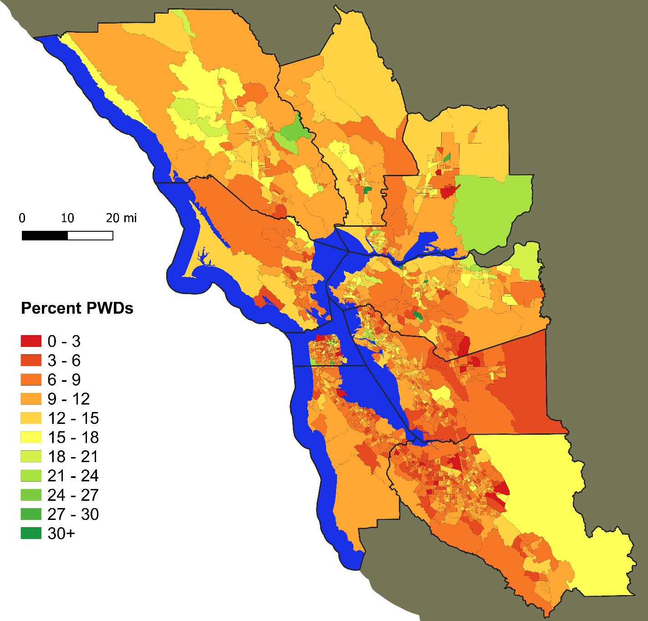

Figure A1.2: Seniors as Percent of Population

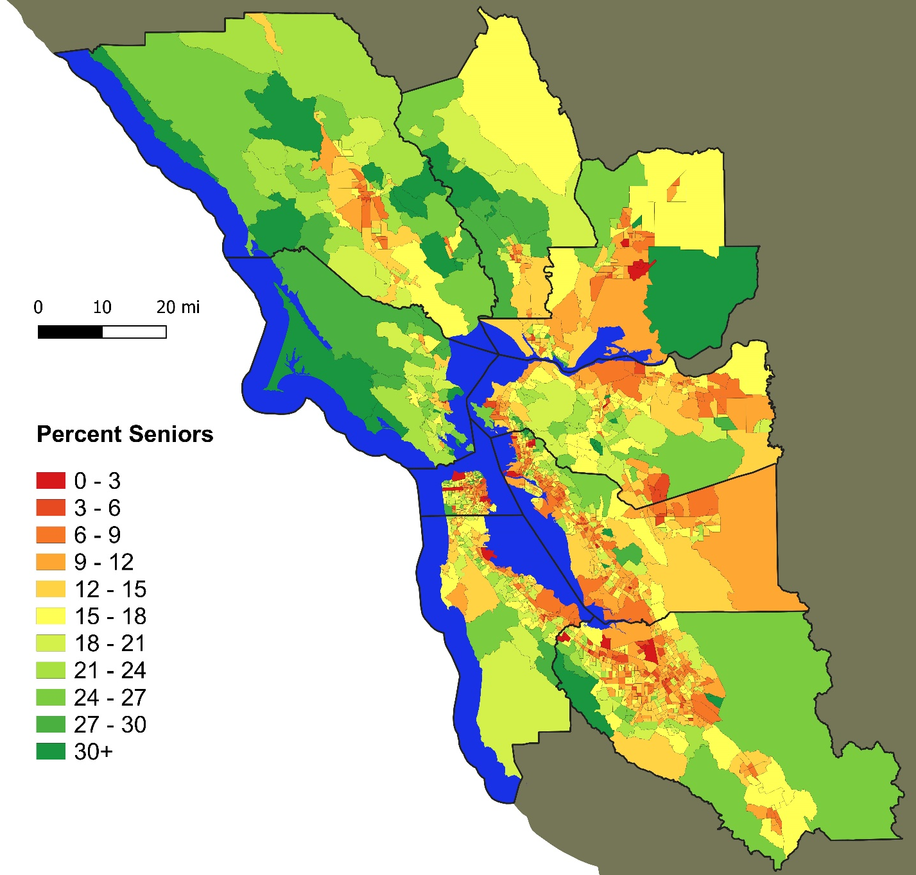

Figure A1.3: people with disabilities & Seniors as Percent of Population

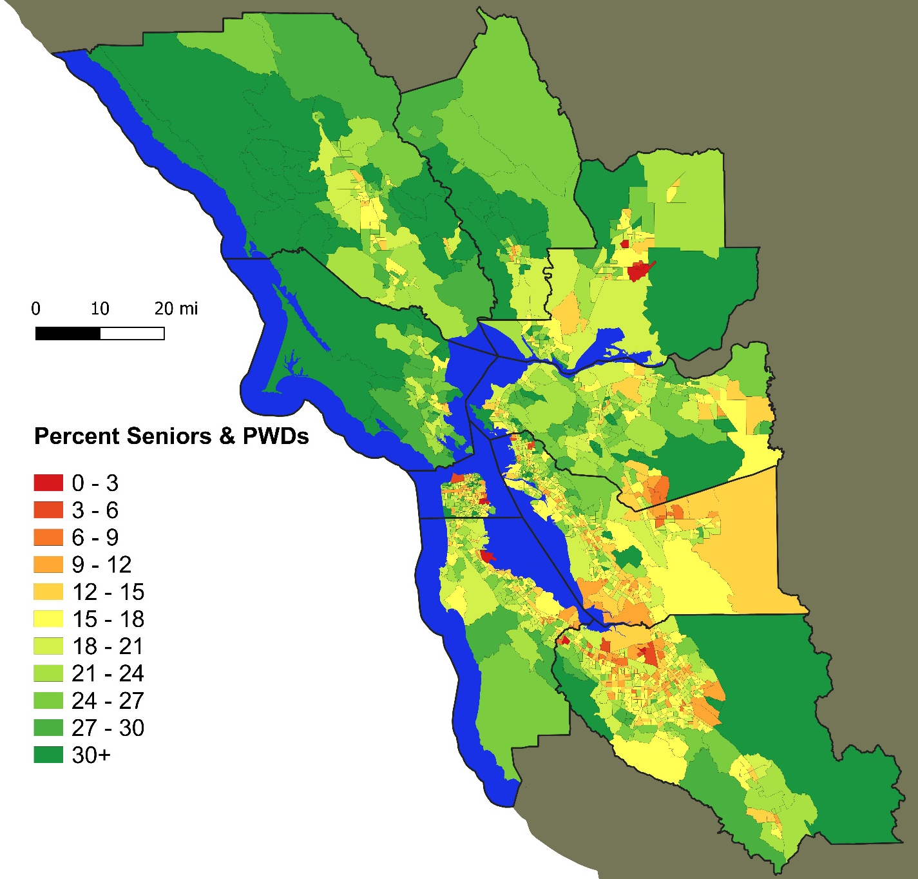

Figure A1.4: people with disabilities per square mile
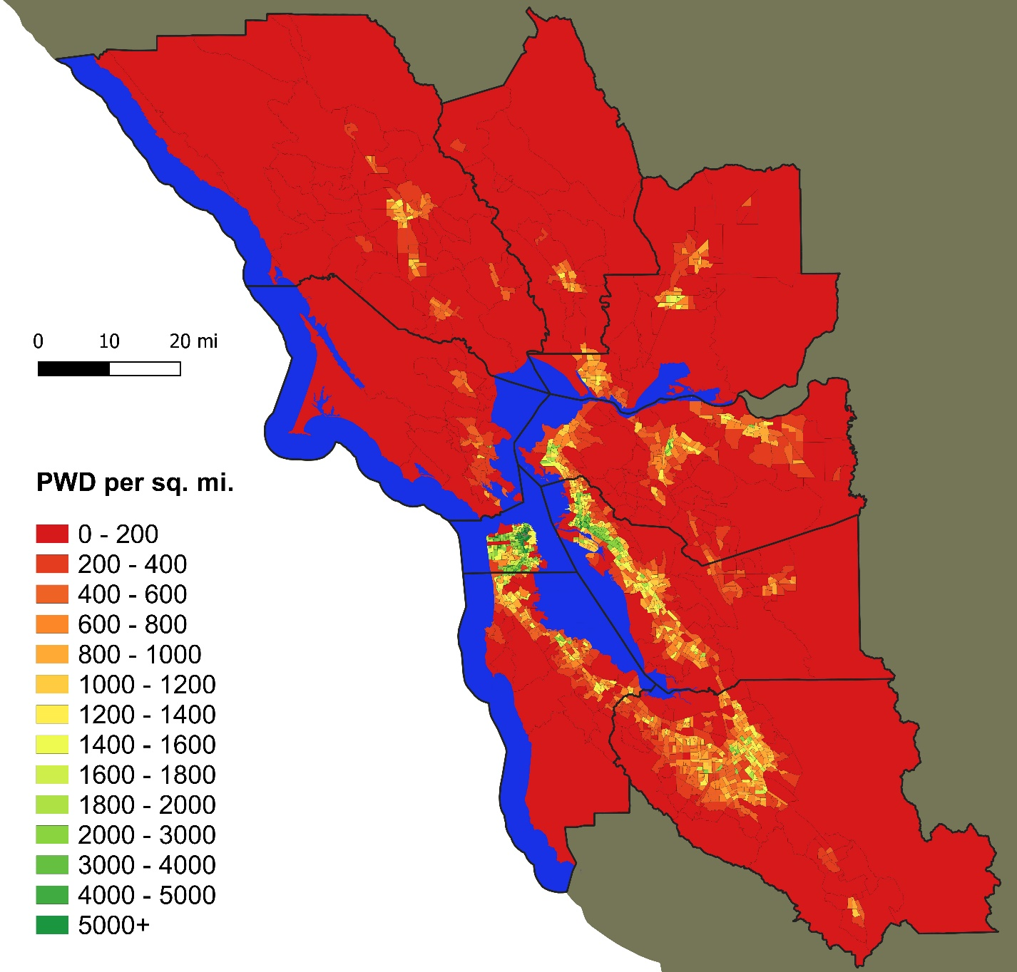

Figure A1.5: Seniors per square mile
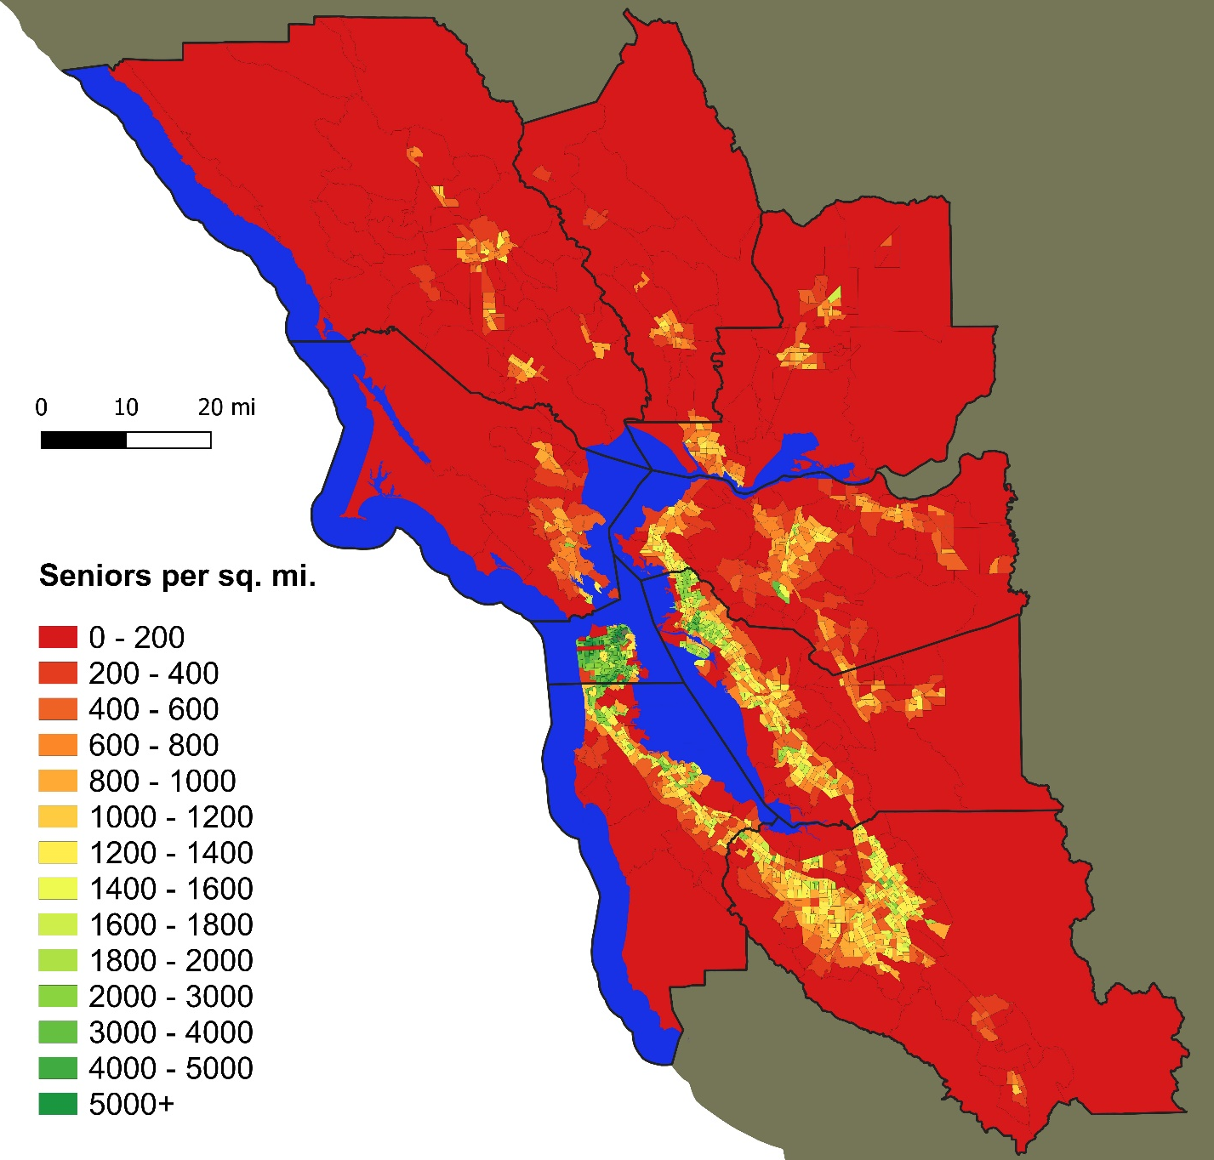

Figure A1.6: people with disabilities & Seniors per square mile
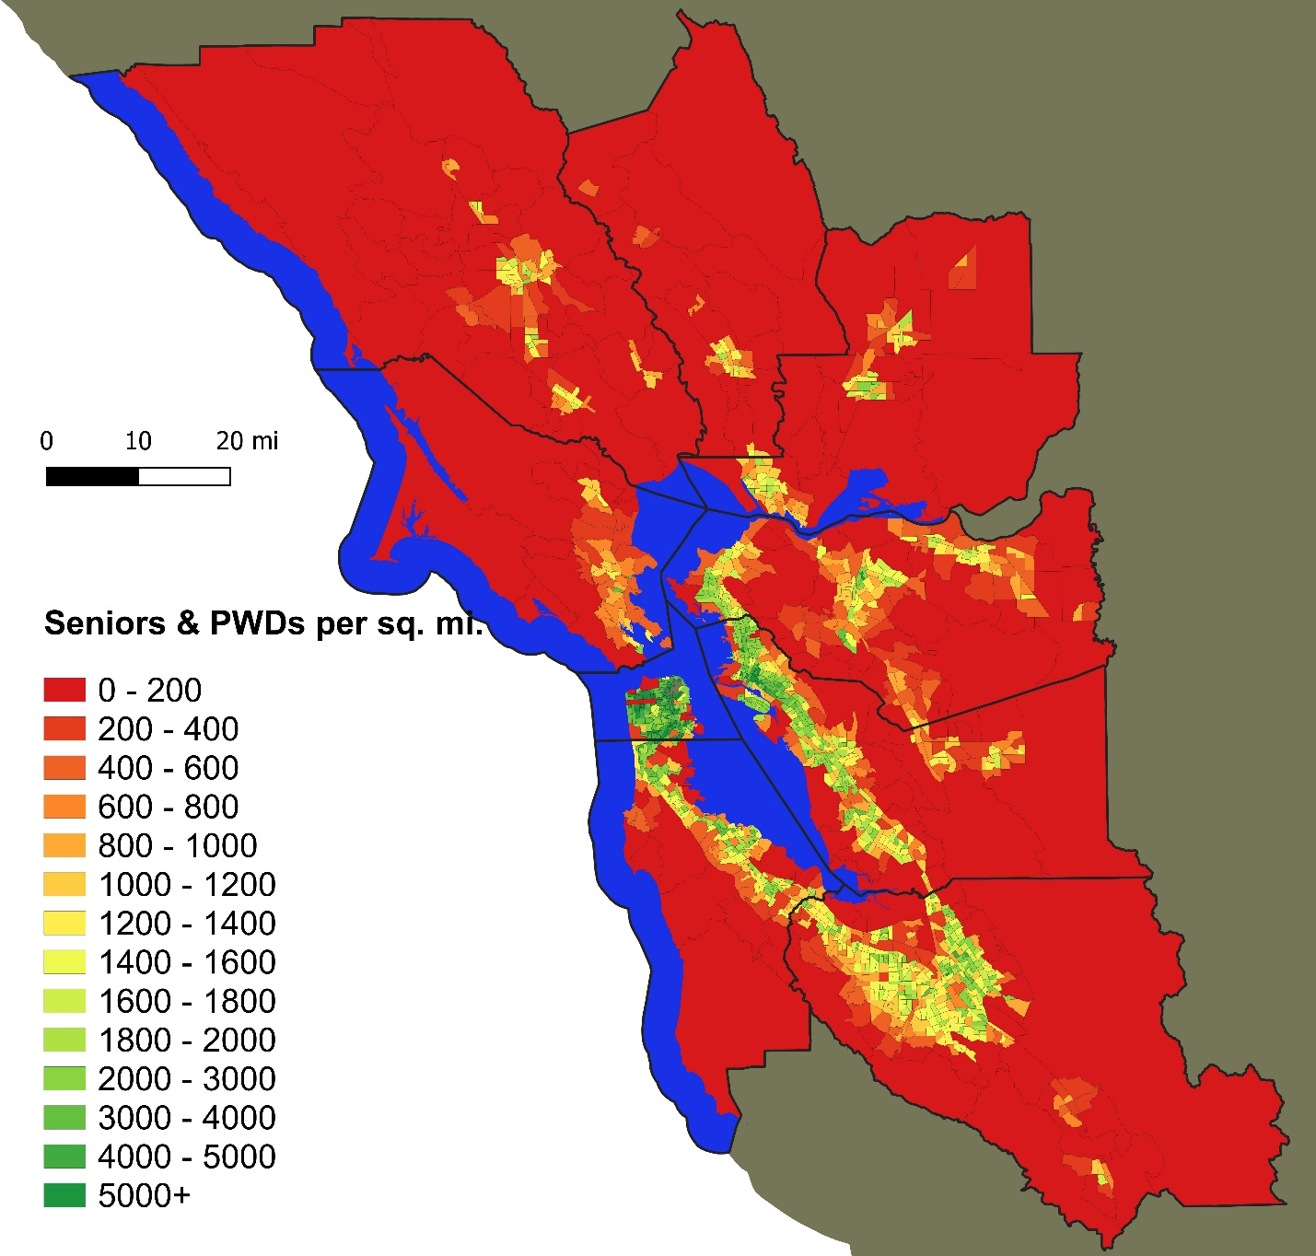

Appendix 2: NHTS Survey Responses (Individual Data)

Table A2.1: Regional Person Totals by Senior and Disability Status (derived from NHTS & ACS)
 | All | Non-seniors w/o disabilities | people with disabilities under age 65 | Seniors w/o disabilities | Seniors with disabilities
Population | 8,146,729 | 6,884,855 | 269,940 | 779,507 | 212,427
Percent | 100% | 84.5% | 3.3% | 9.6% | 2.6%

Table A2.2: Driver Status by Age and Disability
 | All | Non-seniors w/o disabilities | people with disabilities under age 65 | Seniors w/o disabilities | Seniors with disabilities
Percent drivers | 87.0% | 90.2% | 56.4% | 87.0% | 46.4%
Percent non-drivers | 13.0% | 9.8% | 43.6% | 13% | 53.6%

Table A2.3: Frequency of Public Transit Use
Times used in past 30 days | All | Non-seniors w/o disabilities | people with disabilities under age 65 | Seniors w/o disabilities | Seniors with disabilities
Zero | 68.7% | 68.3% | 64.8% | 69.1% | 82.1%
1 to 10 | 20.3% | 20.1% | 25.3% | 23.0% | 11.1%
11 to 20 | 6.3% | 6.6% | 7.6% | 3.7% | 4.1%
More than 20 | 4.8% | 5.1% | 2.3% | 4.2% | 2.7%

Table A2.4: Frequency of Rideshare Use
Times used in past 30 days | All | Non-seniors w/o disabilities | people with disabilities under age 65 | Seniors w/o disabilities | Seniors with disabilities
Zero | 78.9% | 76.4% | 89.7% | 92.5% | 96.8%
1 to 10 | 18.3% | 20.5% | 7.9% | 7.1% | 2.2%
11 to 20 | 2.0% | 2.2% | 1.5% | 0.3% | 0.2%
More than 20 | 0.8% | 0.9% | 0.9% | 0.1% | 0.8%

Table A2.5: Frequency of Delivery Service Use
Times used in past 30 days | All | Non-seniors w/o disabilities | people with disabilities under age 65 | Seniors w/o disabilities | Seniors with disabilities
Zero | 48.2% | 47.4% | 50.7% | 48.2% | 73.5%
1 to 10 | 46.6% | 47.3% | 43.0% | 48.6% | 23.8%
11 to 20 | 4.4% | 4.5% | 6.3% | 3.0% | 2.8%
More than 20 | 0.8% | 0.9% | 0.1% | 0.3% | 0.0%

Table A2.6: Main Reason for Staying Home on Non-Travel Day (% of individuals staying home)
Main Reason | All | Non-seniors w/o disabilities | people with disabilities under age 65 | Seniors w/o disabilities | Seniors with disabilities
Bad Weather | 5.4% | 6.0% | 2.3% | 6.2% | 0.7%
Caretaking | 4.1% | 4.8% | 0.5% | 2.5% | 2.4%
Disabled or Home-bound | 6.5% | 0.9% | 40.1% | 3.5% | 30.2%
No Transportation Available | 0.6% | 0.2% | 1.0% | 1.7% | 3.0%
Not Scheduled to Work | 8.8% | 11.7% | 1.4% | 1.1% | 0.0%
Out of Country | 5.4% | 7.1% | 0.0% | 2.3% | 0.0%
Personally Sick | 11.4% | 9.4% | 22.0% | 12.1% | 19.7%
Something Else | 16.5% | 14.6% | 10.5% | 25.5% | 27.9%
Vacation or Personal Day | 23.9% | 30.1% | 11.6% | 5.2% | 3.7%
Worked Around Home (Not for Pay) | 12.2% | 9.1% | 9.6% | 34.7% | 11.6%
Worked Around Home (for Pay) | 5.2% | 6.1% | 0.8% | 5.3% | 0.7%
PERCENT WHO STAYED HOME | 14.4% | 12.5% | 34.0% | 17.0% | 41.1%

Table A2.7: Travel Alternatives if Car is Unavailable (% of population; not all participants responded, while those who responded could provide multiple answers)
Alternate Transportation Use | All | Non-seniors w/o disabilities | people with disabilities under age 65 | Seniors w/o disabilities | Seniors with disabilities
Public Transportation | 35.0% | 34.7% | 25.9% | 45.6% | 17.7%
Ride with a friend | 31.0% | 30.2% | 28.3% | 41.8% | 20.7%
Rental Car | 16.5% | 16.9% | 12.0% | 17.5% | 4.7%
Biking | 13.3% | 14.4% | 5.7% | 9.3% | 0.5%
Walking | 23.3% | 23.4% | 19.0% | 28.9% | 4.2%
Taxi or Uber | 30.4% | 30.6% | 24.3% | 35.9% | 14.5%
None | 3.2% | 3.3% | 1.3% | 3.0% | 3.1%

Table A2.8 Travel Adjustments due to Disability or Medical Condition (% of population; not all participants responded, while those who responded could provide multiple answers)
Travel Adjustment | All | Non-seniors w/o disabilities | people with disabilities under age 65 | Seniors w/o disabilities | Seniors with disabilities
Reduced Travel | 5.1% | N/A | 76.0% | 5.9% | 78.7%
Ask for Rides | 3.0% | N/A | 40.8% | 4.7% | 45.4%
No Night Driving | 1.9% | N/A | 18.2% | 6.6% | 26.6%
Give Up Driving | 2.1% | N/A | 26.9% | 1.5% | 40.6%
Less Transit Use | 1.2% | N/A | 20.7% | 1.9% | 13.9%
Special Transportation | 0.5% | N/A | 7.6% | 1.2% | 5.1%
Reduced Fare Taxi | 0.3% | N/A | 3.4% | 0.5% | 5.0%

Table A2.9: Reason(s) for Not Using Public Transit More (% of population; not all participants responded, while those who responded could provide multiple answers)
Reason | All | Non-seniors w/o disabilities | people with disabilities under age 65 | Seniors w/o disabilities | Seniors with disabilities
Infrequent Service | 24.9% | 25.6% | 19.4% | 23.8% | 12.6%
Does not Run Early or Late Enough | 12.4% | 13.4% | 8.5% | 8.2% | 2.5%
Reliability | 12.5% | 12.8% | 13.8% | 11.5% | 5.4%
Cost | 10.0% | 10.7% | 11.5% | 5.1% | 3.5%
No Stops Near Destination | 26.9% | 29.8% | 20.9% | 31.5% | 17.6%
Unsafe Street Crossings | 1.2% | 1.0% | 0.8% | 1.7% | 3.8%
Weather Concerns | 5.1% | 4.7% | 10.6% | 7.5% | 5.2%
Safety Concerns | 11.5% | 10.9% | 18.1% | 11.1% | 25.2%
Air Quality | 0.6% | 0.5% | 1.5% | 0.5% | 0.5%
Prefer Driving | 35.7% | 34.5% | 24.2% | 52.0% | 27.8%

Appendix 3: NHTS Data (Householder Responses)

Table A3.1: Householder Totals by Senior and Disability Status (derived from NHTS & ACS)
 | All | Non-seniors w/o disabilities | people with disabilities under age 65 | Seniors w/o disabilities | Seniors with disabilities
Number | 2,843,792 | 2,160,648 | 98,561 | 484,899 | 99,683
Percent | 100% | 76.0% | 3.5% | 17.1% | 3.5%

Table A3.2: Frequency of Personal Vehicle Use
Frequency | All | Non-seniors w/o disabilities | people with disabilities under age 65 | Seniors w/o disabilities | Seniors with disabilities
Daily | 66.8% | 71.0% | 59.0% | 56.8% | 31.4%
A Few Times a Week | 18.2% | 15.5% | 14.3% | 28.9% | 28.0%
A Few Times a Month | 5.1% | 4.7% | 6.8% | 5.3% | 10.8%
A Few Times a Year | 2.0% | 2.3% | 0.4% | 0.8% | 2.8%
Never | 7.9% | 6.5% | 19.4% | 8.2% | 27.0%

Table A3.3: Frequency of Taxi or TNC Use
Frequency | All | Non-seniors w/o disabilities | people with disabilities under age 65 | Seniors w/o disabilities | Seniors with disabilities
Daily | 1.0% | 0.9% | 1.2% | 0.3% | 5.8%
A Few Times a Week | 5.5% | 6.6% | 2.8% | 1.8% | 2.7%
A Few Times a Month | 16.1% | 19.3% | 11.4% | 5.6% | 4.2%
A Few Times a Year | 33.0% | 35.4% | 31.8% | 25.3% | 20.4%
Never | 36.1% | 30.8% | 47.0% | 53.5% | 54.1%
Missing Value | 8.3% | 7.0% | 5.7% | 13.4% | 12.8%

Table A3.4: Frequency of Bus Use
Frequency | All | Non-seniors w/o disabilities | people with disabilities under age 65 | Seniors w/o disabilities | Seniors with disabilities
Daily | 6.7% | 7.4% | 3.6% | 4.6% | 3.5%
A Few Times a Week | 7.6% | 7.1% | 15.3% | 6.6% | 14.9%
A Few Times a Month | 8.5% | 8.6% | 15.1% | 7.4% | 4.0%
A Few Times a Year | 22.7% | 23.8% | 19.7% | 20.5% | 11.9%
Never | 46.3% | 45.5% | 44.7% | 49.3% | 51.0%
Missing Value | 8.2% | 7.5% | 1.7% | 11.6% | 14.7%

Table A3.5: Frequency of Train Use
Frequency | All | Non-seniors w/o disabilities | people with disabilities under age 65 | Seniors w/o disabilities | Seniors with disabilities
Daily | 8.0% | 9.8% | 1.7% | 2.8% | 0.2%
A Few Times a Week | 7.9% | 8.9% | 5.7% | 4.1% | 6.4%
A Few Times a Month | 12.9% | 13.9% | 11.0% | 10.3% | 7.8%
A Few Times a Year | 35.4% | 37.0% | 32.7% | 32.6% | 17.5%
Never | 28.6% | 24.8% | 40.7% | 37.9% | 53.1%
Missing Value | 7.2% | 5.7% | 8.1% | 12.3% | 14.9%

Table A3.6: Frequency of Paratransit Use
Frequency | All | Non-seniors w/o disabilities | people with disabilities under age 65 | Seniors w/o disabilities | Seniors with disabilities
Daily | 0.2% | 0.2% | 0.7% | 0.3% | 0.0%
A Few Times a Week | 0.4% | 0.3% | 3.3% | 0.2% | 0.8%
A Few Times a Month | 0.6% | 0.3% | 4.7% | 0.3% | 5.0%
A Few Times a Year | 2.7% | 2.1% | 8.1% | 3.6% | 5.5%
Never | 85.2% | 87.1% | 78.2% | 81.3% | 69.8%
Missing Value | 10.9% | 10.0% | 4.9% | 14.4% | 18.9%

Table A3.7: Reasons for Choosing Home (Cost and Proximity to Transit listed as a top-3 reason)
Listed as Top 3 (out of 12) | All | Non-seniors w/o disabilities | people with disabilities under age 65 | Seniors w/o disabilities | Seniors with disabilities
Cost | 52.2% | 53.1% | 66.2% | 47.4% | 43.8%
Proximity to Transit | 20.1% | 21.3% | 23.5% | 14.7% | 17.7%

Appendix 4: Quantitative Analysis Tables Using FY 2015-16 Data

Table A4.1: Transit Agency Profiles (2015-16 ridership, expenses & revenues)
Agency | Service Area: mi² | Population (1000s) |  | Active Fleet |  | Total Passengers (1000s) | Operational Expenses (1000s) | Farebox Revenue (1000s) | Farebox Recovery (percent)
AC Transit | 364 |  | 1,415 | 639 | 54,065 |  | $416,706 | $65,483 | 15.71%
ACE | 1,248 |  | 4,145 | 35 | 1,290 |  | $19,042 | $8,558 | 44.94%
BART | 93 |  | 4,083 | 669 | 137,852 |  | $637,378 | $489,583 | 76.81%
Caltrain | 425 |  | 3,450 | 152 | 19,233 |  | $126,954 | $83,738 | 65.96%
County Connection (CCCTA) | 200 |  | 482 | 184 | 3,843 |  | $33,809 | $4,991 | 14.76%
City of Dixon Readi-Ride | 7 |  | 19 | 9 | 56 |  | $629 | $96 | 15.20%
FAST | 41 |  | 142 | 63 | 1,087 |  | $10,121 | $2,435 | 24.06%
Golden Gate Transit | 145 |  | 869 | 181 | 6,084 |  | $97,185 | $35,978 | 37.02%
LAVTA | 40 |  | 219 | 69 | 1,708 |  | $15,532 | $2,240 | 14.42%
Marin Transit | 520 |  | 258 | 113 | 3,301 |  | $22,944 | $3,814 | 16.63%
Petaluma Transit | 13 |  | 59 | 18 | 373 |  | $2,414 | $281 | 11.64%
Pleasanton Paratransit | 14 |  | 74 | 7 | 9 |  | $565 | $24 | 4.25%
Rio Vista Delta Breeze | 7.5 |  | 7.7 | 4 | 10.4 |  | $431 | $17.5 | 4.07%
SamTrans | 448 |  | 753 | 398 | 13,154 |  | $138,057 | $18,078 | 13.09%
Santa Rosa City Bus | 51 |  | 175 | 32 | 2151 |  | $12,637 | $2,249 | 17.8%
SFMTA | 48.6 |  | 867 | 1,152 | 233,114 |  | $758,074 | $206,735 | 27.27%
SolTrans | 65 |  | 149 | 53 | 1,559 |  | $12,402 | $3,622 | 29.2%
Sonoma County Transit | 395 |  | 500 | 80 | 1,224 |  | $14,679 | $2,035 | 13.86%
TriDelta | 225 |  | 306 | 92 | 2,707 |  | $19,956 | $3,274 | 16.41%
Union City Transit | 18 |  | 72 | 25 | 330 |  | $4,479 | $375 | 8.37%
Vacaville | 27 |  | 93 | 21 | 509 |  | $2,242 | $450 | 20.06%
Vine | 82.5 |  | 142 | 24 | 1,316 |  | $19,264 | $1,156 | 6.0%
VTA | 346 |  | 1,928 | 592 | 43,998 |  | $359,996 | $40,366 | 11.21%
WestCAT | 38 |  | 65 | 59 | 1,312 |  | $9,355 | $2,123 | 22.69%
SF Bay Ferry | 120 |  | 282 | 11 | 2,480 |  | $26,771 | $16,682 | 62.31%
TOTAL | 4,981* |  | 20,558* | 4682 | 532,765 |  | $2,761,621 | $994,382 | 36.01%
MEAN | 199.3 |  | 822 | 187.28 | 21,311 |  | $110,465 | $39,775 | 23.75%
MEDIAN | 82.5 |  | 258 | 63 | 1,708 |  | $19,042 | $3,274 | 16.41%

*There is some geographic overlap between agencies, so totals are larger than areas & populations served by all operators. The Bay Area is 6966 mi² with approximately 7.75 million residents (2018).
The following table shows costs & revenue by service type across the Bay Area. The first column (“operators”) shows how many agencies feature a given service: so 18 agencies operate fixed-route buses while 2 operate “flexible fixed-route buses” and only one operates cable cars. Mean and median costs are only for agencies which operate the services, and do not simply average costs across all 25 transit agencies. Of note is that bus service and heavy rail collectively represent over 70% of transit expenditures while paratransit and demand response are slightly under 5%. Performance measures for each service type – including farebox recovery percentages – are featured in later tables.

Table A4.2: Costs & Revenue by Service Type
Service Type | Operators | Costs (total, 1000s) | Costs (mean, 1000s) | Costs (median, 1000s) | Farebox Revenue (total, 1000s) | Farebox Revenue (mean, 1000s) | Farebox Revenue (median, 1000s)
Fixed-Route Bus | 18 | $1,252,118 | $69,562 | $12,794 | $229,234 | $12,735 | $2485
Flexible Fixed-Route Bus | 2 | $508 | $254 | $254 | $75 | $37 | $37
Paratransit | 19 | $131,008 | $6,895 | $1,977 | $10,205 | $537 | $186
Heavy Rail | 3 | $764,450 | $254,817 | $126,954 | $574,345 | $191,448 | $83,738
Automated Guideway | 1 | $7,006 | $7,006 | $7,006 | $6,666 | $6,666 | $6,666
Demand Response | 4 | $5,460 | $1,365 | $930 | $460 | $115 | $137
Ferry | 2 | $57,196 | $28,598 | $28,598 | $36,862 | $18,431 | $18,431
Trolley Bus | 1 | $169,083 | $169,083 | $169,083 | $50,656 | $50,656 | $50,656
Cable Car | 1 | $60,905 | $60,905 | $60,905 | $29,151 | $29,151 | $29,151
Street Car | 1 | $21,254 | $21,254 | $21,254 | $5,799 | $5,799 | $5,799
Light Rail | 2 | $279,687 | $139,843 | $139,843 | $49,770 | $24,885 | $24,885
Shuttle | 1 | $1,863 | $1,863 | $1,863 | $747 | $747 | $747
Non-Traditional Transit | 1 | $1,262 | $1,262 | $1,262 | $411 | $411 | $411
All Services (Combined) | 25 | $2,761,621 | $110,465 | $19,042 | $994,361 | $39,775 | $3,274

The following 2 tables highlight “operating data,” as listed in annual statistical summaries, by transit type for all relevant agencies in the Bay Area. This features total passengers per year (“Pass”), average weekday ridership (“WkPass”), vehicle revenue miles (“VRM”), and vehicle revenue hours (“VRH”)

Table A4.3: Operating Data by Transit Type (pt1)
Service Type | Ridership* (total, 1000s) | Pass (mean, 1000s) | Pass (median, 1000s) | AWRᶧ (total, 1000s) | AWR (mean, 1000s) | AWR (median, 1000s)
Fixed-Route Bus | 224,288 | 12,460 | 1,873 | 730.2 | 40.6 | 29.2
Flexible Fixed-Route Bus | 18.4 | 9.2 | 9.2 | 0.073 | 0.0365 | 0.0365
Paratransit | 3193 | 168 | 52 | 10.2 | 0.538 | 0.164
Heavy Rail | 157,150 | 52,383 | 19,233 | 522.8 | 174.3 | 60.2
Automated Guideway | 1031 | 1,031 | 1,031 | 3.14 | 3.14 | 3.14
Demand Response | 236.6 | 59 | 68 | 0.635 | 0.159 | 0.146
Ferry | 5025 | 2,513 | 2,513 | 16.367 | 8.184 | 8.184
Trolley Bus | 65,121 | 65,121 | 65,121 | 196.2 | 196.2 | 196.2
Cable Car | 5800 | 5,800 | 5,800 | 15.5 | 15.5 | 15.5
Street Car | 7456 | 7,456 | 7,456 | 19.8 | 19.8 | 19.8
Light Rail | 62,846 | 31,423 | 31,423 | 204.9 | 102.5 | 102.5
Shuttle | 429 | 429 | 429 | 1.861 | 1.861 | 1.861
Non-Traditional Transit | 171.4 | 171.4 | 171.4 | 0.67 | 0.67 | 0.67
All Services (Combined) | 532,765 | 21,310.6 | 1707.6 | 1722.1 | 68.9 | 5.6

*Ridership = total annual passengers, including weekends
ᶧ AWR = average weekday ridership

Table A4.4: Operating Data by Transit Type (pt2)
Service Type | VRM* (total 1000s) | VRM (mean 1000s) | VRM (median 1000s) | VRHᶧ (total 1000s) | VRH (mean 1000s) | VRH (median 1000s)
Fixed-Route Bus | 78,275 | 4,349 | 1,842 | 6783 | 377 | 112
Flexible Fixed-Route Bus | 86 | 43 | 43 | 6.5 | 3.2 | 3.2
Paratransit | 22,375 | 168 | 52 | 1684 | 88.7 | 23.7
Heavy Rail | 79,924 | 26,641 | 7216 | 2278 | 759.3 | 217.9
Automated Guideway | 414.3 | 414.3 | 414.3 | 20.6 | 20.6 | 20.6
Demand Response | 898.3 | 224.6 | 101.7 | 70.6 | 17.7 | 12.4
Ferry | 508.7 | 254.4 | 254.4 | 29.3 | 14.6 | 14.6
Trolley Bus | 6205 | 6205 | 6205 | 979 | 979 | 979
Cable Car | 258.5 | 258.5 | 258.5 | 139.2 | 139.2 | 139.2
Street Car | 572.7 | 572.7 | 572.7 | 100.9 | 100.9 | 100.9
Light Rail | 8920 | 4460 | 4460 | 759.9 | 380 | 380
Shuttle | 194 | 194 | 194 | 18 | 18 | 18
Non-Traditional Transit | 227.8 | 227.8 | 227.8 | 18.9 | 18.9 | 18.9
All Services (Combined) | 198,859 | 7954.4 | 2056 | 12,888 | 515.5 | 113.6
*VRM = vehicle revenue miles
ᶧVRH = vehicle revenue hours

Table A4.5: Performance Concepts by Transit Type (part 1)
Service Type | CEffic* (Total $) | CEffic (mean $) | CEffect (median $) | CEffectᶧ (total $) | CEffect (mean $) | CEffect (median $)
Fixed-Route Bus | $5.58 | $7.54 | $7.12 | $184.61 | $134.76 | $112.04
Flexible Fixed-Route Bus | $27.59 | $25.51 | $25.51 | $78.34 | $67.31 | $67.31
Paratransit | $41.03 | $42.21 | $35.28 | $77.78 | $88.54 | $82.36
Heavy Rail | $4.86 | $8.63 | $6.60 | $335.59 | $522.35 | $582.63
Automated Guideway | $6.80 | $6.80 | $6.80 | $340.94 | $340.94 | $340.94
Demand Response | $23.08 | $22.52 | $21.45 | $77.35 | $71.13 | $75.16
Ferry | $11.38 | $11.37 | $11.37 | $1952.94 | $1971.46 | $1971.46
Trolley Bus | $2.60 | $2.60 | $2.60 | $172.69 | $172.69 | $172.69
Cable Car | $10.50 | $10.50 | $10.50 | $437.42 | $437.42 | $437.42
Street Car | $2.85 | $2.85 | $2.85 | $210.61 | $210.61 | $210.61
Light Rail | $4.45 | $6.11 | $6.11 | $368.04 | $384.76 | $384.76
Shuttle | $4.34 | $4.34 | $4.34 | $103.50 | $103.50 | $103.50
Non-Traditional Transit | $2.40 | $2.40 | $2.40 | $21.73 | $21.73 | $21.73
All Services (Combined) | $5.18 | $12.45 | $8.80 | $214.28 | $242.56 | $117.43
*Cost Efficiency = cost ÷ passengers
ᶧCost Effectiveness = cost ÷ vehicle revenue miles

Table A4.6: Performance Concepts by Transit Type (pt2)
Service Type | EffectMi* (Total) |  | EffectMi (mean) | EffectMi (median) | EffectHrᶧ (total) | EffectHr (mean) |  | EffectHr (median)
Fixed-Route Bus |  | 2.87 | 1.64 | 1.12 | 33.07 |  | 19.93 | 15.85
Flexible Fixed-Route Bus |  | 0.21 | 0.27 | 0.27 | 2.84 |  | 3.16 | 3.16
Paratransit |  | 0.14 | 0.18 | 0.16 | 1.90 |  | 2.19 | 2.10
Heavy Rail |  | 1.97 | 1.92 | 1.91 | 68.99 |  | 67.19 | 67.24
Automated Guideway |  | 2.49 | 2.49 | 2.49 | 50.17 |  | 50.17 | 50.17
Demand Response |  | 0.26 | 0.43 | 0.43 | 3.35 |  | 3.95 | 3.52
Ferry |  | 9.88 | 10.59 | 10.59 | 171.58 |  | 172.59 | 172.59
Trolley Bus |  | 10.49 | 10.49 | 10.49 | 66.51 |  | 66.51 | 66.51
Cable Car |  | 22.44 | 22.44 | 22.44 | 41.66 |  | 41.66 | 41.66
Street Car |  | 13.02 | 13.02 | 13.02 | 73.88 |  | 73.88 | 73.88
Light Rail |  | 7.05 | 6.47 | 6.47 | 82.70 |  | 72.68 | 72.68
Shuttle |  | 2.21 | 2.21 | 2.21 | 23.83 |  | 23.83 | 23.83
Non-Traditional Transit |  | 0.75 | 0.75 | 0.75 | 9.06 |  | 9.06 | 9.06
All Services (Combined) |  | 2.68 | 1.6 | 1.07 | 41.34 |  | 27.3 | 13.39
*EffectMi = service effectiveness in passengers per vehicle revenue mile
ᶧEffectHr = service effectiveness in passengers per vehicle revenue hour

Table A4.7: Performance Concepts by Transit Type (pt3)
Service Type | FareRecᶧ (total) | FareRec (mean) | FareRec (median)
Fixed-Route Bus | 18.31% | 18.50% | 17.07%
Flexible Fixed-Route Bus | 14.68% | 39.05% | 39.05%
Paratransit | 7.79% | 8.75% | 7.67%
Heavy Rail | 75.13% | 62.95% | 65.96%
Automated Guideway | 95.15% | 95.15% | 95.15%
Demand Response | 8.42% | 10.57% | 11.02%
Ferry | 64.45% | 64.32% | 64.32%
Trolley Bus | 29.96% | 29.96% | 29.96%
Cable Car | 47.86% | 47.86% | 47.86%
Street Car | 27.29% | 27.29% | 27.29%
Light Rail | 17.79% | 15.82% | 15.82%
Shuttle | 40.10% | 40.10% | 40.10%
Non-Traditional Transit | 32.56% | 32.56% | 32.56%
All Services (Combined) | 36.01% | 23.75% | 16.41%
ᶧFareRec = farebox recovery = farebox revenue ÷ costs

References

The ACS reported rate of disability for non-adults, and especially children under 5 years old, is likely an under-count. This is because, of the 6 questions identifying respondents' disability status, only 2 are asked of children under 5 years old, while one question omits all respondents under age 18. It is also difficult to know if a disability is nascent and not yet expressed during childhood, especially in one's early years.
United States Census Bureau. American Fact Finder: Advanced Search. https://factfinder.census.gov/faces/nav/jsf/pages/searchresults.xhtml?refresh=t#none
U.S. Census Bureau, Current Population Reports. July 2012. “Americans with Disabilities: 2010 – Household Economic Studies.” https://www2.census.gov/library/publications/2012/demo/p70-131.pdf
Longmore, P. K., and L.Umansky, eds. 2001. The New Disability History: American Perspectives. New York: New York University Press.
Hahn, Harlan (1988, Spring) "The Politics of Physical Differences: Disability and Discrimination." Journal of Social Issues: a Journal of the Society for the Psychological Study of Social Issues.
National Disability Authority. The 7 Principles. Retrieved August 20, 2019. http://universaldesign.ie/What-is-Universal-Design/The-7-Principles/
US Department of Transportation. National Household Travel Survey. Retrieved July 2019. https://nhts.ornl.gov/
City of Oakland. Sidewalks. Retrieved August 5, 2019. https://www.oaklandca.gov/topics/sidewalks
US Department of Transportation. National Household Travel Survey. Retrieved July 2019. https://nhts.ornl.gov/
Disability Rights Education and Defense Fund. On-time performance in ADA paratransit. Retrieved August 23, 2019. https://dredf.org/ADAtg/OTP.shtml#window
Americans with Disabilities Act title 42, chapter 126 Sec. 12143. https://www.ada.gov/pubs/adastatute08.htm#12143
Bay Area Rapid Transit. January 2019. In 2019, a more systematic focus to modernizing elevators and escalators. https://www.bart.gov/news/articles/2019/news20190110-0
Capitol Corridor Joint Powers Authority. 2019. Performance report FY 18. https://images.capitolcorridor.org/wp-content/uploads/2019/02/CCJPA_Report2018_Web.pdf
ibid.
Amtrak. Making Reservations for Passengers with a Disability. Retrieved August 20, 2019. https://www.amtrak.com/planning-booking/accessible-travel-services/making-reservations-for-passengers-with-a-disability.html
Amtrak. Thruway Bus Service and Accessibility. Retrieved August 20, 2019. https://www.amtrak.com/planning-booking/accessible-travel-services/accessible-thruway-bus-service.html
Market Street Railway. Historic Streetcars. Retrieved August 10, 2019. https://www.streetcar.org/streetcars/
SFMTA. Access on Historic Streetcars. Retrieved August 20, 2019. https://www.sfmta.com/getting-around/accessibility/muni/muni-access-guide/access-historic-streetcars
Market Street Railway. San Francisco’s World Famous Cable Cars. Retrieved August 20, 2019. https://www.streetcar.org/cablecars/
SFMTA. Cable Cars: Take these national landmarks for a spin. Retrieved August 20, 2019. https://www.sfmta.com/getting-around/muni/cable-cars
Access Northern California. 2007. Retrieved San Francisco. https://www.sftravel.com/sites/sftraveldev.prod.acquia-sites.com/files/70_AccessGuideSF_0507_lz_v6.pdf
Nationwide Limousine Service. Limousine Photo Gallery: 20 Passenger VIP Bus with Wheelchair Lift. Retrieved August 20, 2019 https://www.nlslimo.com/gallery/party-buses/twenty-passenger-wheelchair-accessible.html
Bay Area Rapid Transit. Fare Evasion Prevention. Retrieved August 26, 2019. https://www.bart.gov/about/projects/fare-evasion

