Disaster Readiness for People with Paralysis or Mobility Disabilities
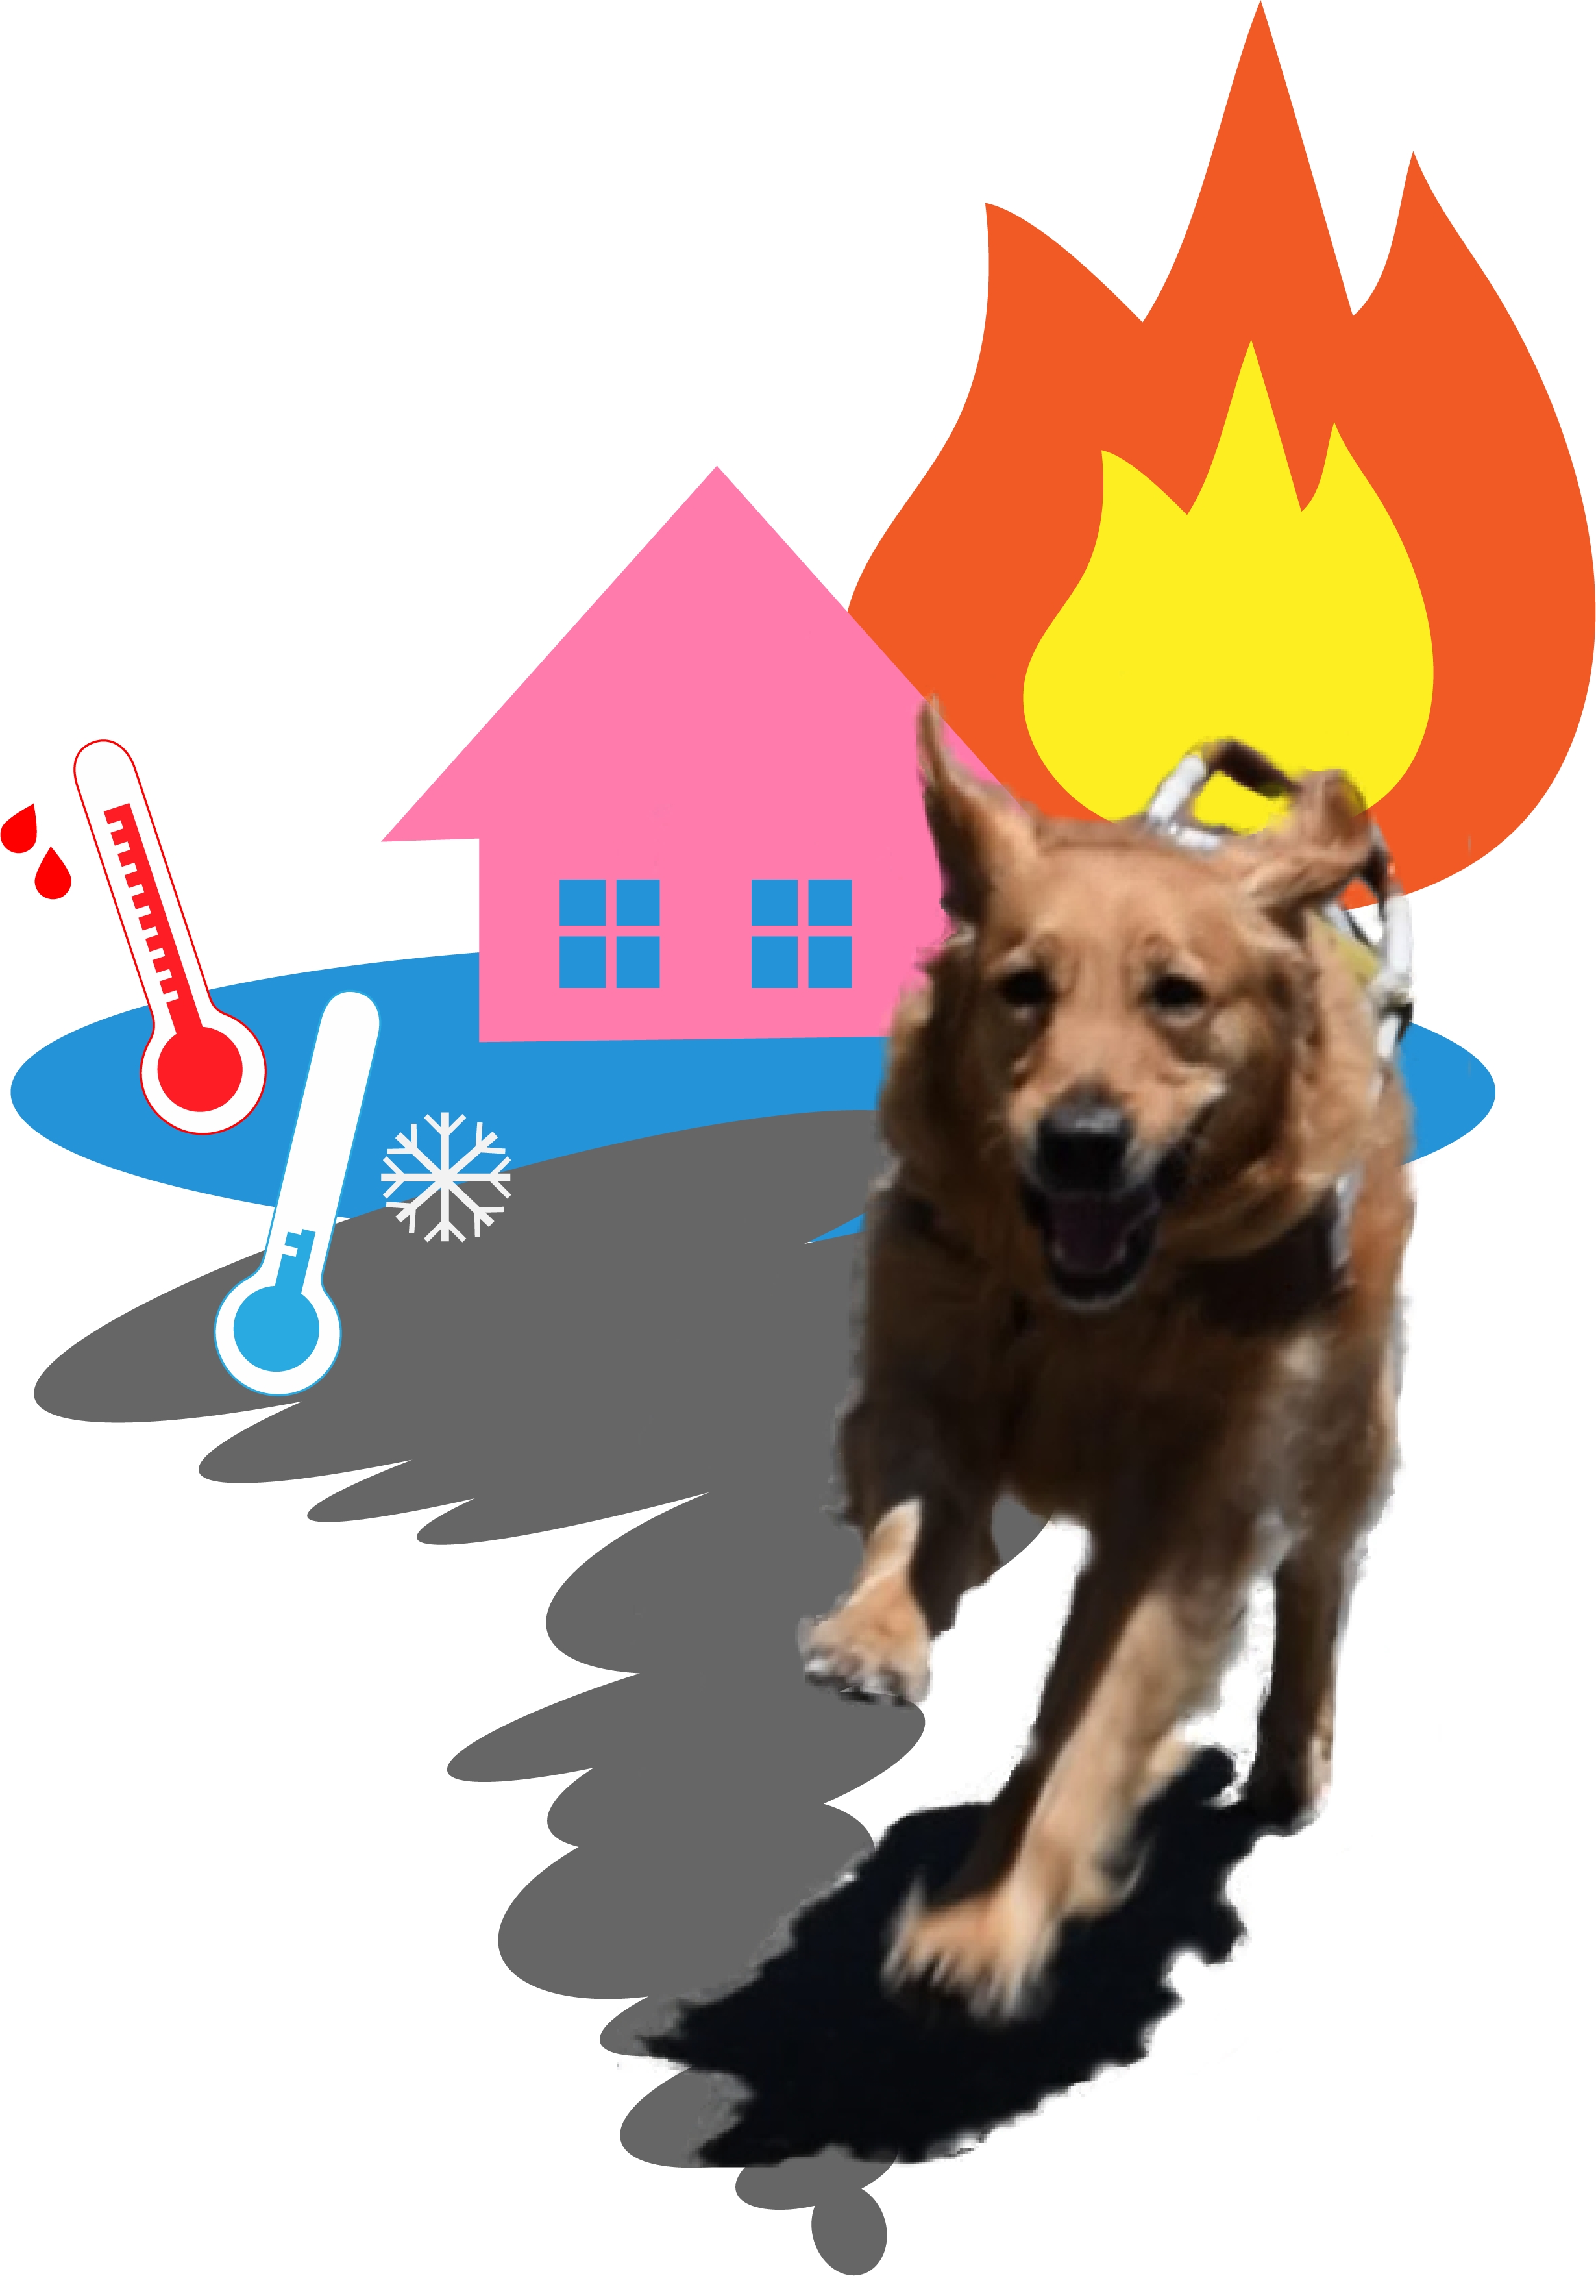
Image 1: A Golden Retriever service dog running away from a variety of climate disasters.

Introduction
Hi Everyone! I’m Ruff ‘n’ Ready the Disaster Prep Dog, at your service! I’m here to tell you how to plan in advance before disaster strikes. This may feel hard to think about! You can help yourself, your family and your community to be safer by planning ahead!

Disasters could include wildfire, floods, extreme weather temperatures, earthquakes, tornados and other major disruptions. Sometimes there are warnings, but not always. In some disasters people are required to evacuate, and in others, to “shelter in place.” We need to think about both.
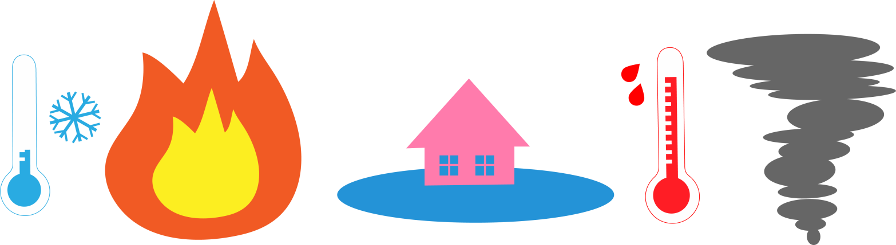
Image 2: Disaster icons lined up, including extreme cold temperatures, fire, flooding, extreme heat, and tornados.
Disaster readiness requires planning ahead and talking to others. It's helpful to discuss these suggestions with your family, friends, your personal assistant or anyone in your support network. Don’t forget to include your pets and service dogs in the planning!

Options to Consider in Your Planning
Connect with at least three people (your team!) to ensure you have back-ups in case any one of them is distracted by their own or their family’s needs in the disaster.

Image 3: 4 people, 3 grouped together, a plus sign, and 4th person with a cell phone

Identify an out-of-town contact person. Make a list of important people and share this with your team and your out-of-town contact person.

Talk with your team about their needs in a disaster,
including your personal assistant or caregiver. They may have family needs to attend to and wouldn’t be able to help you.
If your personal assistance comes from an agency, find out that agency's policy about emergencies.

Prepare and practice providing specific instructions to first responders like police and fire department about your access and safety needs. If you are clear, first responders are more likely to respect you as a competent individual with a disability rather than an “injured patient.”
Your highest priority for your safety is to make connections with people (your team) who can check on you.
These people must understand and agree to go to where you are to assist you, in case:
- You are injured or stuck
- Your exit or path of travel is blocked
- Your phone is dead or the reception is not working
- Your usual form of transportation is not workable

Lead Your Community
You can help others by taking leadership in your building or neighborhood. Alert everyone to disaster readiness.
Consider holding a meeting with your building or neighborhood to discuss some of these ideas. Have a rehearsal of a few different versions of a disaster, such as an earthquake or tornado during the day, or a fire at night. Have each person imagine how this might go, and what everyone would do to connect with you.
The best way to get motivated and follow through with disaster readiness planning is to do it with friends! Consider having a gathering to discuss these suggestions for everyone's well-being. Get a group together and support each other to make Go Bags and think through each person’s needs and plans.

On Independence
Preparing for potential disasters also involves some mental preparation. This is a good to time to consider the concept of independence for people with paralysis or mobility impairments.

The disability community has fought hard for independence and self-determination. We have the Americans with Disabilities Act and other disability laws. We have strong organizations working on full inclusion in our communities. We have Centers for Independence and the resources that enable our independence.

Disasters can change the meaning of independence for people with paralysis. When disaster strikes, the environment may change drastically. Roads, transportation, communications systems, our ability to connect with people we love, and our homes and neighborhoods may be changed in ways that can limit or prevent our ability to do things the way we typically do. We may need help and not be as independent as we like.

The concept of self-determination still applies. Just like everyone else before, during and after a disaster, we can work together to plan and respond with common sense and connection.

It is self-determination that we begin to think and plan for disaster readiness. It is self-determination that we connect with family, friends, and community members to ask for and plan for the assistance we may need in case of a disaster.

Consider these questions:

- Am I willing to let others help me more than usual in order to preserve my well-being?
- What are situations or emotions that have made me strongly independent, in ways that might not be possible following a disaster?
Share these questions with friends in the paralysis community. They will help us think more creatively in our planning. For example, will you be willing to be picked up and carried down stairs? Can you describe the best way for you to do this? Talking about this in advance will help!

Your Home
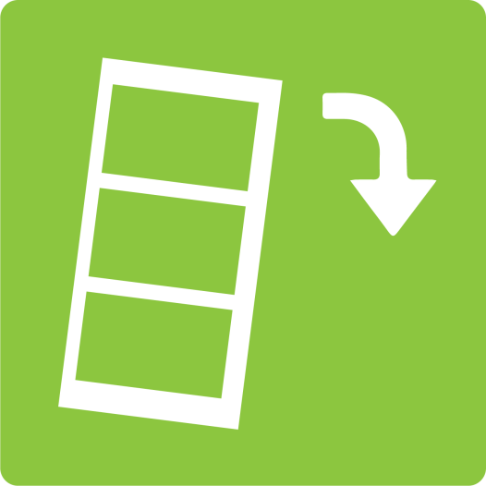
Furniture:
Think about your home regarding safety. Is there furniture that could fall in an earthquake, such as tall bookcases, or heavy items stored on high shelves?
Image 4: Bookshelf with down arrow
Get help securing bookshelves to the wall, and move items that could interfere with your path of travel in your home. Be careful to remove anything that could fall on you in your bed.
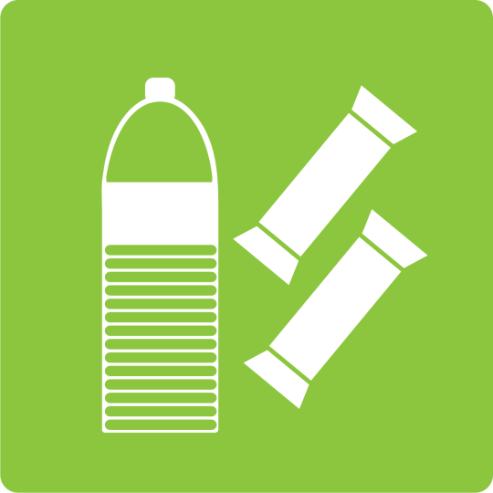
Image 5: Bottled water and granola bars
Shelter in Place Prep:
“Shelter in place” may be required. Plan to have food and bottled water (1 gallon a day) for each person for up to a week. Consider what non-perishable foods would work for you and your family. Include canned and packaged foods that require minimal preparation, as cooking may not be possible. Stock up on things that keep and are easy to eat, like nuts, granola bars, crackers, hard cheese and dried fruit.
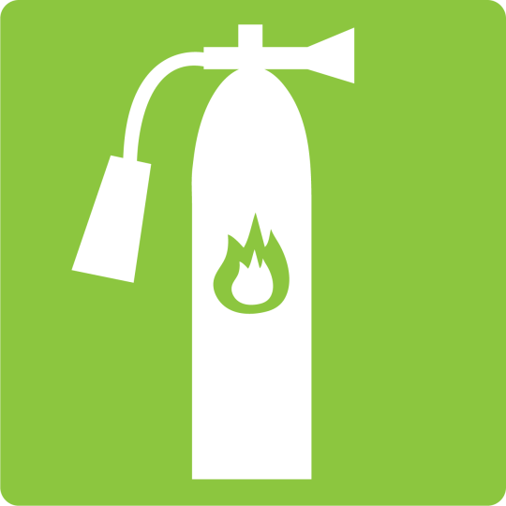
Fire Safety: Make sure to get a fire extinguisher (ABC type), one for each floor of your home if possible. Explain to everyone in the household how to use your fire extinguishers and where they are located in your home. Have working smoke alarms on each floor.
Image 6: Fire extinguisher
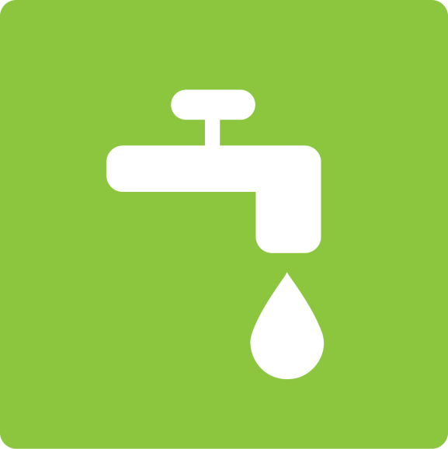

Utilities:
Learn how to turn off water, gas and electricity that have valves or switches. Explain this to family members and assistants. Make sure that you understand your locale’s regulations for power out outages.
Image 7: Dripping faucet
If you are dependent upon electricity to recharge batteries or to use the elevator, let your utility company know and inquire about shut off procedures, where electricity may be shut down during fires or other disasters.

More Considerations

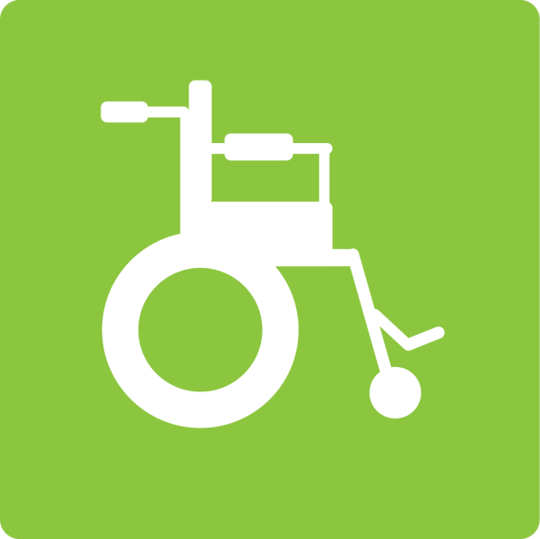
Adaptive Equipment:
Many people with paralysis use devices and adaptive equipment for mobility and communications.
If you use a power wheelchair, it is essential to have a backup manual wheelchair in case of power outages or types of transportation vehicles. If you live upstairs in a building with an elevator, consider keeping a spare wheelchair on the ground floor lobby or in the garage.
Image 8: Manual wheelchair
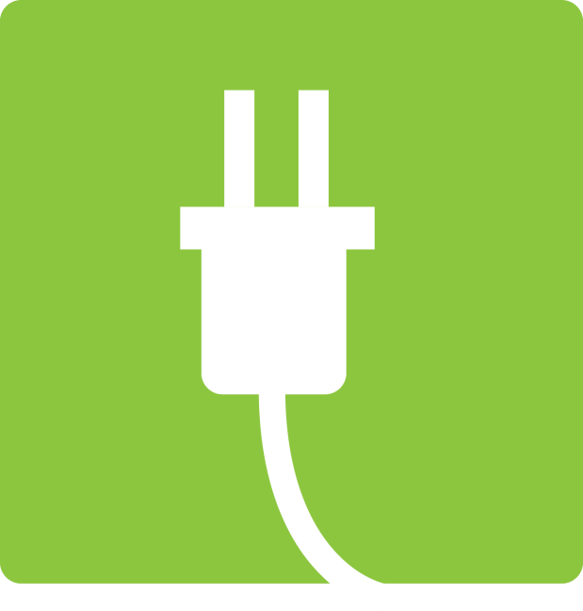
Power & Charging:
Image 9: Power cable
Keep an extra charger for your cell phone, and a portable battery pack.
If you require power for your well-being, consider purchasing a generator for your home.
Consider a medical alert system that will allow you to contact an agency if you cannot move in an emergency.
Consider learning about technologies and devices that allow communications during disasters (such as PDAs, text radio, pagers etc.)

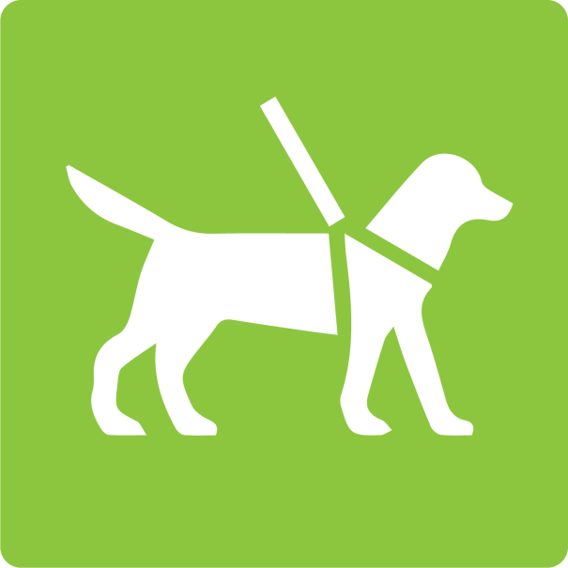
Pets and Service Animals:
Make a plan for your pets or service animals. Don’t assume service animals can accompany you into shelters. By law, official service animals should be allowed. Be aware that some shelter managers are inexperienced and may not know your rights to your service animal, but may not have time or patience to listen to you.
Image 10: Service dog
Have documentation of your service animals with you.

Evacuation
Evacuation may be necessary if there is a fire or flood, or if your building or street is damaged.
Consider the possibility that your typical paths of travel could be disrupted. Think about alternative escape routes within your home, street, and neighborhood if an earthquake, flood, fire, or other disaster disrupts the doorways or environment.

Emergency Alerts

Are there emergency alerts you can have sent to you on your phone? Find out about local networks. For example, phone calls, text messages, email, wireless emergency alert, or neighbors shouting or knocking!

Local Emergency Procedures & Resources

Find out if your city or town has an emergency management office or American Red Cross chapter to get information in advance about services for people with disabilities. Ask about community response plans for disasters.

Find out if your town or city keeps a registry of people with disabilities, and consider signing up. However, don't assume that they will rescue you if you're registered. Police, fire department and all emergency vehicles will be very busy in any disaster.
Ask about emergency procedures in your town, your workplace, or other areas where you and your family spend a lot of time.


If you have a spinal cord injury or other disability that affects your body temperature regulation, you could experience overheating in extreme weather. Find out about cooling centers in your locale.

Find out if your community has a shelter and learn about disability access features. Even if you have an alternate plan, it is an important resource to consider in case your plans fall through. You can also help other people with disabilities by sharing this information.

If it’s “Get out quick!”:
The police or a neighbor may bang on your door in case of a fire, flood or extreme weather. You may not have much warning time to leave. Follow instructions of police and fire department.

No time: Get people and pets, grab your Go Bag (described in the Go Bag section below) and go!

Only 5 minutes: Get medications, glasses, laptop and charger, cell phone and charger, essential medical and adaptive equipment, and your Go Bag!

About 30 minutes: photo albums/family treasures, change of clothing, snack food and water bottle (plus above) Check on neighbors to make sure they are leaving, offer a ride if possible. Make a list in advance of the things in your home that you treasure and post this on your fridge. Know where they are and how you would bring them with you.

If you feel unsafe, leave immediately. Especially if:
- Fire is visible in a nearby home or woods and there are strong winds. Smoke and embers can be carried by winds close by.
- Water is rising in the street or sidewalk.
- Water is entering your home.

If you must evacuate, lock your home and bring your keys.
Designate a place to meet up with your people outside of your home in case of required evacuation.

If evacuation from home is required, you have a few options about where to go. Here are some pros and cons of each.

Shelters
Pros: Local emergency shelters are required to provide disability access, and will have basics like food, water, shelter, and cots.
Cons: Getting the accommodations you need may take some time and persistence, as not everyone will be trained to understand the needs of people with disabilities, and there will be many people trying to advocate for their own needs. Personal health care services are not available in shelters.

Hospitals
Pros: May be necessary if you are injured, it will be wheelchair accessible, have medications and medical devices.
Cons: Will be very crowded, and if they admit you, you will become a “patient,” with limited rights to decide what you want to do. You could be separated from friends and family.

Family or friend’s home
Pros: Comfortable and private, can have trusted people to help you with personal care needs, not as crowded as other options, most likely to receive respect, understanding, and emotional support.
Cons: May not be a wheelchair-accessible home, or may not have the time or accessible transportation to get there.

In general, we advise that people with disabilities try to go somewhere with family or friends if possible. It requires planning ahead and asking family or friends if you could stay with them in an emergency. However, there may not be time or transportation to get to your chosen location. Find out about emergency shelter plans in your town just in case.

Go Bags
Go bags have items you’ve packed up in advance in a backpack or carry case you can grab.

There’s lots of advice in hand-outs or on the web about what to put into your Go Bag. Many items are things that everyone needs and of course, apply to people with paralysis, such as a toothbrush, glasses, cell charger, etc. (See list below.)

But we may not typically need many of the generic things suggested in this advice (like matches and cooking utensils, etc.) as we won’t be alone. We will need items with us that specifically meet our individual needs.

If there is a need to evacuate your home after a disaster strikes, people with paralysis will need to be with people, and may need to go to a shelter or to a friend or relative’s home.
Disasters can occur any time including during daytime hours. You may not be at home. If you work outside the home, keep a stash of essential provisions at your workplace, such as medications, a cell phone charger, a change of underwear, snacks, pet or service animal supplies, and so forth.

Consider always carrying a bag on your wheelchair, if you use one, with a few vital supplies.

How Make Your Go Bag

Begin to make a list of the things you do and need every day related to your disability, such as your mobility equipment, your devices, and your medication. Consider comfort items such as snacks, ear plugs, hand cream, & chapstick. Start to pack a back pack with these items. Don’t wait until you’ve got a full list. Start now! You know why!

Of course, you can’t put an extra wheelchair into a Go Bag. But you can think ahead about what items will fit. Think: what would I take in a small suitcase for a three day trip?

Keep your Go Bag in a place in your home where you can grab it and go in case you need to evacuate. If you spend much of your time other locations, such as your workplace or your car, consider having another Go Bag there.

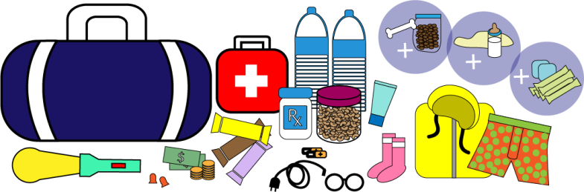
Image 11: Go bag with items spread out around it

Go Bag General List

- First aid kit with alcohol wipes, band aids, anti-biotic cream, gauze, aspirin, towelettes, hand sanitizer.
- Your medications—at least a three day supply
- Charger cables for phone and medical devices
- Cash and coins
- Bottled water and non-perishable snacks, such as nuts or granola bars
- Change of clothing, especially socks, underwear, and warm jacket for each person
- Eye glasses, and/or contact lens solution
- Batteries – for your flashlight, medical devices (including hearing aids), plus extras
- Flashlight
- Toothpaste and toothbrushes
Comfort items, such as earplugs, lip balm, hand cream

If relevant to your family:
- Items for babies and children (such as diapers, bottles, blankets, toys, and clothing)
- Menstrual supplies
- Pet supplies
For Vehicles
- Booster/jumper cables
- Tire repair tools and flares
- Bottled water and snacks

More Disaster Preparation Resources
Thanks for joining us in disaster readiness! For more information on disaster readiness, here are some places to start:

FEMA, P.O. Box 2012, Jessup, MD, 20794-2012
FEMA has a downloadable brochure with extensive planning guidelines.
https://www.fema.gov/resources-people-disabilities-access-functional-needs

The Red Cross offers several different approaches and assessments for disaster preparedness for people with disabilities.
https://www.redcross.org/get-help/how-to-prepare-for-emergencies/disaster-safety-for-people-with-disabilities.html

United States Department of Agriculture Animal and Plant Health Inspection Service offers further guidelines and links for protecting pets and service animals in disasters. https://www.aphis.usda.gov/aphis/ourfocus/animalwelfare/sa_ep/links-pet-disasters

The World Institute on Disability is a nonprofit specializing in disability research, policy, and consulting. For more information about disaster preparedness for people with disabilities, visit the “Disaster Prep” page of our website.
https://wid.org/climate-change/

