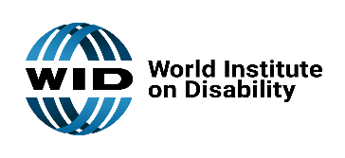 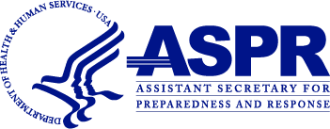

[Delete this textbox and replace with agency/organization logo]

# You Are Invited!

The [Agency/organization name] is inviting your participation in a government funded project to improve post-disaster health and social outcomes for people in our community. We are coordinating with the World Institute on Disability (WID) and the Assistance Secretary for Preparedness and Response under the Department of Health and Human Services (HHS ASPR) to establish a Health Equity in Disasters Task Force in our community.  
We are bringing together community representatives to assess the causes of health inequities after disasters and develop strategies to improve outcomes.

We need leaders in:

* Emergency management
* Disability-led organizations
* Community healthcare clinic
* Community policy
* Small business
* People with disabilities
* Disproportionately impacted communities

Team members can expect:

* Monthly meetings
* Communicate with your point of contact
* Share information with your community
* Implement tools
* Provide feedback

If you are interested in joining our task force, please contact us at:

[Point of Contact Name] [Point of Contact Email]