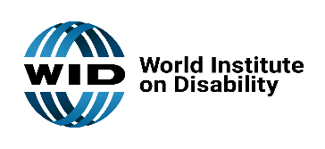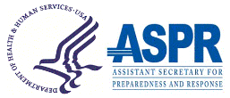

[Agency Logo]

YOU ARE INVITED

The [ ] is inviting your participation in a government funded project to improve post-disaster health and social outcomes for people in our community. We are coordinating with the World Institute on Disability (WID) and the Assistance Secretary for Preparedness and Response under the Department of Health and Human Services (HHS ASPR) to establish a Health Equity in Disasters Task Forces in our community.

We are bringing together community representatives to assess the causes of health inequities after disasters and develop strategies to improve outcomes.

We need leaders in:

* Emergency Management Team
* Disability-led organizations
* Community Healthcare clinic
* Community policy leaders
* Small businesses
* People with disabilities
* Disproportionately impacted communities

Team members can expect:

* Monthly strategic planning meetings
* Communicate with point of contact for Task Force
* Share information to their community
* Implement tools
* Provide feedback

If you are interested in joining our task force please contact us at: [fillable section for points of contact [agency POC email].

If you have other questions about the project, please contact [healthequity@wid.org](mailto:healthequity@wid.org).