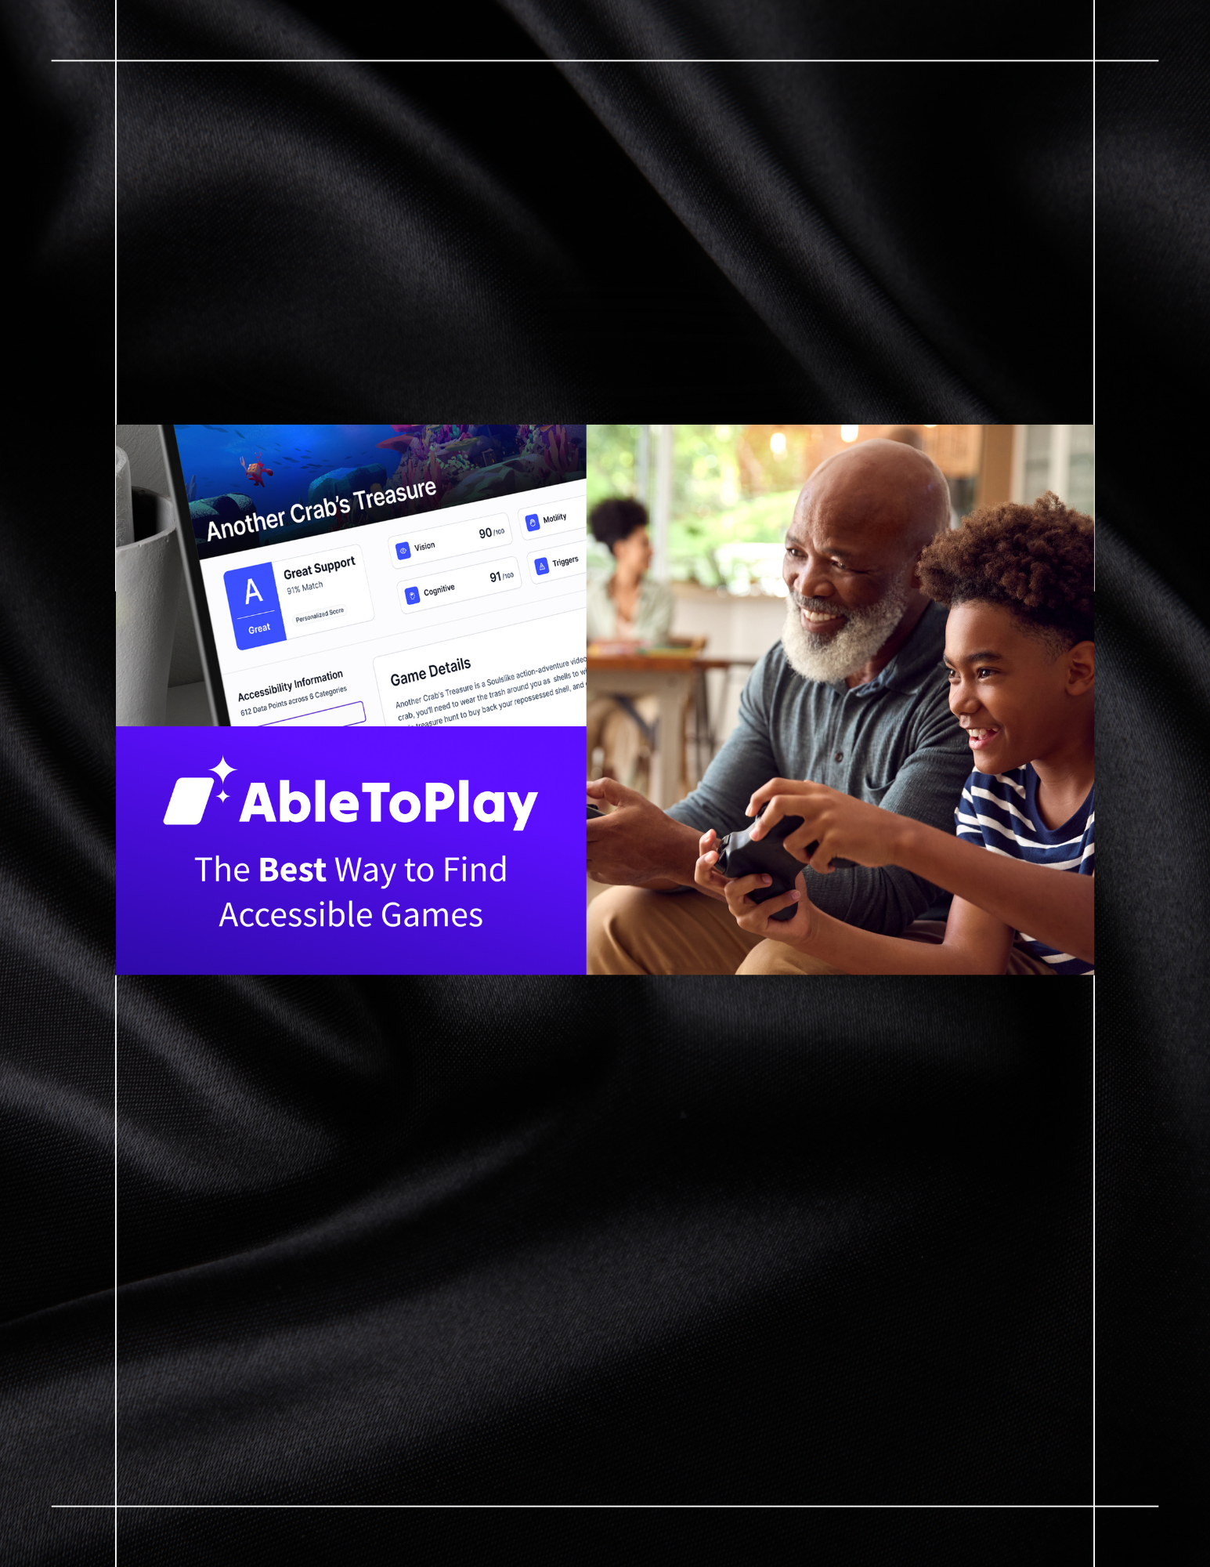
AbleToPlay
Gaming Should Be for Everyone
GAAD Toolkit 2026

Gaming Should Be for Everyone
WID is inviting you to celebrate Global Accessibility Awareness Day (GAAD) by sharing AbleToPlay throughout the month of May. In a time when everything is becoming digital, GAAD is an opportunity to raise awareness to both the need and innovations around digital accessibility in community living. Gaming is a premier example of accessible community living.
By sharing the opportunity for accessible gaming throughout our networks and communities, we can celebrate the intention of GAAD and benefit our community members.
WID is providing this media toolkit to give you the resources you need to join us in this month-long initiative.

What Is AbleToPlay?
AbleToPlay is a free website that helps people find video games that match their accessibility needs. Users create a private profile and get personalized game recommendations with a Personal Score.

What Makes It Different
- Personalized results based on individual needs
- Detailed accessibility information for each game
- Content and trigger awareness
- Fast and easy to use
- Built with the disability community

Why This Matters
Many people with disabilities spend hours searching for accessible games or buy games they cannot play. AbleToPlay fills a critical gap and makes accessibility simple and easy to understand.

Accessibility Areas Covered
- Vision
- Mobility
- Hearing
- Cognitive
- Content triggers

What You Can Do
- Try AbleToPlay
- Share it with your network through newsletters, blogs, posts, and emails
- Elevate others social media posts
- Tell every gamer you know
- Sign up for a free account
- Explore accessible games
- Host a gaming event

Sample Social Post
Gaming should be for everyone. AbleToPlay helps people with disabilities find games that work for them. #GAAD #AbleToPlay #Accessibility (add image of Able to Play)

Email/Newsletter
This Global Accessibility Awareness Day, we’re highlighting AbleToPlay , a free platform that helps people with disabilities find accessible video games. Users create a profile based on their needs and get personalized recommendations.

Key Message
AbleToPlay matches gamers with disabilities to games that fit their needs. Join thousands of gamers on AbleToPlay and discover new favorite games that fit your needs!

Closing
When everyone can play, everyone benefits. Thank you for joining WID during GAAD month.

Images
